**PROFORMA FOR ANNUAL REPORT 2021 (January-December 2021)**

1.1. Name and address of KVK with phone, fax and e-mail

|  |  |  |  |
| --- | --- | --- | --- |
| Address | Telephone | | E mail |
|  | Office | FAX |  |
| Darjeeling KVK  Uttar Banga Krishi Viswavidyalaya  Kalimpong, Darjeeling, West Bengal - 734301 | 03552-355357 | 03552-355357 | djkvk93@gmail.com |

1.2 .Name and address of host organization with phone, fax and e-mail

|  |  |  |  |
| --- | --- | --- | --- |
| Address | Telephone | | E mail |
| Office | FAX |  |
| Dr. Prabhat Pal  Uttar Banga Krishi Viswavidyalaya  P.O Pundibari, Cooch Behar | 03582-270141/986 | 03582-270249/986 | dee_ubkv@gmail.com |

1.3. Name of Senior Scientist and Head with phone & mobile No.

|  |  |  |  |
| --- | --- | --- | --- |
| Name | Telephone / Contact | | |
|  | Residence | Mobile | Email |
| Dr. Pranab Barma | Scientist Quarter, RRS (Hill Zone), UBKV, Kalimpong | 9434619287 | pranab.barma@gmail.com |

1.4. Year of sanction of KVK: 1993

1.5. Staff Position (**as on 1stJanuary, 2021**)

|  |  |  |  |  |  |  |  |  |
| --- | --- | --- | --- | --- | --- | --- | --- | --- |
| **Sl.**  **No.** | **Sanctioned post** | **Name of the incumbent** | **Designation** | **Discipline/** | **Pay**  **Scale with present basic** | **Date of joining** | **Permanent/**  **Temporary** | **Category (SC/ST/**  **OBC/**  **Others)** |
| 1 | Senior Scientist | Dr. Mendel Wangchuk Moktan | Senior Scientist | Agril. Extension | PB-4 | 01/08/2014 | Permanent | ST |
| 2 | Subject Matter Specialist | Mrs Akriti Pradhan | SMS | Home Science | PB – 3 | 14/07/2014 | Permanent | OBC |
| 3 | Subject Matter Specialist | Dr. Pranab Barma | SMS | Plant Protection | PB – 3 | 18/07/2014 | Permanent | SC |
| 4 | Subject Matter Specialist | Mrs. Snehlata Lama | SMS | Horticulture | PB – 3 | 25/11/2014 | Permanent | ST |
| 5 | Subject Matter Specialist | Dr. Ranajit Panda | SMS | Soil Science | PB-3 | 02/11/2018 | Permanent | General |
| 6 | Subject Matter Specialist | Dr. M Hasan Khan | SMS | Animal Science | PB-3 | 24/08/2020 | Permanent | OBC |
| 7 | Subject Matter Specialist | Vacant | SMS | Agril Extension |  |  |  |  |
| 8 | Programme Assistant | Dr. Basu Deo Kharga | Programme Assistant (Training) | Agril. Extension | PB – 3 | 20.06.2007 | Permanent | General |
| 9 | Computer Programmer | Dr. Subrata Manna | Programme Assistant | Computer Science | PB – 3 | 30.01.2006 | Permanent | OBC |
| 10 | Farm Manager | Akash Deep Thapa | Farm Manager | Agril. Extension | PB – 3 | 02.07.2007 | Permanent | OBC |
| 11 | Accountant / Superintendent | Dinesh Kr.Diyali | Assistant | M.com. | PB – 2 | 30.01.2006 | Permanent | SC |
| 12 | Stenographer | Mr. Bhaskar Roy | Stenographer Gr III | B.A | PB-1 | 31/05/2019 | Permanent | SC |
| 13. | Driver | Ashok Tamang | Driver | HS | PB – 1 | 12.09.2007 | Permanent | ST |
| 14. | Driver | Harish Kr.Chhetri | Driver | HS | PB – 1 | 13.09.2007 | Permanent | General |
| 15. | Supporting staff | Mrs. Mingma Lhamu Lama | Supporting staff | HS | PB-1 | 31/10/2014 | Permanent | ST |
| 16. | Supporting staff | Sri Sandeep Thapa | Supporting staff | B.A. | PB-1 | 03/11/2014 | Permanent | OBC |

1.6. Total land with KVK (in ha) :

|  |  |  |
| --- | --- | --- |
| S. No. | Item | Area (ha) |
| 1 | Under Buildings | 0.036 |
| 2. | Under Demonstration Units | 1.00 |
| 3. | Under Crops | 2.50 |
| 4. | Orchard/Agro-forestry | 1.88 |
| 5. | Others with details | 16.77 |
|  | Total | **22.186** |

*Total area should be matched with breakup*

1.7. Infrastructure Development:

1. Buildings and others

|  |  |  |  |  |  |  |  |  |  |
| --- | --- | --- | --- | --- | --- | --- | --- | --- | --- |
| S. No. | Name of infrastructure | Not yet started | Completed up to plinth level | Completed up to lintel level | Completed up to roof level | Totally completed | Plinth area (sq.m) | Under use or not* | Source of funding |
| 1. | Administrative Building |  |  |  |  | 2004 | 293 | Yes | ICAR |
| 2. | Farmers Hostel |  |  |  |  | 2006 | 293 | Yes | ICAR |
| 3. | Staff Quarters (6) |  |  |  |  | 2009 | 400 | 2 out of 6 | ICAR |
| 4. | Piggery unit  (Dalapchand) |  |  |  |  | 2012 | 14 | No | RKVY Project |
|  | Piggery unit  (Demo Unit) |  |  |  |  | 2020 | 10 | Yes | ICAR |
| 5 | Fencing |  |  |  |  |  |  |  |  |
| 6 | Rain Water harvesting |  |  |  |  | 2009 | 75000 L | Yes | ICAR |
| 7 | Threshing floor |  |  |  |  | 2012 | 400 sq ft | Yes | RKVY Project |
| 8 | Farm godown |  |  |  |  | 2010 | 800 Sq ft | Yes | ICAR |
| 9. | Dairy unit |  |  |  |  |  |  |  |  |
| 10. | Poultry unit |  |  |  |  | 2012 | 450 Sq ft | No | RKVY Project |
| 11. | Goatary unit |  |  |  |  | 2012 | 120 Sq ft | No | RKVY Project |
| 12. | Mushroom Lab |  |  |  |  | 2018 |  | No |  |
| 13. | Mushroom production unit |  |  |  |  | 2012 | 800 Sq ft | No | RKVY Project |
| 14. | Shade house |  |  |  |  | 2012 | 180 Sq ft | Yes | University |
| 15. | Soil test Lab |  |  |  |  | 2012 | 300 sq ft | Yes | RKVY Project |
| 16 | Others,Please Specify |  |  |  |  |  |  |  |  |
| 17 | Vermi Compost Unit |  |  |  |  | 2004 | 293 | Yes | ICAR |

* If not in use then since when and reason for non-use

B) Vehicles

|  |  |  |  |  |
| --- | --- | --- | --- | --- |
| Type of vehicle | Year of purchase | Cost (Rs.) | Total km. Run | Present status |
| Mahindra Max (4 wheel drive) | 2006 | 5.0 lacks | More than 2 Lakh | Condemned by MVI |
| Honda Unicon Bike | 2016 | 0.75 Lakh | 5758 | Good |
| Mahindra Gusto Scooty | 2016 | 0.60 Lakh | 7560 | Good |

1. Equipment & AV aids

|  |  |  |  |  |
| --- | --- | --- | --- | --- |
| **Name of equipment** | **Year of purchase** | **Cost (Rs.)** | **Present status** | **Source of fund** |
| **a. Lab equipment** | | | | |
| Spectrophotometer |  | 0.60 |  | ICAR |
| Flame Photometer |  | 0.50 |  | ICAR |
| PH Meter |  | 0.10 |  | ICAR |
| Conductivity bridge |  | 0.10 |  | ICAR |
| Physical balance |  | 0.10 |  | ICAR |
| Chemical balance |  | 1.00 |  | ICAR |
| Digestion unit |  |  |  | ICAR |
| Kjeldhal Distillation set |  | 0.60 |  | ICAR |
| Mechanical shaker |  | 0.50 |  | ICAR |
| Refrigerator |  | 0.20 |  | ICAR |
| Hot air oven |  | 0.15 |  | ICAR |
| Hot plate |  | 0.25 |  | ICAR |
| Grinder |  | 0.30 |  | ICAR |
| Water distillation unit (double) |  | 1.00 |  | ICAR |
| Chemical and Glass wares |  | 2.50 |  | ICAR |
| Soxlet Apparatus (Big &Small) |  | 0.50 |  | ICAR |
| Laboratory set up |  | 3.30 |  | ICAR |
| Soil and plant sample processing and storage facility |  | 0.50 |  | ICAR |
| **b. Farm machinery** | | | | |
| Power tiller | (2 nos) one from RRS, Hill Zone & another from Khoribari | One is in working condition another working but need some repairing | |  |
| Mini Power tiller | 2019 | 1,00,000 | Working |  |
| Rotary power tiller | 2011 | 68500 | working | RKVY |
| Weed cutter | 2011 | 32800 | Working | RKVY |
| Mobile sprayer | 2011 | 32600 | Not Working | RKVY |
| Rocker sprayer | 2011 | 4800 | Working | RKVY |
| Branch cutter | 2011 | 61000 (2nos) | Working | RKVY |
| Paddy cutter | 2011 | 36000 | working | RKVY |
| Weigh machine | 2011 | 16640(2nos) | Not Working | RKVY |
| P.A. System | 2011 | 2860 | working | RKVY |
| **C. AV Aids** | | | | |
| Over Head Projector | 1995 | 9042 | Not good |  |
| Television | 2004 | 13500 | Not Good |  |
| DVD | 2006 | 4050 | Not Good |  |
| Camera | 1994 | 2350 | Not good |  |
| Digital Camera Sony F217 | 2004 | 64990 | Not good |  |
| LCD Projector | 2008 | 78000 | Not Working |  |
| LCD Projector | 2009 | 56000 | Not Good |  |
| Nikon SLR Camera | 2009 | 30000 | Not Good |  |
| Handy Cam | 2009 | 25000 | Not Good |  |
| Laptop | 2009 | 30000 | outdated |  |
| Laptop | 2011 | 30000 | Not Good |  |
| Netbook | 2011 | 25000 | Not Good |  |
| Ahuja Sound system for Conference Hall |  |  | Not Good |  |
| Canon Photo copier |  |  | Not Good |  |
| FAX Machine |  |  | Good |  |
| Laptop | 2011 | 44780 | Working |  |
| Desktop | 2011 | 40980 | Not Working |  |
| LCD Projector | 2011 | 54000 | Working |  |
| Printer | 2011 | 10900 | Not Working |  |
| UPS | 2011 | 1750 | Not working |  |
| LCD Projector | 2021 |  |  | SCSP |
| 3 Lenevo Desktop PC | 2021 | 1,20,000 | Working | DAMU |
| 3 Printer Epson L3110 | 2021 | 36,000 | Working | DAMU |

1. Farm implements

|  |  |  |  |  |
| --- | --- | --- | --- | --- |
| **Name of equipment** | **Year of purchase** | **Cost (Rs.)** | **Present status** | **Source of fund** |
| Maize Sheller | 2011 | 1500 (10 pcs) | Working | ICAR |
| Secateurs | 2011 | 2100 (6pcs) | 4 Damaged 2 working | RKVY |
| Tree pruner | 2011 | 1645 (1pc) | Not Working | RKVY |
| Hedge shear | 2011 | 1000 (1pc) | Working | RKVY |
| Pruning saw | 2011 | 400 (2pcs) | Working | RKVY |
| Garden tools | 2011 | 1200 (3 pcs) | Working | RKVY |
| Spade | 2011 | 3750 (12 pcs) | Damaged | RKVY |
| Rake | 2011 | 1344 (6 pcs) | 4 Damaged 2 working | RKVY |
| Khurpa | 2011 | 900 (8 pcs) | 4 Damaged 4 working | RKVY |
| Datri | 2011 | 375 (3pcs) | Working | RKVY |
| Knapsack sprayer | 2011 | 5100 (2 pcs) | Not Working | RKVY |
| Turmeric cutter machine | 2016 | 14000 ( 1 Pcs) | Not Working | TSP |
| Honey Extractor | 2016 | 6600 (2 pcs) | Working | TSP |
| Bee Hives | 2016 | 5400 ( 3 Pcs) | Working | TSP |
| Drier with 2 trays |  |  | Working | ICAR |
| Refrigerator LG |  |  | Not working | ICAR |
| Electronic weighing scale | 2018 | 5000 | Working | ICAR |
| Mixer grinder  (Morphy Richards) | 2018 | 4500 | Working | ICAR |
| Electric Kettel (Scarlet) | 2018 | 1500 | Working | ICAR |
| Hand Sealing Machine | 2018 | 2500 | Working | ICAR |
| Gas Stove | 2018 | 5500 | Working | ICAR |
| Kitchen Utensils (37 nos.) | 2018 | 16,500 | Working | ICAR |
| Cardamom harvesting knife (5 No.s) | 2017 | 600 | Working | ICAR |
| Spade and Fork (5 piece each) | 2018 | 9000 | Working | ICAR |

1.8. Details SAC meeting* conducted in the year

**Proceedings of**

**20th Scientific Advisory Committee**

**Krishi Vigyan Kendra, UBKV, Kalimpong**

**Date: 22.03.2021**

The recommendations suggested during the meeting were as follows:

|  |  |  |  |
| --- | --- | --- | --- |
| **Sl.No.** | **Salient Recommendations** | **Action taken** | **If not conducted, state reason** |
| 1. | As suggested by the honorable Vice Chancellor Dr. Swarup Kumar Chakrabarti, UBKV, Pundibari, COOch Behar that an orientation training programme for the newly appointed SMS to be organized at U.B.K.V main campus. | Not Done |  |
| 2 | OFT on Horticulture, Dr A. Halder, PS, ATARI, Kolkata suggested that considering the negative result of the third technology option the said technology option should be dropped. | Technology option III: Capsicum cultivation on the elevation 0f 1500-1750 msl is dropped and as per the suggestion, this technology was done at Dalapchand farm as On Station Trial. |  |
| 3 | Dr A. Halder PS, ATARI, Kolkata suggested that the successful OFT conducted in the previous years may be converted to FLD. | Successful OFT on varietal trial of Strawberry varieties. Navella variety has been distributed to the farmer under FLD programme. |  |
| 4 | Dr Halder, PS, ATARI, Kolkata, suggested that while considering the training programme the content should be specific he further added that SMS (Soil Science) must encourage the farmers more on Hands on Training programme on vermicompost production. | Hands on training programme on vermicomposting has been taken up according to action plan and distributed vermicomposting polybag unit under SCSP scheme. |  |
| 5 | Dr Halder PS, ATARI, Kolkata suggested that as rainfall is very high in Kalimpong Hills we must emphasize more on conservation of rain water through propagation of Jalkund Technology. | Not Done. | KVK will be initiated this programme at Paiyong Village under NICRA Scheme. |
| 6 | OFTs on Animal Science should be re-casted. Dr Halder suggested considering the availability of Rani variety of pig, the said variety may be propagated at KVK farm and then the OFT programme may be conducted at the farmers level. He further added that the OFTs of Animal Science on Nutrition of Pig and Backyard poultry may be taken up. | In Consultation with Dr A. Haldar, Principal Scientist, ATARI, has permitted and suggested the OFT on Nutrition of Pig and Backyard Poultry. | Due to non availability of .Rani breed of pig, it was not included in the OFT programme. |
|  | As suggested by Dr Tulsi S Ghimiray, RRS (Hill Zone), UBKV, Kalimpong, and DDEE Dr Saikat Mukarjee, UBKV, Majhian, Short duration rice variety should be incorporated as for example Annada ,parijat etc in the OFT of Soil Science. | Short duration variety of rice, Sahabhagi ans Bina 11has been incorporated in the OFT programme. |  |
|  | OST trial on capsicum to be conducted on Dalapchand Farm. | Seedling production of Capsicum has taken up as OST. |  |
|  | OFTs on Home Science should be re-casted | OFT on Home Science has already been recasted and new action plan was submitted. |  |
|  | Mr Kumar Pakhrin, representative-KOFPC reported that apple cultivation under ATMA Scheme of Agriculture dept. is found successful in Sakyong village and suggested for supply of apple sapling for cultivation from KVK if possible | Not Done | Varietal trial on Apple cultivation under the scheme of ATMA at KVK station has already been initiated. Later it will be supplied to farming community. |
|  | Mr Arun Chettri and Mrs Usha Tamang progressive farmers engaged in floricultural activity shared their experiences expressing that the cultivation of Orchid, ornamental flowers and succulents have been found economically viable | Technology on the cultivations of Orchid, Ornamental flowers and succulents has been disseminated through training. |  |
|  | Dr Haldar PS, ATARI, Kolkata, suggested that the considering the decline in yield of Manadarin, Ginger and other spices crop, more programmes should be taken up simultaneously. Hort.SMS should work in collaboration with RRS, SAUs and UBKV | Done as per the suggestion from RRS (HZ), UBKV   1. Single bud propagation of ginger 2. Nutritional management of Darjeeling Mandaring 3. Training was also conducted |  |
|  | Dr Haldar PS, ATARI, Kolkata, further suggested that more programmers on Pig farming, Backyard poultry farming and Animal Nutrition should be taken up. He also suggested that Considering Soil erosion in hill areas, fodder crop cultivation having soil conservation capacity should be grown | Training was taken up on pig farming, backyard poultry and fodder cultivation. |  |
|  | Dr P.K.Pal, DEE, UBKV, Pundibari, Cooch Behar suggested that OFT and FLD should be framed with the consultation of RRS, Hill Zone, UBKV, Kalimpong and further emphasized on dissemination of Field need based technology. He also suggested that the technology developed by the institution should be presented to such type of scientific meeting and forwarded to the university authority | The new technology innovated by Darjeeling KVK is in the process of patenting.  DST has granted fund for patenting in the name of UBKV. |  |
|  | Honorable Vice Chancellor, UBKV, Pundibari, Cooch Behar stressed upon the offseason vegetable and fruits cultivation, floriculture and good quality mushroom cultivation as well as entrepreneurship development. Honorable sir also suggested that there should be communication between University Authority as well other Research and Extension wings | Done as per the suggestion of Hon’ble VC sir. Entrepreneurship development on floriculture under SCSP programme has already been initiated. |  |

*\* Salient recommendation of SAC in bullet form*

*Attach a copy of SAC proceedings along with list of participants*

20th SAC Meeting of Darjeeling Krishi Vigyan Kendra, Uttar Banga Krishi Viswavidyalaya, Kalimpong (virtual Mode) was held on 22nd March, 2021. List of participants are as follows,

1. Honorable Vice Chancellor Dr Swarup Kumar Chakrabarti Uttar Banga Krishi Viswavidalaya ,Pundibari Coochbehar.
2. Director of Extension Education Dr Prabhat Kumar Pal, Uttar Banga Krishi Viswavidalaya ,Pundibari Coochbehar.
3. Dr Saikat Mukarjee, Deputy Director of Extension Education, Uttar Banga Krishi Viswavidalaya ,Pundibari Coochbehar.
4. Dr Abhijit Haldar Principal Scientist ATARI ,Kolkata ,
5. Prof.Tulsi Saran Ghimiray RRS Hill Zone Kalimpong
6. Prof. Binay Raj Sharma RRS Hill Zone Kalimpong,
7. Dr. Rakesh Roy, SS & Head. Malda KVK, UBKV .
8. Mr. Nirmal Chandra Barma, DDA, Kalimpiong,
9. Dr Navin Kumar Pradhan, A.D.O, Kalimpong.
10. Dr M.W Moktan (S.S & Head, DJKVK).
11. Farmers` Representative- Usha Tamang, Kumar Pakhrin, Arun Chhetri, Yohan Lepcha, Shailesh Darnal and Rajen Bhetwal.

2.a. District level data on agriculture, livestock and farming situation (2021)

|  |  |  |  |
| --- | --- | --- | --- |
| **Sl. no.** | **Item** | **Information** | |
| 1 | Major Farming system/enterprise | Hill and mountain farming system with horticulture base crop enterprise | |
| 2 | Agro-climatic Zone | | |
|  | Hill Zone | 1. Sloppy land – high soil erosion, shallow depth 2. Acidity problem 3. Low soil fertility – due to NPK and micro nutrient 4. Low Nitrogen release from organic matter due to soil acidity and low temperature | |
|  | Tarai Zone | 1. High leaching loss of nutrient due to light texture soil 2. Low availability of P due to soil acidity 3. Bo and Mo deficiency | |
| 3 | Agro ecological situation | 1. Due to sub-humid climate organic matter content moderate to high (2%) but decrease with depth 2. The eastern Himalayan region acidic to neutral range pH found | |
| 4 | Soil type |  | |
|  | Brown forest soil | 1. Slow release nutrients from organic matter due to acidity and low temperature 2. Micro nutrient deficiency 3. Leaching loss of nutrients due to high rainfall | |
| 5 | Productivity of major 2-3 crops under cereals, pulses, oilseeds, vegetables, fruits and others | Crop | Productivity (q/ha) |
| Rice | 16.98 |
| Wheat | 13.18 |
| Maize | 20.42 |
| Gram | 10.65 |
| Other Pulses | 6.19 |
| Mustard | 3.01 |
| Linseed | 2.05 |
| Potato | 164.40 |
| Tea | 18.89 |
| Chilli (dry) | 7.5 |
| Ginger | 35 |
| Mandarin Orange | 92 |
| Tomato | 160.79 |
| Cabbage | 340.21 |
| Cauliflower | 343.55 |
| Radish | 135.04 |
| Gladiolus | 146733 spikes |
| 6 | Mean yearly temperature, rainfall, humidity of the district | **Attached below** |  |
| 7 | Production of major livestock products like milk, egg, meat etc. | **Category** | **Population** |
| **Cattle** |  |
| *Crossbred* | **277057** |
| *Indigenous* |  |
| **Buffalo** | **5520** |
| **Sheep** |  |
| Crossbred | **2649** |
| *Indigenous* |  |
| **Goats** | **187975** |
| **Pigs** | **53875** |
| *Crossbred* |  |
| *Indigenous* |  |
| **Rabbits** |  |
| **Poultry** | **673026** |
| Hen |  |
| *Desi* |  |
| *Improved* |  |
| Duck |  |
| others | **71593** |

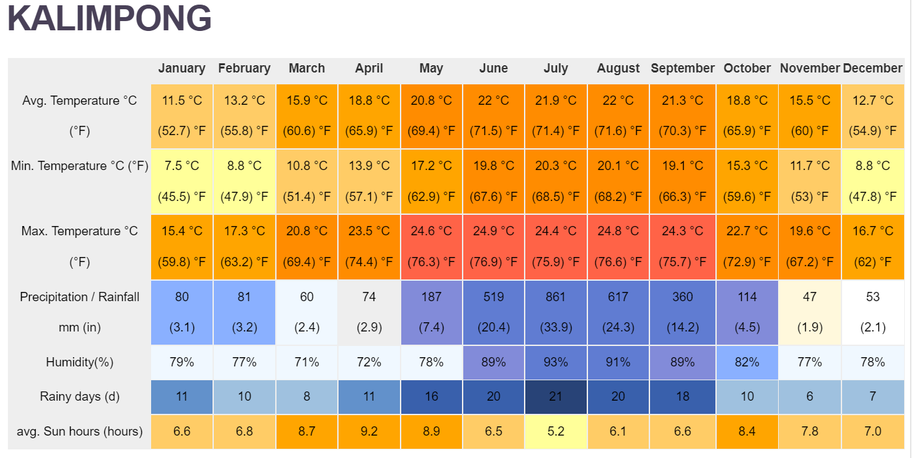

Source : https://en.climate-data.org/asia/india/west-bengal/kalimpong-33810/

2.b. Details of operational area / villages (2021)

|  |  |  |  |  |  |  |  |
| --- | --- | --- | --- | --- | --- | --- | --- |
| **Sl.**  **No.** | **Name of Taluk** | **Name of the block** | **Name of the villages** | **Major crops**  **& enterprises** | **Major problems identified (crop-wise)** | **Identified Thrust Areas** | **Discipline intervened** |
| 01 | Kalimpong | Kalimpong -I | Tirwa Gaon, Chibbo | Vegetables, Maize, | Low productivity of vegetables | Labour intensive and Improper management practices. | Horticulture  Soil Science |
| Bong Busty, Darnal Gaon | Ginger  Paddy, Vegetables, Maize, | Ginger Rhizome rot, low productivity of paddy and vegetables | Rhizome rot disease of ginger | Soil Science  Animal Science  Horticulture |
| Sindebong | Paddy, Maize, Potato Vegetables | Blight in potato, less production, Improper management practices. | Soil Health Management | Soil Science |
| Kalimpong-II | Sangsay | Large Cardamom  Vegetables  Ginger  Potato | Blight in Large cardamom and potato, low market price for vegetables Rhizome rot in ginger. | Rhizome rot in ginger, Blight of large cardamom. | Horticulture  Soil  Animal Science |
| Kagey | Paddy, Vegetables, maize ,potato, Ginger | low productivity of paddy and vegetables | Rhizome rot in ginger, high acidity of soil | Soil Science  Horticulture  Animal Science |
| Sakyong | Large Cardamom, Potato, Maize, Zinger, Round chilli | Low productivity of Potato, Mandarin orange. | Citrus dieback, disease pest infestation, high acidity of soil. | Horticulture  Soil  Animal Science |
|  | Lingsey | Paddy, Mandarin orange, Large Cardamom, Vegetables | Low productivity of Paddy & Mandarin orange. | Citrus dieback, disease pest infestation, high acidity of soil. | Horticulture |
| Gorubathan | Jaldhaka | Black pepper, Paddy , areca-nut and vegetables | low productivity of paddy and vegetables. | Labour intensive and Improper management practices. | Horticulture  Animal Science |
| Kurseong | Mirik | Duptin no 10  Zimba Gaon  Sadhu gaon  Rangamohan  Panighatta | Mandarin  Large cardamom  Vegetables  Ginger  Paddy ,Mustard , maize, | Decline in yield of Mandarin, Rhizome rot in ginger, Low production of vegetables ,Blight of large cardamom | Blight of large cardamom, fruit drop of mandarin , rhizome rot of ginger .  Labour intensive and Improper management practices of paddy . | Horticulture  Soil |
|  |  | Kalimpong II | Gitkolbung  Nokdara | Dairy | Marketing  Low productivity | Lack of marketing channel of Milk  Improper management | Animal Science  Plant Protection |

2. c. Details of village adoption programme:

Name of the villages adopted by PC and SMS (2020) for its development and action plan

|  |  |  |
| --- | --- | --- |
| ***Name of village*** | ***Block*** | ***Action taken for development*** |
| Lower Ecchey | Block I | Income and enterprise generating activities on Value addition, Mushroom cultivation, Kitchen gardening for nutrition security, Observation of important events like National Nutrition week, International Breast feeding week, Swach Bharat Abhiyan |
| Sangsay | Block II | Income generation through Off season cultivation of vegetables in low cost polyhouse, Nutritional management of Darjeeling Mandarin, media preparation for the Commercial cultivation of Alstromeria flower. Strawberry cultivation, |
| Sindebong | Kpg-I | Cultivation of Potato with application of Vermi-compost for better production and soil health management. |
| Sakyong | Kpg-II | Application of Bio-products and vermi-compost for cultivation of Potato check the acidity of soil and improve the nutritional status of soil. |
| Tirwa Gaon | Kpg – I | FLD on Vermi-compost production for income and enterprise generation. |
| Darnal Gaon | Kpg-I | Vermi-compost production in polybag method for improving organic cultivation. |
| Lower Dungra | Kpg-I | Eco-friendly management of diamond back moth in cauliflower grown in Darjeeling Hills |
| Tare Gaon | Kpg-I | Integrated disease management strategy of rice blast disease (*Pyriculariaoryzae*) |
| Duptin Busty | Mirik | Management of Trunk borer in Mandarin orange |
| Bong Busty  Kagey  Sakyong | Kpg- I | FLD on Azolla feeding in backyard poultry for reduction of feed cost. |
| Sakyong, Kagey, Sangsay | Kpg-II | Training on Livestock and Poultry for sustainable development |
| Today-Tangta | Gorubathan | Training on Livestock and Poultry for sustainable development |
| Kagey | Kpg – II | Training on low cost food preparation and nutri-gardening |
| Dungra | Kpg-I | Training and FLD on Value Addition of local fruits and vegetables |
| Sakyong | Kpg – II | Training on entrepreneur development for farm women |
| Sakyong | Kpg – II | OFT on Pig feeding, FLD on Azolla feeding on Poultry |

2.1 Priority thrust areas

|  |  |
| --- | --- |
| **S. No** | **Discipline wise Thrust area** |
| **Soil Science** | |
| 1. | Soil fertility management |
| 2. | Soil Acidity management |
| 3. | Integrated Nutrient Management |
| 4. | Production and use of organic inputs |
| 5. | Management of Problematic soils |
| 6. | Micro nutrient deficiency in crops |
| 7. | Nutrient Use Efficiency |
| **Plant Protection** | |
| 8 | Integrated Pest Management |
| 9 | Integrated Disease Management |
| 10 | Bee Keeping |
| 11 | Mushroom Cultivation |
| 12 | Bio-control of pests and diseases |
| 13 | Production of bio control agents and bio pesticides |
| **Animal Science** | |
| 14 | Low productive breed |
| 15 | Feeding with poor quality feed |
| 16 | Improper Bio-security and vaccination. |
| 17 | Irregular deworming of animals. |
| 18 | Improper management especially in winter season. |
| **Home Science** | |
| 19 | Food insecurity and under-nutrition (kitchen gardening) |
| 20 | Food storage and shelf-life enhancement |
| 21 | Income generating activity for women |
| 22 | Processing and value addition |
| 23 | Location specific drudgery reduction technologies |
| **Horticulture** | |
| 23 | Crop Production |
| 24 | Integrated nutrient management |
| 25 | Off-season vegetables |
| 26 | Production of low volume and high value crops |
| 27 | Cultivation of Fruit |
| 28 | Nursery Management |
| 29 | Spices crop management |
| 30 | Post-harvest technology |

3. TECHNICAL ACHIEVEMENTS

3.A.Details of target and achievement of mandatory activities by KVK during the year

|  |  |  |  |  |  |  |  |  |  |  |  |  |  |  |  |  |  |  |  |  |  |  |  |
| --- | --- | --- | --- | --- | --- | --- | --- | --- | --- | --- | --- | --- | --- | --- | --- | --- | --- | --- | --- | --- | --- | --- | --- |
| OFT | | | | | | | | | | | | FLD | | | | | | | | | | | |
| No. of technologies tested: | | | | | | | | | | | | No. of technologies demonstrated: | | | | | | | | | | | |
| Number of OFTs | | Number of farmers | | | | | | | | | | Number of FLDs | | Number of farmers | | | | | | | | | |
| Target | Achievement | Target | Achievement | | | | | | | | | Target | Achievement | Target | Achievement | | | | | | | | |
|  |  |  | SC | | ST | | Others | | Total | | |  |  |  | SC | | ST | | Others | | Total | | |
|  |  |  | M | F | M | F | M | F | M | F | T |  |  |  | M | F | M | F | M | F | M | F | T |
| 8 | 5 | 43 | 5 | 1 | 3 | 0 | 15 | 3 | 20 | 1 | 27 | 10 | 6 | 109 | 24 | 12 | 23 | 4 | 18 | 8 | 65 | 22 | 87 |

|  |  |  |  |  |  |  |  |  |  |  |  |  |  |  |  |  |  |  |  |  |  |  |  |
| --- | --- | --- | --- | --- | --- | --- | --- | --- | --- | --- | --- | --- | --- | --- | --- | --- | --- | --- | --- | --- | --- | --- | --- |
| Training | | | | | | | | | | | | Extension activities | | | | | | | | | | | |
|  | | | | | | | | | | | |  | | | | | | | | | | | |
| Number of Courses | | Number of Participants | | | | | | | | | | Number of activities | | Number of participants | | | | | | | | | |
| Target | Achievement | Target | Achievement | | | | | | | | | Target | Achievement | Target | Achievement | | | | | | | | |
|  |  |  | SC | | ST | | Others | | Total | | |  |  |  | SC | | ST | | Others | | Total | | |
|  |  |  | M | F | M | F | M | F | M | F | T |  |  |  | M | F | M | F | M | F | M | F | T |
| 60 | 41 | 1500 | 481 | 76 | 187 | 98 | 257 | 241 | 925 | 415 | 1340 | 150 | 144 | 2000 | 244 | 255 | 232 | 477 | 406 | 310 | 878 | 1064 | 1942 |

|  |  |  |  |  |  |  |  |  |  |  |  |  |  |  |  |  |  |  |  |  |  |  |
| --- | --- | --- | --- | --- | --- | --- | --- | --- | --- | --- | --- | --- | --- | --- | --- | --- | --- | --- | --- | --- | --- | --- |
| Impact of capacity building | | | | | | | | | | | Impact of Extension activities | | | | | | | | | | | |
|  | | | | | | | | | | | | | | | | | | | | | | |
| Number of Participants trained | | Number of Trainees got employment (self/ wage/ entrepreneur/ engaged as skilled manpower) | | | | | | | | | | Number of Participants attended | | Number of participants got employment (self/ wage/ entrepreneur/ engaged as skilled manpower) | | | | | | | | |
| Target | Achievement | SC | | ST | | Others | | Total | | | | Target | Achievement | SC | | ST | | Others | | Total | | |
|  |  | M | F | M | F | M | F | M | F | T | |  |  | M | F | M | F | M | F | M | F | T |
| -- | -- | --- | --- | --- | --- | --- | -- | --- | --- | --- | | --- | --- | -- | -- | -- | --- | -- | -- | -- | -- | - |

|  |  |  |  |
| --- | --- | --- | --- |
| Seed production (q) | | Planting material (in Lakh) | |
|  | |  | |
| Target | Achievement | Target | Achievement |
| 500 Kg | 340 Kg | 30000 (No.s) | 24500(No.s) |

|  |  |  |  |
| --- | --- | --- | --- |
| Livestock strains and fish fingerlings produced (in lakh)* | | Soil, water, plant, manures samples tested (in lakh) | |
|  | |  | |
| Target | Achievement | Target | Achievement |
|  |  | 200 | 30 |

* * Give no. only in case of fish fingerlings

|  |  |  |  |  |  |  |  |
| --- | --- | --- | --- | --- | --- | --- | --- |
| Publication by KVKs | | | | | | | |
| Item | Number | No. circulated | No. of 1s in NAAS rated Journals | Highest NAAS rating of any publication | Average NAAS rating of the publications | Details of awarded publication, if any | Details of Award given to the publication |
| Research paper | 1 |  |  |  | 4.15 |  |  |
| Seminar/conference/ symposia papers |  |  |  |  |  |  |  |
| Books |  |  |  |  |  |  |  |
| Bulletins |  |  |  |  |  |  |  |
| News letter | 4 |  |  |  |  |  |  |
| Popular Articles |  |  |  |  |  |  |  |
| Book Chapter | 1 |  |  |  |  |  |  |
| Extension Pamphlets/ literature | 4 |  |  |  |  |  |  |
| Technical reports | 6 |  |  |  |  |  |  |
| Electronic Publication (CD/DVD etc) | 5 |  |  |  |  |  |  |
| TOTAL |  |  |  |  |  |  |  |

1 Achievements on technologies assessed and refined

OFT-1 (Animal Science)

|  |  |  |
| --- | --- | --- |
| 1. | Title of On Farm Trial | **Assessment of Economic Feeding Strategies to Achieve Better Growth performance in Pigs in Kalimpong Hills** |
| 2. | Problem diagnosed | Traditional feeding with poor nutrition |
| 3. | Details of technologies selected for assessment/refinement  (Mention either Assessed or Refined) | **Farmers’ practice:** Feeding with poor quality locally available vegetables and kitchen waste  **Tech. option I:** Kitchen waste (60%) mixed with standard concentrate mixture (40%) (as per BIS recommendation)  **Tech. option II:** Standard concentrate feed (40%) (as per BIS recommendation) + Kitchen waste (53%) + Molasses ( 7%) |
| 4. | Source of Technology (ICAR/ AICRP/SAU/other, please specify) | ICAR Research complex for NEH region, Barapani |
| 5. | Production system and thematic area | Small scale piggery, low production and traditional feeding |
| 6. | Performance of the Technology with performance indicators | Growth rate, Feed Conversion Ratio and body weight gain, B:C ratio |
| 7. | Final recommendation for micro level situation |  |
| 8. | Constraints identified and feedback for research |  |
| 9. | Process of farmers participation and their reaction |  |

*Ongoing

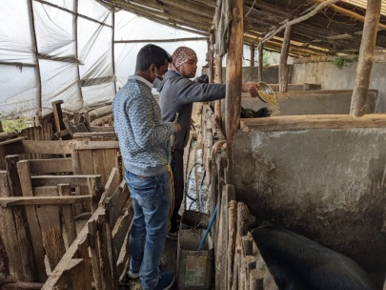 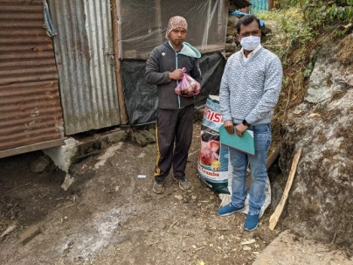 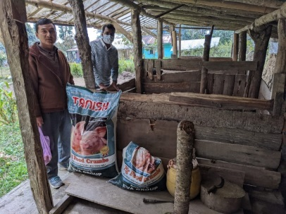

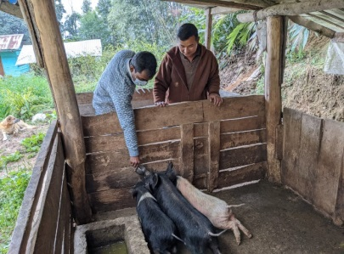 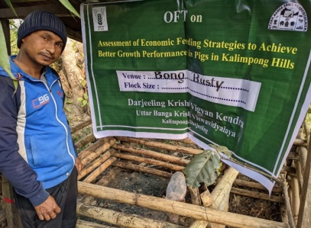 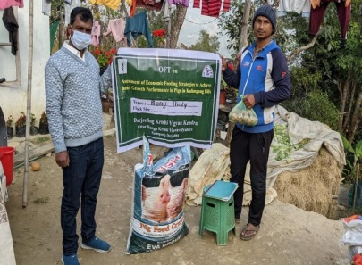

OFT on **Assessment of Economic Feeding Strategies to Achieve Better Growth performance in Pigs in Kalimpong Hills**

OFT-2 (Soil Science)

|  |  |  |
| --- | --- | --- |
| 1. | Title of On farm Trial | Efficacy of Organic manure, Vermi-compost & bio-product (*Trichoderma viride*) to increase the productivity of Potato &Nutrient status (N-P-K) in hilly region of West Bengal. |
| 2. | Problem diagnosed | Due to high acidity & low nutrient status cause less productivity |
| 3. | Details of technologies selected for assessment/refinement  (Mention either Assessed or Refined) | Farmers Practice: Application of FYM @ 15 t/ha  T1:Seed treatment with Trichoderma viride @ 5 gm/kg of seed + 675kg FYM/bigha (i.e. 5t/ha) + 335 kg Vermicompost /bigha (i.e 2.5t/ha) in the main field 10 days before sowing of seeds.  T2:Seed treatment with Trichoderma viride @ 5 gm/kg of seed + 675kg FYM/bigha (i.e. 5t/ha) + 675kg vermicompost/ bigha (i.e.5t/ha) 10 days before sowing of seeds |
| 4. | Source of Technology (ICAR/ AICRP/SAU/other, please specify) | RVKSVV, Gwalior |
| 5. | Production system and thematic area | Vegetable based cropping system  Soil health management |
| 6. | Performance of the Technology with performance indicators | Application of bio-products and vermi-compost increases the pH status of soil and as well as increases the production of potato. |
| 7. | Final recommendation for micro level situation | Technology option2 *i.e.* Seed treatment with *Trichoderma viride*@ 5 gm/kg of seed + 675kg FYM/bigha (i.e. 5t/ha) + 675kg vermicompost/ bigha (i.e.5t/ha) 10 days before sowing of seeds, resulted to produce highest yield 22.06 t/ha as well as the N-K status rises. |
| 8. | Constraints identified and feedback for research | Production of potato was hampered to some extent due to scarcity of water. |
| 9. | Process of farmers participation and their reaction | Progressive farmers of selected village were identified and conducted the oft programme. They have appreciated the work after getting result and accepted the technology. |

**Results**

|  |  |  |  |  |  |  |
| --- | --- | --- | --- | --- | --- | --- |
| ***Technology option*** | ***Yield***  ***(t/ha)*** | ***Yield % increase over Farmer’s practice*** | ***Net return***  ***(Rs./ha)*** | ***BC ratio*** | ***Initial Soil N-P-K status kg/ha*** | ***After Harvest Soil N-P-K Status kg/ha*** |
| Farmers Practice: Application of FYM @ 15 t/ha | 17.43 | - | 75,451/- | 2.1:1 | N-361  P-49  K-326 | N-412  P-45.1  K-341.6 |
| T1:Seed treatment with Trichoderma viride @ 5 gm/kg of seed + 675kg FYM/bigha (i.e. 5t/ha) + 335 kg Vermicompost /bigha (i.e 2.5t/ha) in the main field 10 days before sowing of seeds. | 18.90 | 8.43% | 85,800/- | 2.3:1 |
| T2:Seed treatment with Trichoderma viride @ 5 gm/kg of seed + 675kg FYM/bigha (i.e. 5t/ha) + 675kg vermicompost/ bigha (i.e.5t/ha) 10 days before sowing of seeds. | 22.06 | 26.56% | 1,15560/- | 2.6:1 |
| CD (p=0.05) | 0.76 |  |  |  |  |  |
| SEM | 0.195 |  |  |  |  |  |

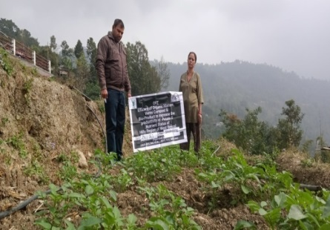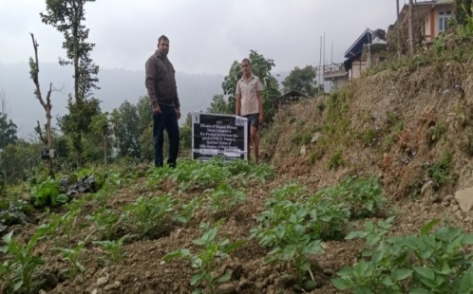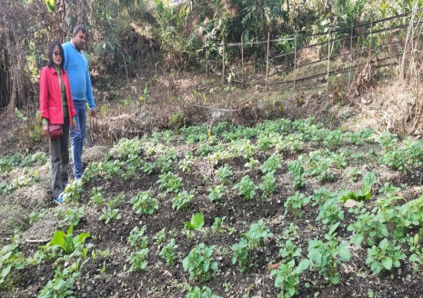

On Farm Trial (OFT)-3 (Soil Science – continuing )

|  |  |  |
| --- | --- | --- |
| 1. | Title of On farm Trial | Assessment of soil fertility in different cropping system through Resource Conservation Technology (RCT) |
| 2. | Problem diagnosed | Low system productivity and declining nutrient status of soil. |
| 3. | Details of technologies selected for assessment/refinement | Introduction of Pulse crop in new cropping system and RCT |
| 4. | Source of Technology | UBKV |
| 5. | Production system and thematic area | Rice-vegetables based cropping system |
| 6. | Performance of the Technology with performance indicators | Soil nutrient status (N-P-K), Yield & economics after harvest. |
| 7. | Final recommendation for micro level situation | It is recommended that **Tech. Opt. 2:**Rice(short duration)-Pea-vegetables (Cauliflower) (by Zero Tillage method) |
| 8. | Constraints identified and feedback for research | Lack of awareness and traditional methods with exhaustive cropping system. |
| 9. | Process of farmers participation and their reaction | Group Discussion, Training, and Field visit. |

Table:

|  |  |  |  |  |  |  |
| --- | --- | --- | --- | --- | --- | --- |
| Technology option | No. of trials | Yield  (q/ha) | Cost of cultivation  (Rs./ha) | Gross return (Rs/ha) | Net return  (Rs./ha) | BC ratio |
|
| **Farmers’ Practice**: Rice-vegetables (Cauliflower) (Traditional Method) | 7 | 22.5 |  |  |  |  |
| **Tech. Option 1:**Rice(short duration)-Pea- vegetables (Cauliflower) (conventional methods) | 7 | 26.56 |  |  |  |  |
| **Tech. Option 2:**Rice(short duration)-Pea-vegetables (Cauliflower) (by Zero Tillage method) | 7 | 28.70 |  |  |  |  |
| CD (0.5%) |  |  |  |  |  |  |

**Results:**From this OFT, it is recommended for the new cropping system with inclusion of Pulse crop by ZT method i.e. Rice(short duration)-Pea-vegetables (Cauliflower) (by Zero Tillage method) may adopt for more profit and long term sustainability. The recommend cropping system has more B:C () over the other Technology option.

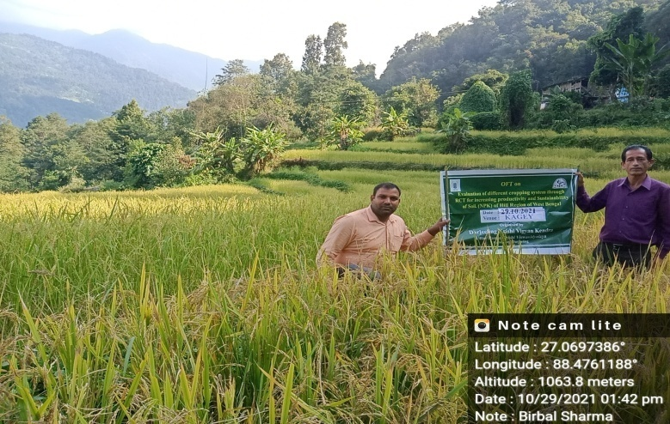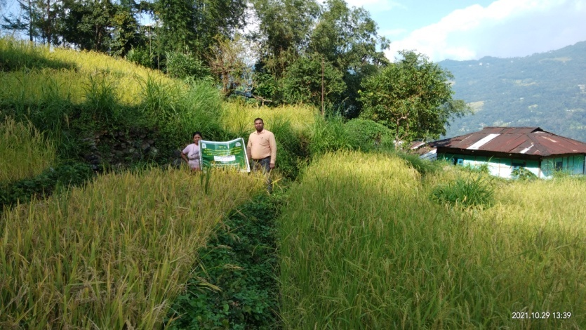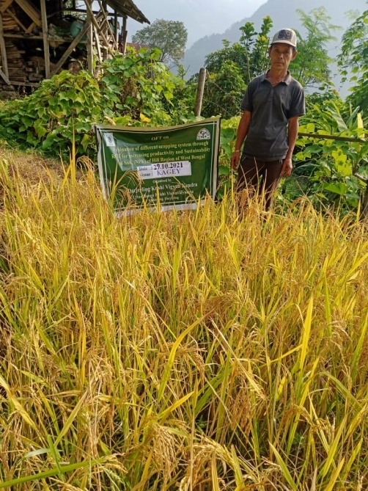

**OFT-4 (Horticulture)**

|  |  |  |
| --- | --- | --- |
| 1. | Title of On farm Trial | Assessment of Turmeric Varieties *(Curcuma longa)* in Kalimpong Hills |
| 2. | Problem diagnosed | Local variety gives very low yield. |
| 3. | Details of technologies selected for assessment/refinement | Farmers’ practice - use of local variety with FYM 20 t/ha.  Tech. option I: use of with Uttar Rangini (TCP-129) FYM 15 t/ha and N:P:K 60:60:90 kg/ha  Tech. option II: use of Suranjana (TCP-2)variety with FYM 15 t/ha and N:P:K 60:60:90 kg/ha  Tech. option III: use of Uttar Rupanjana (TCP-64) variety) with FYM 15 t/ha and N:P:K 60:60:90 kg/ha |
| 4. | Source of Technology (ICAR/ AICRP/SAU/other, please specify) | U.B.K.V |
| 5. | Production system and thematic area | Vegetable based production system |
| 6. | Performance of the Technology with performance indicators | Based on the rhizome yield, Average weight of rhizome and comparative economics of different varieties compared to locally available variety |
| 7. | Final recommendation for micro level situation | Among the different Varieties , the Technology option III was recommended but further trial on commercial production against the local variety. |
| 8. | Constraints identified and feedback for research | Non-availability of quality materials and lack of awareness about the proper production technology. That’s why further research and training programmes have to be conducted to standardize the variety. |
| 9. | Process of farmers participation and their reaction | Farmers participated actively through phone calls, personal contacts, field days, etc. Farmers participated in this programme were highly interested in raising crops from the different variety and demanded a larger quantity and a regular supply of the different varieties for turmeric production. |

Thematic area: Vegetable based cropping systems

Problem definition: Local variety gives very low yield.

Technology assessed: Assessment of Turmeric Varieties.

Results: Table:

|  |  |  |  |  |  |  |  |
| --- | --- | --- | --- | --- | --- | --- | --- |
| Technology option | No. of trials | Yield component  Average weight of rhizome (g) | Yield  (t/ha) | Gross return  (Rs/ha) | Gross cost (Rs/ha) | Net return  (Rs./ha) | BC ratio |
| Farmers Practice : - use of local variety with FYM 20 t/ha– | 6 | 105.01 | 12.89 | 3,86,700/- | 1,97,350/- | 1,89,350/- | 1.95:1 |
| Tech. option I: use of with Uttar Rangini (TCP-129) FYM 15 t/ha and N:P:K 60:60:90 kg/ha | 183.38 | 19.10 | 5,73,000/- | 2,01,900/- | 3,71,100/- | 2.83:1 |
| Tech. option II: use of Suranjana (TCP-2)variety with FYM 15 t/ha and N:P:K 60:60:90 kg/ha | 165.01 | 17.98 | 5,39,400/- | 2,01,900/- | 3,37,500/- | 2.67:1 |
| Tech. option III: use of Uttar Rupanjana (TCP-64) variety) with FYM 15 t/ha and N:P:K 60:60:90 kg/ha | 233.98 | 21.03 | 6,30,900/- | 2,01,900/- | 4,29,000/- | 3.1:1 |

Result: Among the different Technology options Tech.option III Uttar Rupanjana (TCP-64) variety) with FYM 15 t/ha and N:P:K 60:60:90 kg/ha gave the highest yield 20.03t/ha compared to the local.

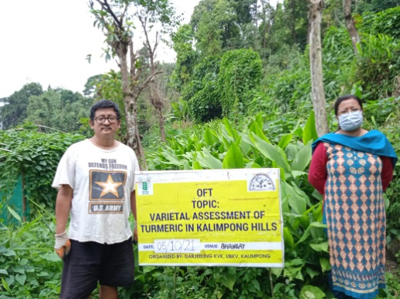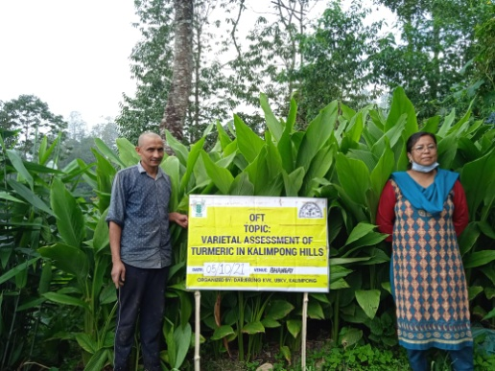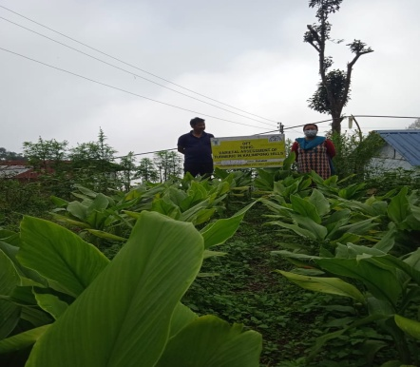

**OFT-5 (Horticultue)**

|  |  |  |
| --- | --- | --- |
| 1. | Title of On farm Trial | **Influence of altitude on production of Bell pepper (*Capsicum annum*)** |
| 2. | Problem diagnosed | Low fruit set and small size of fruits. |
| 3. | Details of technologies selected for assessment/refinement | Farmers Practice :1251-1500 M above sea level N:P:K@160:60:30 kg/ha FYM@25 t/ha  Tech. option I:1001-1250M above sea level N:P:K@160:60:30 kg/ha FYM@25 t/ha  Tech. option II: 751-1000 M above sea level N:P:K@160:60:30 kg/ha FYM@25 t/ha  Tech. option III– 500-750 M above sea level N:P:K@160:60:30 kg/ha FYM@25 t/ha |
| 4. | Source of Technology (ICAR/ AICRP/SAU/other, please specify) | TNAU |
| 5. | Production system and thematic area | Vegetable based production |
| 6. | Performance of the Technology with performance indicators | =---- |
| 7. | Final recommendation for micro level situation | --- |
| 8. | Constraints identified and feedback for research | ---- |
| 9. | Process of farmers participation and their reaction | ---- |

Thematic area: Vegetable based cropping systems Results: Table: Standing crop –seedling stage

OFT – 6 (Plant Protection ) 2021: Eco-friendly management of fruit fly in Darjeeling Mandarin Orange

|  |  |  |
| --- | --- | --- |
| 1. | Title of On farm Trial | Eco-friendly management of fruit fly in Darjeeling Mandarin Orange |
| 2. | Problem diagnosed | Fruit fall due to fruit fly attack. |
| 3. | Details of technologies selected for assessment/refinement | **Farmers Practice (FP):** Collection and destruction of fallen fruits  **Technology option-I(TO-I):** Collection and destruction of fallen fruits + use of bait traps using molasses  **Technology option-II(TO-II):** Collection and destruction of fallen fruits + use of bait traps using molasses + Apply fungus *Metarhiziumanisopliae* (1x109 CFU/ml or 1x108 CFU/gm) @ 5ml or 6gm/lt as soil treatment |
| 4. | Source of Technology (ICAR/ AICRP/SAU/other, please specify) | BCKV |
| 5. | Production system and thematic area | Fruit orchard and Integrated Pest Management |
| 6. | Performance of the Technology with performance indicators | Pest incidence, Yield and BC ratio |
| 7. | Final recommendation for micro level situation | Collection and destruction of fallen fruits + use of bait traps using molasses + Apply fungus *Metarhiziumanisopliae* (1x109 CFU/ml or 1x108 CFU/gm) @ 5ml or 6gm/lt as soil treatment was effectively controlled of fruit fly population at Mandarin orchard |
| 8. | Constraints identified and feedback for research | - |
| 9. | Process of farmers participation and their reaction | For selection of farmers a group meeting was organized from where a few farmers was selected considering the production system and farming situation as per action plan. Ultimately 8 no. of farmers were selected from primary list after in situ visit of the farmers’ field. |

Thematic area: Integrated Pest Management

Problem definition: Fruit fall due to fruit fly attack.

Technology assessed: **Technology option-I(TO-I):** Collection and destruction of fallen fruits + use of bait traps using molasses.

**Technology option-II(TO-II):** Collection and destruction of fallen fruits + use of bait traps using molasses + Apply fungus

*Metarhiziumanisopliae*

|  |  |  |  |  |  |
| --- | --- | --- | --- | --- | --- |
| ***Technology option*** | ***Fruit fly population/tree*** | ***Yield***  ***(Fruits/plant)*** | ***Yield % increase over Farmer’s practice*** | ***Net return***  ***(Rs./ha)*** | ***BC ratio*** |
| Farmers Practice (FP): Collection and destruction of fallen fruits | 350no. | 50 fruits/tree | -- | 803/- | 3.7:1 |
| Technology option-I(TO-I): Collection and destruction of fallen fruits + use of bait traps using molasses | 175no. | 110 fruits/tree | 120% | 2080/- | 7.1:1 |
| Technology option-II(TO-II): Collection and destruction of fallen fruits + use of bait traps using molasses + Apply fungus *Metarhiziumanisopliae* (1x109 CFU/ml or 1x108 CFU/gm) @ 5ml or 6gm/lt as soil treatment | 140no. | 160 fruits/tree | 220% | 3095/- | 8.3:1 |
| CD (p=0.05) | 2.61 | 1.30 |  |  |  |
| SEM | 0.66 | 0.33 |  |  |  |
| CV% | 0.52 | 0.54 |  |  |  |

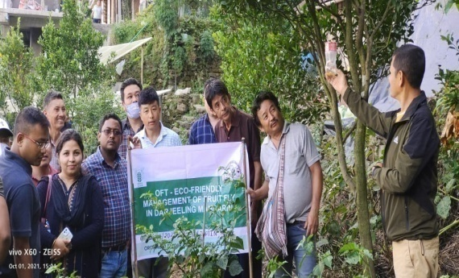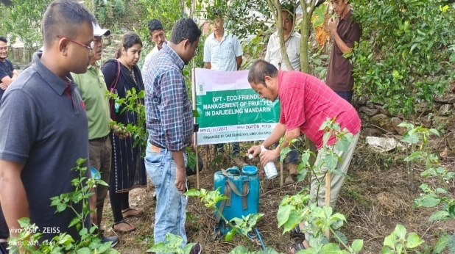

3.2 Achievements of Frontline Demonstrations

A. Details of FLDs conducted during the year

Cereals

|  |  |  |  |  |  |  |  |  |  |  |  |  |  |  |  |
| --- | --- | --- | --- | --- | --- | --- | --- | --- | --- | --- | --- | --- | --- | --- | --- |
| Sl.  No. | Crop | Thematic area | Technology Demonstrated with detailed treatments | Area (ha) | | No. of farmers/  demonstration | | | | | | | | | Reasons for shortfall in achievement |
| Proposed | Actual | SC | | ST | | Others | | Total | | |  |
|  |  |  |  |  |  | M | F | M | F | M | F | M | F | T |  |
| 1. |  |  |  |  |  |  | | | |  | |  | | |  |
| 2. |  |  |  |  |  |  | | | |  | |  | | |
| 3. |  |  |  |  |  |  | | | |  | |  | | |  |
| 4. |  |  |  |  |  |  | | | |  | |  | | |

Details of farming situation

|  |  |  |  |  |  |  |  |  |  |  |  |
| --- | --- | --- | --- | --- | --- | --- | --- | --- | --- | --- | --- |
| Crop | Season | Farming situation (RF/Irrigated) | Soil type | Status of soil  (Kg/ha) | | | Previous crop | Sowing date | Harvest date | Seasonal rainfall (mm) | No. of rainy days |
| N | P2O5 | K2O |
|  |  |  |  |  |  |  |  |  |  |  |  |
|  |  |  |  |  |  |  |  |  |  |  |  |
|  |  |  |  |  |  |  |  |  |  |  |  |
|  |  |  |  |  |  |  |  |  |  |  |  |

In both the Tables, information of same crop should be provided. For example, if in Table 3.2A crops are mentioned as a,b,c,d etc., in the table for Details of farming situation, the same crop should be mentioned in the identical sequence.

Performance of FLD

Oilseeds:

Frontline demonstrations on oilseed crops

|  |  |  |  |  |  |  |  |  |  |  |  |  |  |  |  |
| --- | --- | --- | --- | --- | --- | --- | --- | --- | --- | --- | --- | --- | --- | --- | --- |
| Crop | Thematic Area | Name of the technology demonstrated | No. of Farmers | Area  (ha) | Yield (q/ha) | | % Increase | *Economics of demonstration (Rs./ha) | | | | *Economics of check  (Rs./ha) | | | |
| Demo | Check | Gross  Cost | Gross  Return | Net Return | **  BCR | Gross  Cost | Gross  Return | Net Return | **  BCR |
|  |  |  |  |  |  |  |  |  |  |  |  |  |  |  |  |
|  |  |  |  |  |  |  |  |  |  |  |  |  |  |  |  |
| Total |  |  |  |  |  |  |  |  |  |  |  |  |  |  |  |

* Economics to be worked out based on total cost of production per unit area and not on critical inputs alone.

** BCR= GROSS RETURN/GROSS COST

Pulses   
Frontline demonstration on pulse crops

|  |  |  |  |  |  |  |  |  |  |  |  |  |  |  |  |
| --- | --- | --- | --- | --- | --- | --- | --- | --- | --- | --- | --- | --- | --- | --- | --- |
| Crop | Thematic Area | Name of the technology demonstrated | No. of Farmers | Area  (ha) | Yield (q/ha) | | % Increase | *Economics of demonstration (Rs./ha) | | | | *Economics of check  (Rs./ha) | | | |
| Demo | Check | Gross  Cost | Gross  Return | Net Return | **  BCR | Gross  Cost | Gross  Return | Net Return | **  BCR |
|  |  |  |  |  |  |  |  |  |  |  |  |  |  |  |  |
|  |  |  |  |  |  | | | | | | | | | | |
|  | Total |  |  |  |  |  |  |  |  |  |  |  |  |  |  |

* Economics to be worked out based on total cost of production per unit area and not on critical inputs alone.

** BCR= GROSS RETURN/GROSS COST

Other crops

|  |  |  |  |  |  |  |  |  |  |  |  |  |  |  |  |  |  |
| --- | --- | --- | --- | --- | --- | --- | --- | --- | --- | --- | --- | --- | --- | --- | --- | --- | --- |
| Crop | Thematic area | Name of the technology demonstrated | No. of Farmer | Area  (ha) | Yield (q/ha) | | % change in yield | Other parameters | | *Economics of demonstration (Rs./ha) | | | | *Economics of check  (Rs./ha) | | | |
| Demons  ration | Check | Demo | Check | Gross  Cost | Gross  Return | Net Return | **  BCR | Gross  Cost | Gross  Return | Net Return | **  BCR |
|  |  |  |  |  |  |  |  |  |  |  |  |  |  |  |  |  |  |
|  |  |  |  |  |  |  |  |  |  |  |  |  |  |  |  |  |  |
|  | Total | |  |  |  | | | | | | | | | | | | |

Livestock

|  |  |  |  |  |  |  |  |  |  |  |  |  |  |  |  |  |  |
| --- | --- | --- | --- | --- | --- | --- | --- | --- | --- | --- | --- | --- | --- | --- | --- | --- | --- |
| Category | Thematic  area | Name of the technology demonstrated | No. of Farmer | No. of units | Major parameters | | % change in major parameter | Other parameter | | *Economics of demonstration (Rs.) | | | | *Economics of check  (Rs.) | | | |
| Demons  ration | Check | Demons  ration | Check | Gross  Cost | Gross  Return | Net Return | **  BCR | Gross  Cost | Gross  Return | Net Return | **  BCR |
| Dairy | Production performance | Area specific mineral mixture | 25 | 25 | Milk Production | Milk Production | 19 | -- | -- | 15500 | 51800 | 36300 | 3.34:1 | 14560 | 43850 | 29290 | 3.01:1 |
| Cow |  |  |  |  |  |  |  |  |  |  |  |  |  |  |  |  |  |
| Buffalo |  |  |  |  |  |  |  |  |  |  |  |  |  |  |  |  |  |
| Poultry | Production performance | Azolla feeding | 25 | 25 | Weight gain | Weight gain | 14 | Egg production | Egg production | 5250 | 18550 | 13300 | 3.53:1 | 4200 | 12925 | 8725 | 3.08:1 |
| Rabbitry |  |  |  |  |  |  |  |  |  |  |  |  |  |  |  |  |  |
| Pigerry |  |  |  |  |  |  |  |  |  |  |  |  |  |  |  |  |  |
| Sheep and goat |  |  |  |  |  |  |  |  |  |  |  |  |  |  |  |  |  |
| Duckery |  |  |  |  |  |  |  |  |  |  |  |  |  |  |  |  |  |
| Others (pl.specify) |  |  |  |  |  |  |  |  |  |  |  |  |  |  |  |  |  |
| Total |  |  |  |  |  |  |  |  |  |  |  |  |  |  |  |  |  |

* Economics to be worked out based on total cost of production per unit area and not on critical inputs alone.

** BCR= GROSS RETURN/GROSS COST

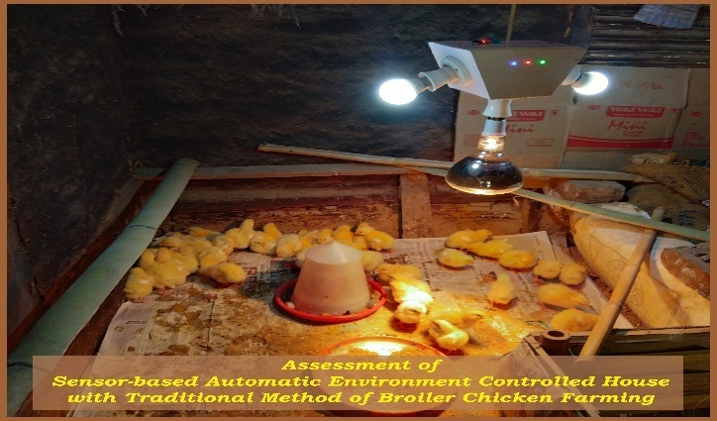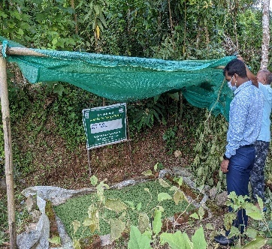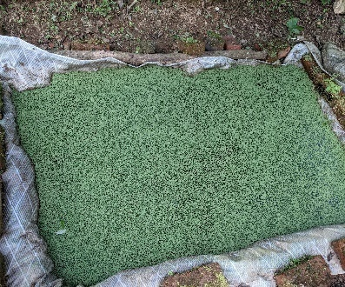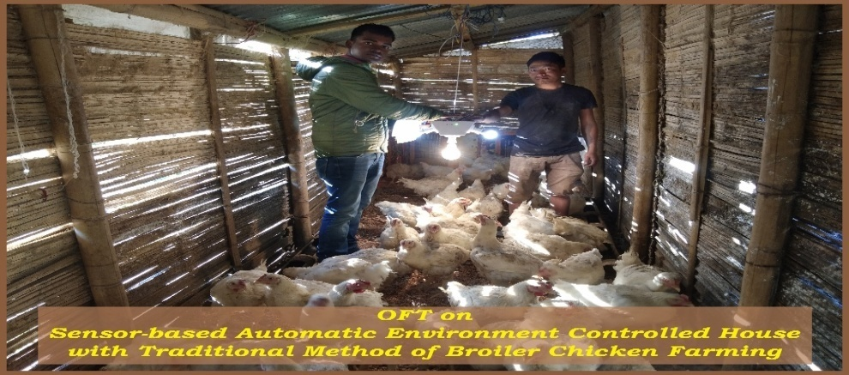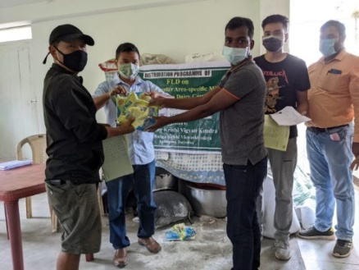

3.2 Achievements of Frontline Demonstrations (SS)

1. Details of FLDs conducted during the year-2021 (**Vermicompost)**

|  |  |  |  |  |  |  |  |  |  |  |  |  |  |  |  |
| --- | --- | --- | --- | --- | --- | --- | --- | --- | --- | --- | --- | --- | --- | --- | --- |
| Sl.  No. | Category | Thematic area | Technology Demonstrated with detailed treatments | Area (ha)/Unit | | No. of farmers/  demonstration | | | | | | | | | Reasons for shortfall in achievement |
| Proposed | Actual | SC | | ST | | Others | | Total | | |
|  |  |  |  |  |  | M | F | M | F | M | F | M | F | T |
| 1. | Vermicompost  (SS) | Vermicompost production | Polybag Methods | 9 | 9 | 8 | 1 | 0 | 0 | 0 | 0 | 8 | 1 | 09 | NIL |

Performance of FLD

|  |  |  |  |  |  |  |  |  |  |  |  |  |  |  |  |
| --- | --- | --- | --- | --- | --- | --- | --- | --- | --- | --- | --- | --- | --- | --- | --- |
| Category | Thematic Area | Name of the technology demonstrated | No. of Farmers | Area  (ha)/  Unit | Yield (q/ha) | | % Increase | *Economics of demonstration (Rs./unit) | | | | *Economics of check  (Rs./unit) | | | |
| Demo | Check | Gross  Cost | Gross  Return | Net Return | **  BCR | Gross  Cost | Gross  Return | Net Return | **  BCR |
| Vermicompost  (SS) | Vermicompost production | Polybag methods | 9 | 9 | 9 | 5.1 | 76.07 | 9,600 | 22,500 | 12,900 | 2.3:1 | 7,600 | 12.750 | 5,150 | 1.67:1 |

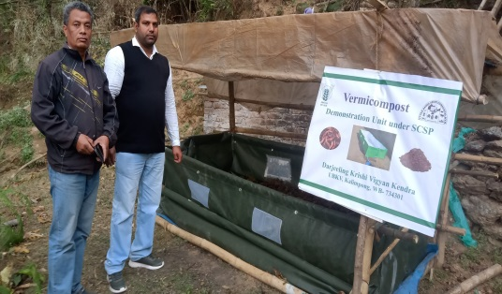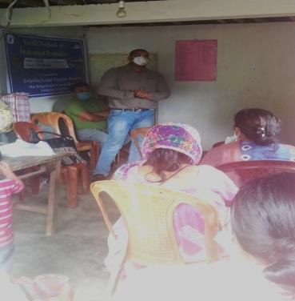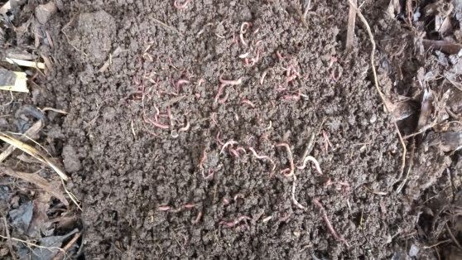

**Demonstration**

**Training**

**Plate: Vermicompost production under polybag unit**

Details of FLDs conducted during the year

Cereals

|  |  |  |  |  |  |  |  |  |  |  |  |  |  |  |  |
| --- | --- | --- | --- | --- | --- | --- | --- | --- | --- | --- | --- | --- | --- | --- | --- |
| Sl.  No. | Crop | Thematic area | Technology Demonstrated with detailed treatments | Area (ha) | | No. of farmers/  demonstration | | | | | | | | | Reasons for shortfall in achievement |
| Proposed | Actual | SC | | ST | | Others | | Total | | |  |
|  |  |  |  |  |  | M | F | M | F | M | F | M | F | T |  |
| 1. | Mandarin | Nutrient Management | N:P:K@300:250:300 g, B 50 g, Z 250g, Vermicompost 12.5kg,Pig Manure 6.25kg and FYM 25 kg/tree | 0.1 | 0.1 | 0 | 0 | 0 | 0 | 10 | 0 | 10 | 0 | 10 |  |
| 2. | Marigold | Varietal replacement | FYM 5 kg/m2 +Azobacter (5 gm/kg of FYM) +PSB (5 gm/kg of FYM) | 0.1 | 0.1 | 0 | 0 | 2 | 0 | 1 | 3 | 3 | 3 | 6 |

Details of farming situation

|  |  |  |  |  |  |  |  |  |  |  |  |
| --- | --- | --- | --- | --- | --- | --- | --- | --- | --- | --- | --- |
| Crop | Season | Farming situation (RF/Irrigated) | Soil type | Status of soil  (Kg/ha) | | | Previous crop | Sowing date | Harvest date | Seasonal rainfall (mm) | No. of rainy days |
| N | P2O5 | K2O |
| Marigold | Rainy | Rain fed | Acidic | 280.1 | 37.9 | 158.3 | Paddy | 27/07/2021  Transplanting | 03/11/21 |  |  |
| Mandarin | Perennial | Rain fed | Acidic | 383.2 | 27.3 | 120.9 | -- |  | 29/01/21 |  |  |

Other crops

|  |  |  |  |  |  |  |  |  |  |  |  |  |  |  |  |
| --- | --- | --- | --- | --- | --- | --- | --- | --- | --- | --- | --- | --- | --- | --- | --- |
| Crop | Thematic area | Name of the technology demonstrated | No. of Farmer | Area  (ha) | Yield (q/ha) | | % change in yield | *Economics of demonstration (Rs./ha) | | | | *Economics of check  (Rs./ha) | | | |
| Demons  ration | Check | Gross  Cost | Gross  Return | Net Return | **  BCR | Gross  Cost | Gross  Return | Net Return | **  BCR |
| Mandarin | Nutrient Management | Nutritional Management of Darjeeling Mandarin | 10 | 0.10 | 550 (fruits/tree) | 298(fruits/tree) | 45.81 | 2,37,500/- | 5,44,500 | 3,07,000/- | 2.29:1 | 1,60,500 | 2,95,020 | 1,34,520 | 1.83:1 |
| Marigold | Varietal Replacement | FYM 5 kg/m2 +Azobacter (5 gm/kg of FYM) +PSB (5 gm/kg of FYM) | 6 | 0.10 | 86.62 | 60.33 | 23.69 | 87,450/ | 1,73,240 | 85,790/- | 1.97:1 | 78,060 | 1,20,660 | 45,600 | 1.54:1 |

*

Extension and Training activities under FLD

|  |  |  |  |  |  |
| --- | --- | --- | --- | --- | --- |
| Sl.No. | Activity | Date | No. of activities organized | Number of participants | Remarks |
| 1. | Field days | 03/11/2021 | 1 | 10 |  |
| 2. | Farmers Training | 12/11/2021 | 1 | 10 |  |
| 3. | Media coverage |  |  |  |  |
| 4. | Training for extension functionaries |  |  |  |  |

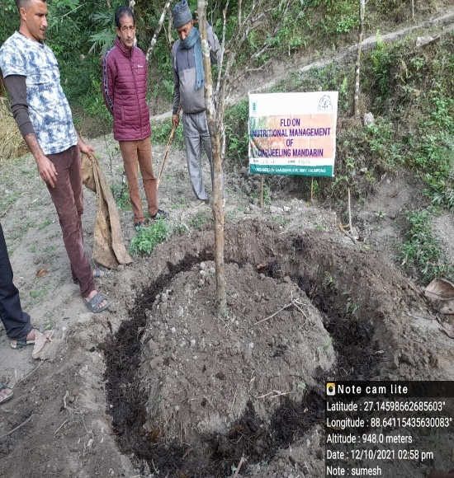 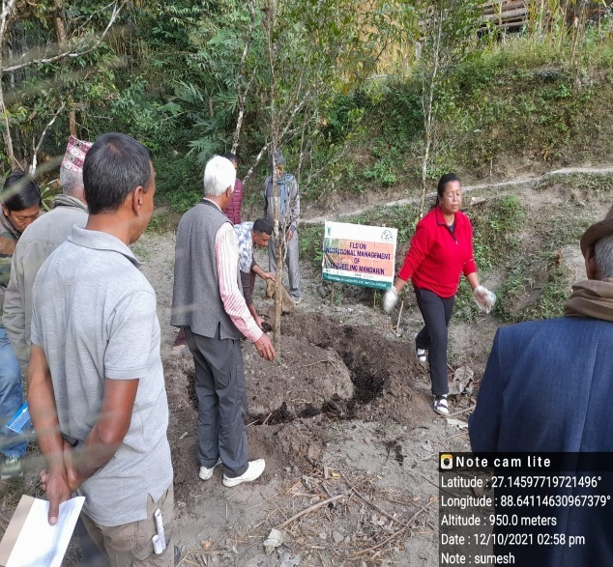 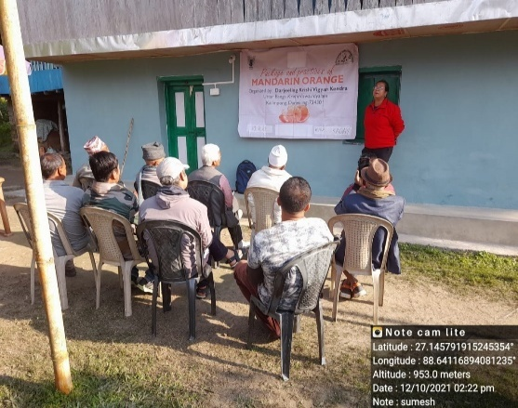

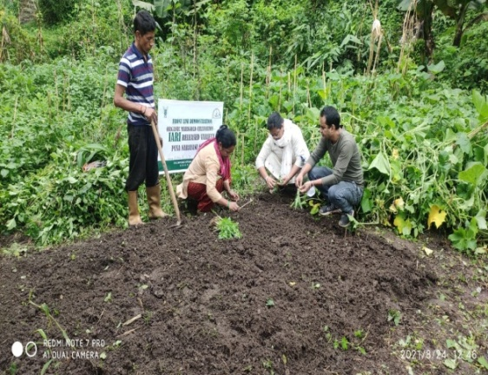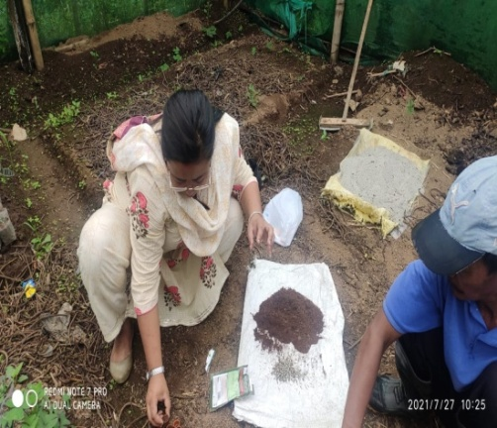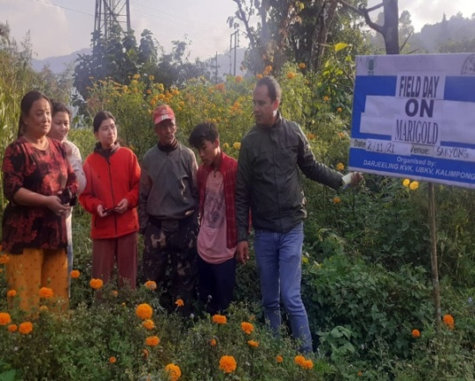

FLD Result (PP), 2021

3.1 Achievements of Frontline Demonstrations (PP)

1. Details of FLDs conducted during the year-2021 (**Beekeeping)**

|  |  |  |  |  |  |  |  |  |  |  |  |  |  |  |  |
| --- | --- | --- | --- | --- | --- | --- | --- | --- | --- | --- | --- | --- | --- | --- | --- |
| Sl.  No. | Category | Thematic area | Technology Demonstrated with detailed treatments | Area (ha)/Unit | | No. of farmers/  demonstration | | | | | | | | | Reasons for shortfall in achievement |
| Proposed | Actual | SC | | ST | | Others | | Total | | |
|  |  |  |  |  |  | M | F | M | F | M | F | M | F | T |
| 1. | Bee Keeping  (PP) | Apiculture | Apiary with Critical Inputs: Bee box, accessories, Bee colony (Apiscerenaindica) and dearth feeding of sugar and water (1:1) during lean period | 10 | 10 | 2 | 1 | 2 | 3 | 1 | 1 | 5 | 5 | 10 | NIL |

Performance of FLD

|  |  |  |  |  |  |  |  |  |  |  |  |  |  |  |  |
| --- | --- | --- | --- | --- | --- | --- | --- | --- | --- | --- | --- | --- | --- | --- | --- |
| Category | Thematic Area | Name of the technology demonstrated | No. of Farmers | Area  (ha)/  Unit | Yield (q/ha) | | % Increase | *Economics of demonstration (Rs./unit) | | | | *Economics of check  (Rs./unit) | | | |
| Demo | Check | Gross  Cost | Gross  Return | Net Return | **  BCR | Gross  Cost | Gross  Return | Net Return | **  BCR |
| Bee Keeping  (PP) | Apiculture | Apiary with Critical Inputs: Bee box, accessories, Bee colony (Apiscerenaindica) and dearth feeding of sugar and water (1:1) during lean period | 10 | 10 | 4 | 1 | 76.07 | 2000/- | 9600/- | 7600/- | 4.8:1 | 900/- | 2400/- | 1500/- | 2.6:1 |

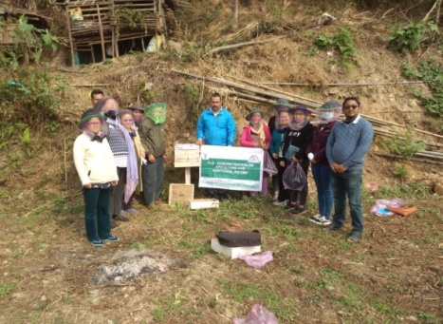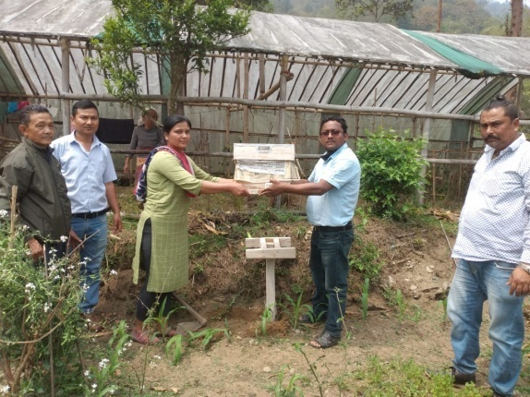

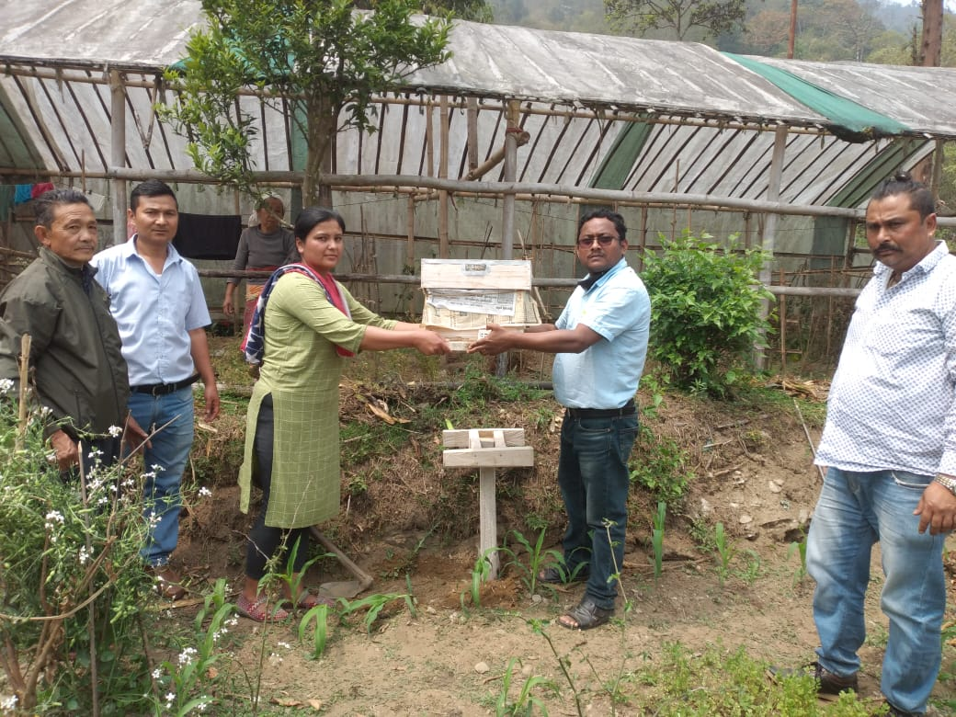

Fisheries

|  |  |  |  |  |  |  |  |  |  |  |  |  |  |  |  |  |  |  |
| --- | --- | --- | --- | --- | --- | --- | --- | --- | --- | --- | --- | --- | --- | --- | --- | --- | --- | --- |
| Category | Thematic area | | Name of the technology demonstrated | No. of Farmer | No.of units | Major parameters | | % change in major parameter | Other parameter | | *Economics of demonstration (Rs.) | | | | *Economics of check  (Rs.) | | | |
| Demons  ration | Check | Demons  ration | Check | Gross  Cost | Gross  Return | Net Return | **  BCR | Gross  Cost | Gross  Return | Net Return | **  BCR |
| Common carps |  | |  |  |  |  |  |  |  |  |  |  |  |  |  |  |  |  |
| Mussels |  | |  |  |  |  |  |  |  |  |  |  |  |  |  |  |  |  |
|  |  | |  |  |  |  |  |  |  |  |  |  |  |  |  |  |  |  |
| Ornamental fishes |  | |  |  |  |  |  |  |  |  |  |  |  |  |  |  |  |  |
| Others (pl.specify) |  | |  |  |  |  |  |  |  |  |  |  |  |  |  |  |  |  |
|  |  | |  |  |  |  |  |  |  |  |  |  |  |  |  |  |  |  |
|  | | Total | |  |  |  | | | | | | | | | | | | |

* Economics to be worked out based on total cost of production per unit area and not on critical inputs alone.

** BCR= GROSS RETURN/GROSS COST

Other enterprises

|  |  |  |  |  |  |  |  |  |  |  |  |  |  |  |  |  |
| --- | --- | --- | --- | --- | --- | --- | --- | --- | --- | --- | --- | --- | --- | --- | --- | --- |
| Category | Name of the technology demonstrated | No. of Farmer | No. of units | Major parameters | | % change in major parameter | Other parameter | | *Economics of demonstration (Rs.) or Rs./unit | | | | *Economics of check  (Rs.) or Rs./unit | | | |
| Demons  ration | Check | Demons  ration | Check | Gross  Cost | Gross  Return | Net Return | **  BCR | Gross  Cost | Gross  Return | Net Return | **  BCR |
| Oyster mushroom | Enterprise development |  |  |  |  |  |  |  |  |  |  |  |  |  |  |  |
| Button mushroom |  |  |  |  |  |  |  |  |  |  |  |  |  |  |  |  |
| Vermicompost |  |  |  |  |  |  |  |  |  |  |  |  |  |  |  |  |
| Sericulture |  |  |  |  |  |  |  |  |  |  |  |  |  |  |  |  |
| Apiculture |  |  |  |  |  |  |  |  |  |  |  |  |  |  |  |  |
| Others (pl.specify) |  |  |  |  |  |  |  |  |  |  |  |  |  |  |  |  |
| Total | |  |  |  | | | | | | | | | | | | |

* Economics to be worked out based on total cost of production per unit area and not on critical inputs alone.

** BCR= GROSS RETURN/GROSS COST

Women empowerment

|  |  |  |  |  |  |
| --- | --- | --- | --- | --- | --- |
| Category | Name of technology | No. of demonstrations | Observations | | Remarks |
| Demonstration | Check |
| Farm Women |  |  |  |  |  |
| Pregnant women |  |  |  |  |  |
| Adolescent Girl |  |  |  |  |  |
| Other women |  |  |  |  |  |
| Children |  |  |  |  |  |
| Neonatal |  |  |  |  |  |
| Infants |  |  |  |  |  |

Farm implements and machinery

|  |  |  |  |  |  |  |  |  |  |  |  |  |  |  |  |
| --- | --- | --- | --- | --- | --- | --- | --- | --- | --- | --- | --- | --- | --- | --- | --- |
| Name of the implement | Crop | Name of the technology demonstrated | No. of Farmer | Area (ha) | Filed observation (output/man hour) | | % change in major parameter | Labor reduction (man days) | | | | Cost reduction (Rs./ha or Rs./Unit) | | | |
| Demons  ration | Check |  |  |  |  |  |  |  |  |
|  |  |  |  |  |  |  |  |  |  |  |  |  |  |  |  |

**\* Economics to be worked out based on total cost of production per unit area and not on critical inputs alone.**

**\*\* BCR= GROSS RETURN/GROSS COST**

Demonstration details on crop hybrids

|  |  |  |  |  |  |  |  |  |  |  |
| --- | --- | --- | --- | --- | --- | --- | --- | --- | --- | --- |
| Crop | Name of the Hybrid | No. of  farmers | Area  (ha) | Yield (kg/ha) / major parameter | | | Economics (Rs./ha) | | | |
| Cereals |  |  |  | Demo | Local check | % change | Gross  Cost | Gross  Return | Net  Return | BCR |
|  |  |  |  |  |  |  |  |  |  |  |
| Bajra |  |  |  |  |  |  |  |  |  |  |
| Maize |  |  |  |  |  |  |  |  |  |  |
| Paddy |  |  |  |  |  |  |  |  |  |  |
| Sorghum |  |  |  |  |  |  |  |  |  |  |
| Wheat |  |  |  |  |  |  |  |  |  |  |
| Others (Pl.specify) |  |  |  |  |  |  |  |  |  |  |
| Total |  |  |  |  |  |  |  |  |  |  |
| Oilseeds |  |  |  |  |  |  |  |  |  |  |
| Castor |  |  |  |  |  |  |  |  |  |  |
| Mustard |  |  |  |  |  |  |  |  |  |  |
| Safflower |  |  |  |  |  |  |  |  |  |  |
| Sesame |  |  |  |  |  |  |  |  |  |  |
| Sunflower |  |  |  |  |  |  |  |  |  |  |
| Groundnut |  |  |  |  |  |  |  |  |  |  |
| Soybean |  |  |  |  |  |  |  |  |  |  |
| Others (Pl.specify) |  |  |  |  |  |  |  |  |  |  |
| Total |  |  |  |  |  |  |  |  |  |  |
| Pulses |  |  |  |  |  |  |  |  |  |  |
| Greengram |  |  |  |  |  |  |  |  |  |  |
| Blackgram |  |  |  |  |  |  |  |  |  |  |
| Bengalgram |  |  |  |  |  |  |  |  |  |  |
| Redgram |  |  |  |  |  |  |  |  |  |  |
| Others (Pl.specify) |  |  |  |  |  |  |  |  |  |  |
| Total |  |  |  |  |  |  |  |  |  |  |
| Vegetable crops |  |  |  |  |  |  |  |  |  |  |
| Bottle gourd |  |  |  |  |  |  |  |  |  |  |
| Capsicum |  |  |  |  |  |  |  |  |  |  |
| Cucumber |  |  |  |  |  |  |  |  |  |  |
| Tomato |  |  |  |  |  |  |  |  |  |  |
| Brinjal |  |  |  |  |  |  |  |  |  |  |
| Okra |  |  |  |  |  |  |  |  |  |  |
| Onion |  |  |  |  |  |  |  |  |  |  |
| Potato |  |  |  |  |  |  |  |  |  |  |
| Field bean |  |  |  |  |  |  |  |  |  |  |
| Others (Pl.specify) |  |  |  |  |  |  |  |  |  |  |
| Total |  |  |  |  |  |  |  |  |  |  |
| Commercial crops |  |  |  |  |  |  |  |  |  |  |
| Cotton |  |  |  |  |  |  |  |  |  |  |
| Coconut |  |  |  |  |  |  |  |  |  |  |
| Others (Pl.specify) |  |  |  |  |  |  |  |  |  |  |
|  |  |  |  |  |  |  |  |  |  |  |
| Total |  |  |  |  |  |  |  |  |  |  |
| Fodder crops |  |  |  |  |  |  |  |  |  |  |
| Napier (Fodder) |  |  |  |  |  |  |  |  |  |  |
| Maize (Fodder) |  |  |  |  |  |  |  |  |  |  |
| Sorghum (Fodder) |  |  |  |  |  |  |  |  |  |  |
| Others (Pl.specify) |  |  |  |  |  |  |  |  |  |  |
| Total |  |  |  |  |  |  |  |  |  |  |

Technical Feedback on the demonstrated technologies

|  |  |  |
| --- | --- | --- |
| Sl. No | Crop | Feed Back |
| 01 | Dairy | Technology – Providing area specific mineral mixture for dairy cattle  Supplementation of mineral mixture for dairy cattle feeding has increased the milk production. Hence the technology is adopted well by the farmers. |
|  | Poultry | Technology - Azola feeding in poultry  Most of the farmers adopted well and reported that it has reduced the feeding cost. |
|  |  |  |

Extension and Training activities under FLD

|  |  |  |  |  |  |
| --- | --- | --- | --- | --- | --- |
| Sl.No. | Activity | Date | No. of activities organized | Number of participants | Remarks |
| 1. | Field days |  |  |  |  |
| 2. | Farmers Training |  |  |  |  |
| 3. | Media coverage |  |  |  |  |
| 4. | Training for extension functionaries |  |  |  |  |

**Performance of the demonstration under CFLD on Oilseed Crops during Kharif2021 and Rabi 2021-2022:**

|  |  |  |  |  |  |  |  |  |  |  |  |  |  |  |
| --- | --- | --- | --- | --- | --- | --- | --- | --- | --- | --- | --- | --- | --- | --- |
| **Progress report of Project on “Cluster Frontline Demonstration on Oilseeds under NFSM during 2021-22”** | | | | | | | | | | | | | | |
| **Kharif, 2021** | |  |  |  |  |  | |  |  |  |  |  |  |  |
|  | **Crop/ Variety (year of release)** | **Physical (No. of CFLDs/Area in ha)** | | **Financial (Rs. in lakhs)** | | | | **Technology demonstrated** | **Details of Input Provided** | **Yield (Quintal/ha)** | | | **Status of Geo tagging (Yes/No)** | **Reasons for shortfall, if any** |
| **Target** | **Achievement** | **Allocation** | **Release** | | **Expenditure** | **Demo plot** | **Check* plot** | **% of yield gap** |
| Darjeeling KVK, | Soybean | 10 | 10 | 75,000 | 75000 | | 74,448 | Varietal | Seeds | 14.6 | 11.9 | 22.68% | Yes | No. |
| Kalimpong-734301 | PS1368 |  |  |  |  | |  |  | Vermicompost |  |  |  |  |  |
| [djkvk93@gmail.com](mailto:djkvk93@gmail.com) | Year of Release 2013 | | | | | | | | | | | | | |

**Technical Parameters:**

|  |  |  |  |  |  |  |  |  |  |  |  |  |  |  |  |
| --- | --- | --- | --- | --- | --- | --- | --- | --- | --- | --- | --- | --- | --- | --- | --- |
| Sl.  No. | Crop demonstrated | Existing (Farmer's) variety name | Existing yield  (q/ha) | Yield gap (Kg/ha)  w.r.to | | | Name of Variety + Technology  demonstrated | Number of farmers | Area in ha | Yield obtained (q/ha) | | | Yield gap minimized  (%) | | |
| District  yield (D) | State  yield (S) | Potential  yield (P) |
| Max. | Min. | Av. | D | S | P |
| 1. | Soybean | Local | 11.9 | 12.4 | 12.6 | 14.2 | Soybean Var.PS1368  Organic production with application of Vermicompost | 30 | 10 | 14.93 | 14.1 | 14.6 | 17.74 | 15.87 | 2.73 |

1. **Economic parameters**

|  |  |  |  |  |  |  |  |  |  |
| --- | --- | --- | --- | --- | --- | --- | --- | --- | --- |
| Sl.  No. | Variety demonstrated & Technology demonstrated | Farmer’s Existing plot | | | | Demonstration plot | | | |
| Gross Cost  (Rs/ha) | Gross return  (Rs/ha) | Net Return  (Rs/ha) | B:C  ratio | Gross Cost  (Rs/ha) | Gross return  (Rs/ha) | Net Return  (Rs/ha) | B:C  ratio |
| 1 | PS-1368 | 19,100 | 41,450.5 | 22350.5 | 2.1:1 | 22727.30 | 58,289.30 | 35,562 | 2.5:1 |

1. **Socio-economic impact parameters**

|  |  |  |  |  |  |  |  |  |
| --- | --- | --- | --- | --- | --- | --- | --- | --- |
| Sl.  No. | Crop and variety  Demonstrated | Total Produce  Obtained (kg) | Produce sold  (Kg/household) | Selling  Rate  (Rs/Kg) | Produce used for own sowing (Kg) | Produce distributed to other farmers (Kg) | Purpose for which income gained was utilized | Employment Generated (Mandays/house hold) |
| 1. | Soybean  Var.PS-1368 | 1460 | 1050 | 40.00 | 5.0 | 10.0 | To maintain livelihood and family expenses | Household |

1. **Oilseed Farmers’ perception of the intervention demonstrated**

|  |  |  |  |  |  |  |  |
| --- | --- | --- | --- | --- | --- | --- | --- |
| Sl.  No. | Technologies demonstrated  (with name) | Farmers' Perception parameters | | | | | |
| Suitability to their farming system | Likings  (Preference) | Affordability | Any negative effect | Is Technology acceptable to all in the group/village | Suggestions, for change/improvement, if any |
| 1. | Soybean Var. PS-1368  Organic Production with Vermicompost | Variety is good to fit in cropping system.  Practice is very appropriate to maintain soil health | (early sown variety) | Affordable | No negative effect | Yes, the technology is acceptable to the group | Farmers are looking for Organic production of Soybean. |

1. **Specific Characteristics of Technology and Performance**

|  |  |  |  |
| --- | --- | --- | --- |
| Specific Characteristic | Performance | Performance of Technology vis-a vis Local Check | Farmers Feedback |
| **Soybean**  Bold seeds, diseases resistant | All the pods and seeds are equal and bold and are suitable for oil extraction | 22.68% yield increase over local control | The technology of using Vermicompost for better organic production is accepted |

1. **Extension activities under FLD conducted till dates:**

|  |  |  |  |
| --- | --- | --- | --- |
| Sl. No. | Extension Activities organized | Date and place of activity | Number of farmer attended |
| 1 | Field visit | 27.10.2021, Sakyong, KPG-II | 5 |
| 2 | Field visit | 29.10.2021, Kagey, KPG-II | 7 |
| 7 | Training programme on Oilseed (Soybean) | 05.07.2021, Sakyong, KPG-II | 32 |

**8. Sequential good quality photographs (as per crop stages i.e. growth & development**

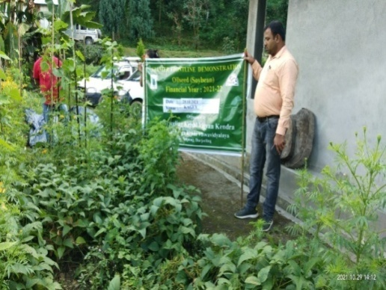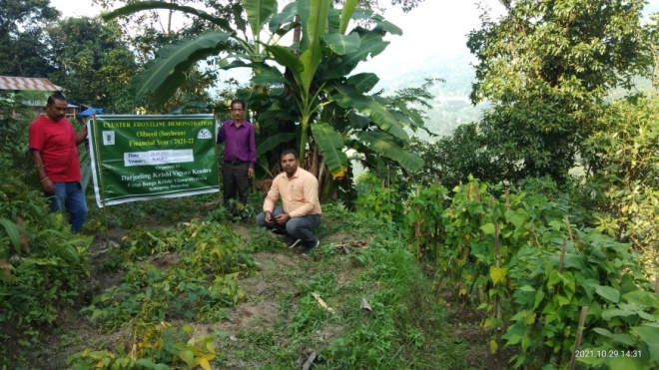

**9. Farmers' training photographs**

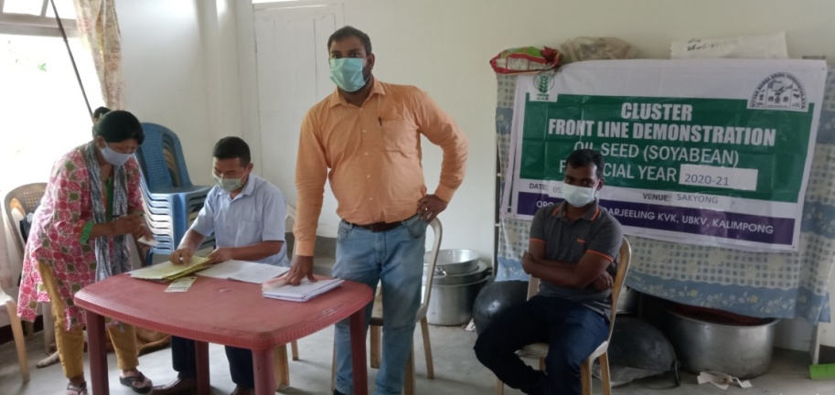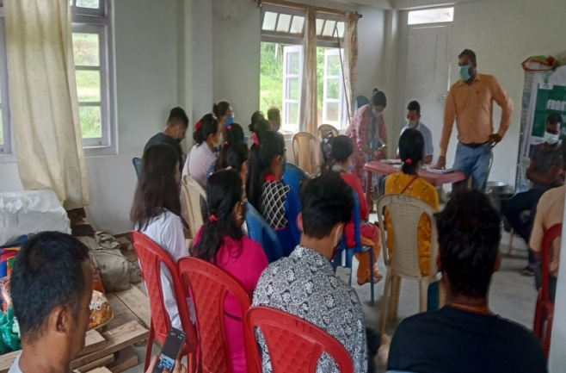

**10. Quality Photographs of field visits/field days and technology demonstrated.**

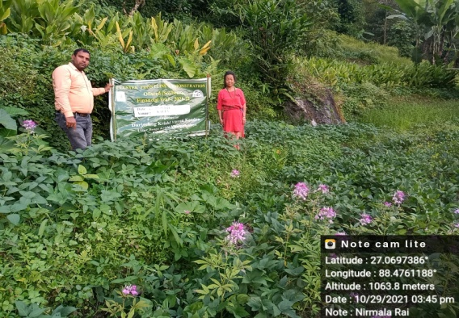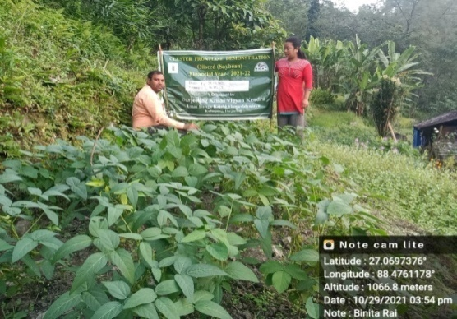

**11. Details of budget utilization**

|  |  |  |  |  |
| --- | --- | --- | --- | --- |
| **Crop**  **(provide crop wise information )** | **Items** | **Budget**  **Received**  **(Rs.)** | **Budget**  **Utilization**  **(Rs.)** | **Balance**  **(Rs.)** |
| Mustard | i) Critical input | 60,000/- | 59,448/- | 552 |
| ii) TA/DA/POL etc. for monitoring | 7,500/- | 7,500/- | NIL |
| iii) Extension Activities (Field day) | 7500/- | 7,500/- | NIL |
| iv)Publication of literature |  |  |  |
|  | **Total** | **75,000/-** | **74,448** | **552** |

**12. List of Farmer under FLD (Crop wise)**

1. **Crop1: Soybean**

|  |  |  |  |  |  |  |  |  |  |  |  |  |  |  |
| --- | --- | --- | --- | --- | --- | --- | --- | --- | --- | --- | --- | --- | --- | --- |
| **Name of farmer** | **Father’s name** | **Village** | **Block** | **Mobile No.** | **GPS Coordinates (DDMMSS format)** | | **Soil testing done (Yes/No)** | **Recommendations based on soil test value** | **Brief technology intervention** | **Variety** | **Seed quantity used** | **Demo. Yield (q/ha)** | **Yield of local check q/ha** | **% increase** |
| **Latitude** | **Longitude** |
| V. P. Dahal | Late Hari Prasad dahal | South Pabak, Kagey | Kalimpong-II | 9002774183 | 27.0945762 | 88.36546847 | Yes | Acidic | Organic Production with Vermicompost | PS1368 Release-2013 | 60kg/ha | 14.5 | 11.85 | 22.36 |
| Devika Rai | W/O-Maniram Rai | Kagey, | Kalimpong-II | 9832355526 | 27.094585 | 88.3654696 | Yes | Acidic | Organic Production with Vermicompost | PS1368 Release-2013 | 60kg/ha | 14.3 | 11.6 | 23.28 |
| Lal Bahadur Subba | JitangSubba | Kagey | Kalimpong-II | 9749575744 | 27.0946865 | 88.364785 | Yes | Acidic | Organic Production with Vermicompost | PS1368 Release-2013 | 60kg/ha | 14.2 | 11.8 | 20.34 |
| Naresh Rai | Late Sukmar Rai | Kagey | Kalimpong-II | 8001429165 | 27.0946676 | 88.36546679 | Yes | Acidic | Organic Production with Vermicompost | PS1368 Release-2013 | 60kg/ha | 14.7 | 12 | 22.50 |
| Adeep Rai | Sital Man Rai | Kagey | Kalimpong-II | 7797371235 | 27.0864987 | 88.40236941 | Yes | Acidic | Organic Production with Vermicompost | PS1368 Release-2013 | 60kg/ha | 14.4 | 11.81 | 21.93 |
| Mohan Rai | Llate Jit Bahadur Rai | Kagey | Kalimpong-II | 7432877143 | 27.0769874 | 88.4123897 | Yes | Acidic | Organic Production with Vermicompost | PS1368 Release-2013 | 60kg/ha | 14.78 | 11.87 | 24.52 |
| Viktar Rai | Late Sukbahadur Rai | Kagey | Kalimpong-II | 9002205512 | 27.0769874 | 88.4123897 | Yes | Acidic | Organic Production with Vermicompost | PS1368 Release-2013 | 60kg/ha | 14.2 | 11.38 | 24.78 |
| Durga Devi sharma | W/O-Tikaram Sharma | South Pabak, Kagey | Kalimpong-II | 9063680593 | 27.0692589 | 88.47269872 | Yes | Acidic | Organic Production with Vermicompost | PS1368 Release-2013 | 60kg/ha | 14.93 | 11.89 | 25.57 |
| Roshan Ghimiray | Late Lila Prasad Ghimirey | Kagey | Kalimpong-II | 7797850071 | 27.0698541 | 88.47869412 | Yes | Acidic | Organic Production with Vermicompost | PS1368 Release-2013 | 60kg/ha | 14.92 | 11.9 | 25.38 |
| Pawan Sharma | Tikaram Sharma | South Pabak, Kagey | Kalimpong-II | 7718310409 | 27.0692684 | 88.47269976 | Yes | Acidic | Organic Production with Vermicompost | PS1368 Release-2013 | 60kg/ha | 14.1 | 11.4 | 23.68 |
| Nilima Rai | W/O-Mandeep Rai | Kagey | Kalimpong-II | 9832355526 | 27.0769868 | 88.4123882 | Yes | Acidic | Organic Production with Vermicompost | PS1368 Release-2013 | 60kg/ha | 14.6 | 11.9 | 22.69 |
| BirbalSharma | LateChuramaniSharma | LadamKhashmalKagey | Kalimpong-II | 9749086743 | 27.0697386 | 88.4761188 | Yes | Acidic | Organic Production with Vermicompost | PS1368 Release-2013 | 60kg/ha | 14.8 | 11.97 | 23.64 |
| Kamala Sharma | Dhan Kumar Sharma | LadamKhashmalKagey | Kalimpong-II | 9733384481 | 27.0697382 | 88.4761169 | Yes | Acidic | Organic Production with Vermicompost | PS1368 Release-2013 | 60kg/ha | 14.66 | 11.86 | 23.61 |
| Ranjana Sharma | W/O-Vimalsharma | LadamKhashmalKagey | Kalimpong-II | 9547600308 | 27.0697386 | 88.4761188 | Yes | Acidic | Organic Production with Vermicompost | PS1368 Release-2013 | 60kg/ha | 14.3 | 11.73 | 21.91 |
| Kushila Rai |  | Sakyong | Kalimpong-II | 8768104778 | 27.8268914 | 88.36314194 | Yes | Acidic | Organic Production with Vermicompost | PS1368 Release-2013 | 60kg/ha | 14.5 | 11.86 | 22.26 |
| Dilip Pradhan |  | Sakyong | Kalimpong-II | 8972219143 | 27.8249621 | 88.3621496 | Yes | Acidic | Organic Production with Vermicompost | PS1368 Release-2013 | 60kg/ha | 14.2 | 11.8 | 20.34 |
| BhimBhadhur Pradhan |  | Sakyong | Kalimpong-II | 9002577932 | 27.8218956 | 88.3623569 | Yes | Acidic | Organic Production with Vermicompost | PS1368 Release-2013 | 60kg/ha | 14.2 | 11.67 | 21.68 |
| Saroj Pradhan |  | Sakyong | Kalimpong-II | 7318923147 | 27.8210276 | 88.3622892 | Yes | Acidic | Organic Production with Vermicompost | PS1368 Release-2013 | 60kg/ha | 14.5 | 11.87 | 22.16 |
| Rekha Rai |  | Sakyong | Kalimpong-II | 9002183076 | 27.822569 | 88.3618946 | Yes | Acidic | Organic Production with Vermicompost | PS1368 Release-2013 | 60kg/ha | 14.9 | 11.94 | 24.79 |
| Urmila Thapa |  | Sakyong | Kalimpong-II | 8158043518 | 27.8219674 | 88.36274894 | Yes | Acidic | Organic Production with Vermicompost | PS1368 Release-2013 | 60kg/ha | 14.7 | 11.89 | 23.63 |
| Mamata Pradhan |  | Sakyong | Kalimpong-II | 8016212943 | 27.8246912 | 88.36221893 | Yes | Acidic | Organic Production with Vermicompost | PS1368 Release-2013 | 60kg/ha | 14.93 | 12.04 | 24.00 |
| Kajal Tiwari |  | Sakyong | Kalimpong-II | 8436721106 | 27.8258972 | 88.36301892 | Yes | Acidic | Organic Production with Vermicompost | PS1368 Release-2013 | 60kg/ha | 14.88 | 12.02 | 23.79 |
| Suman Das Rai |  | Sakyong | Kalimpong-II | 890616658 | 27.822556 | 88.36185976 | Yes | Acidic | Organic Production with Vermicompost | PS1368 Release-2013 | 60kg/ha | 14.44 | 11.89 | 21.45 |
| Reena Rai |  | Sakyong | Kalimpong-II | 9609853843 | 27.8225679 | 88.362789 | Yes | Acidic | Organic Production with Vermicompost | PS1368 Release-2013 | 60kg/ha | 14.38 | 11.83 | 21.56 |
| Ambrose Singh |  | Lower Sakyong | Kalimpong-II | 9932735210 | 27.8224896 | 88.3612469 | Yes | Acidic | Organic Production with Vermicompost | PS1368 Release-2013 | 60kg/ha | 14.52 | 11.89 | 22.12 |
| Roshan Rai |  | Sakyong | Kalimpong-II | 9002730645 | 27.8258914 | 88.36304194 | Yes | Acidic | Organic Production with Vermicompost | PS1368 Release-2013 | 60kg/ha | 14.48 | 11.86 | 22.09 |
| Rina Singh |  | Lower Sakyong | Kalimpong-II | 9933632971 | 27.8250497 | 88.36308912 | Yes | Acidic | Organic Production with Vermicompost | PS1368 Release-2013 | 60kg/ha | 14.62 | 11.89 | 22.96 |
| Kamal Pradhan |  | Sakyong | Kalimpong-II | 9635670893 | 27.825894 | 88.3629614 | Yes | Acidic | Organic Production with Vermicompost | PS1368 Release-2013 | 60kg/ha | 14.87 | 11.96 | 24.33 |
| NorjumLepcha |  | Sakyong | Kalimpong-II | 81168333365 | 27.825567 | 88.36205978 | Yes | Acidic | Organic Production with Vermicompost | PS1368 Release-2013 | 60kg/ha | 14.75 | 11.98 | 23.12 |

**Performance of the demonstration under CFLD on Pulse Crops during Kharif2021 and Rabi 2021-2022:**

1. **Technical Parameters:**

|  |  |  |  |  |  |  |  |  |  |  |  |  |  |  |  |
| --- | --- | --- | --- | --- | --- | --- | --- | --- | --- | --- | --- | --- | --- | --- | --- |
| Sl.  No. | Crop demonstrated | Existing (Farmer's) variety name | Existing yield  (q/ha) | Yield gap (Kg/ha)  w.r.to | | | Name of Variety + Technology  demonstrated | Number of farmers | Area in ha | Yield obtained (q/ha) | | | Yield gap minimized  (%) | | |
| District  yield (D) | State  yield (S) | Potential  yield (P) |
| Max. | Min. | Av. | D | S | P |
| 01 | Green Gram | Local (Paheli) | 5.17 | 553 | 843 | 1500 | Kharif –Green Gram Variety: SML668 +seed treatment rhizobium 25 gm/kg seed + Neem oil spray @3ml/liter water. | 25 | 10 | 10.05 | 6.32 | 8.18 | 47.92 | --- |  |

1. **Economic parameters**

|  |  |  |  |  |  |  |  |  |  |
| --- | --- | --- | --- | --- | --- | --- | --- | --- | --- |
| Sl.  No. | Variety demonstrated & Technology demonstrated | Farmer’s Existing plot | | | | Demonstration plot | | | |
| Gross Cost  (Rs/ha) | Gross return  (Rs/ha) | Net Return  (Rs/ha) | B:C  ratio | Gross Cost  (Rs/ha) | Gross return  (Rs/ha) | Net Return  (Rs/ha) | B:C  ratio |
| 01. | Var: SML668 +seed treatment rhizobium 25 gm/kg seed + Neem oil spray @3ml/liter water. | 20100 | 31020 | 10920 | 1.54 | 21950 | 49,080 | 27130 | 2.23 |

1. **Socio-economic impact parameters**

|  |  |  |  |  |  |  |  |  |
| --- | --- | --- | --- | --- | --- | --- | --- | --- |
| Sl.  No. | Crop and variety  Demonstrated | Total Produce  Obtained (kg) | Produce sold  (Kg/household) | Selling  Rate  (Rs/Kg) | Produce used for own sowing (Kg) | Produce distributed to other farmers (Kg) | Purpose for which income gained was utilized | Employment Generated (Mandays/house hold) |
| 01. | Variety: SML668 +seed treatment rhizobium 25 gm/kg seed + Neem oil spray @3ml/liter water. | 8180kg | 100 | 60 | Rest is kept for Dal processing and sowing seeds in the next season | ---- | Payment for Labor bill, payment for manures and pesticide expenditures. | 11 |

1. **Oilseed Farmers’ perception of the intervention demonstrated**

|  |  |  |  |  |  |  |  |
| --- | --- | --- | --- | --- | --- | --- | --- |
| Sl.  No. | Technologies demonstrated  (with name) | Farmers' Perception parameters | | | | | |
| Suitability to their farming system | Likings  (Preference) | Affordability | Any negative effect | Is Technology acceptable to all in the group/village | Suggestions, for change/improvement, if any |
| 01. | Variety: SML668 +seed treatment rhizobium 25 gm/kg seed + Neem oil spray @3ml/liter water. | Suitable to a large extent. | Farmers prefer medium size of seeds and luxurious shiny colour of the seeds of the variety. | New improved variety seeds are affordable. However other components of package of practices like herbicides, plant protection chemicals, micro-nutrients, chemical fertilizers, irrigations etc. are not at all affordable except a very few from the beneficiaries when the programme support would be withdrawn | None | No, the improved variety and the technological supportive package of practices are acceptable to the partner farmers of the Cluster FLD; but other farmers are still apprehensive about the availability of seeds of the improved varieties and the market acceptance of these new improved varieties. The farmers are greatly concerned about the rising prices of inputs like herbicides, micronutrients, plant protection chemicals, irrigation water, labour etc. | Availability of seeds should be ensured in time. Appropriate good quality Rhizobium culture should be ensured for supply among the farmers. Low cost quality herbicides and micronutrients should be encouraged for dissemination among the farming community. Proper irrigation facilities should be created by the Governmental agencies. |

1. **Specific Characteristics of Technology and Performance**

|  |  |  |  |
| --- | --- | --- | --- |
| Specific Characteristic | Performance | Performance of Technology vis-a vis Local Check | Farmers Feedback |
| 1. Duration | Shorter | New variety: 85days Local check: 95-110 days | 58.22% increase in yield was obtained through the new technology than local check. The new variety fetched more benefit in shorter duration i.e. additional net return Rs. /ha than local check which is very much encouraging for summer green gram cultivation instead of summer rice |
| 3. No. of pods /plant | Higher | New technology: 34 Local check: 21 |
| 4. No. of Seeds/Pod | More | New technology: 12 Local check: 7 |

1. **Extension activities under FLD conducted:**

|  |  |  |  |
| --- | --- | --- | --- |
| Sl. No. | Extension Activities organized | Date and place of activity | Number of farmer attended |
| 01. | Training Package and Practice of green gram cultivation | Yok Busty 12/07/2021 | 21 |
| 02. | Training Package and Practice of green gram cultivation | Kagay Busty 16/07/2021 | 20 |
| 03. | Field visit | Kagay Busty28/10/2021 | 10 |
| 04. | Field visit | Yok Busty 29/10/2021 | 15 |
| 05. | Training on seed preservation techniques of Green gram | Kagay Busty13/12/2021 | 15 |
| 06. | Field Day | Kagay Busty13/12/2021 | 10 |

1. **Sequential good quality photographs (as per crop stages i.e. growth & development)**

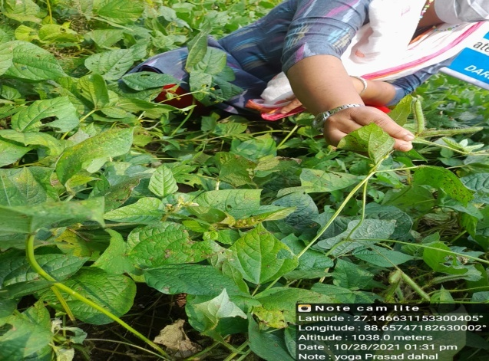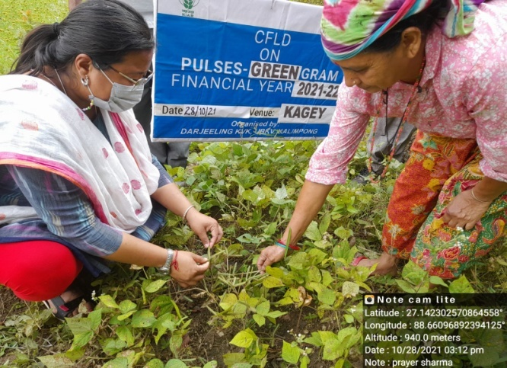

1. **Farmers' training photographs**

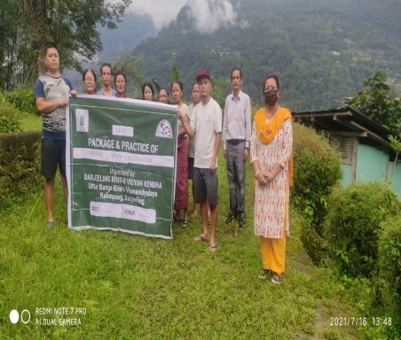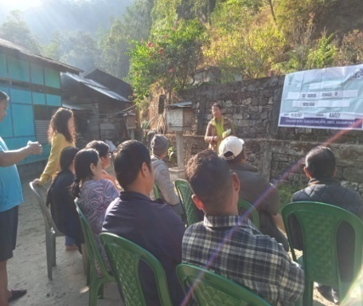

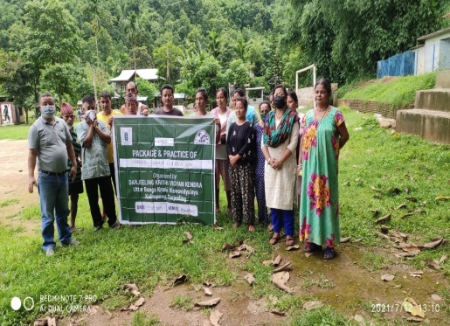

1. **Quality Photographs of field visits/field days and technology demonstrated.**

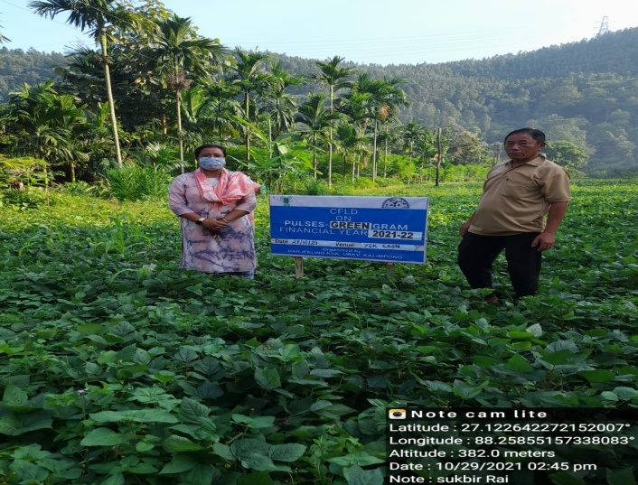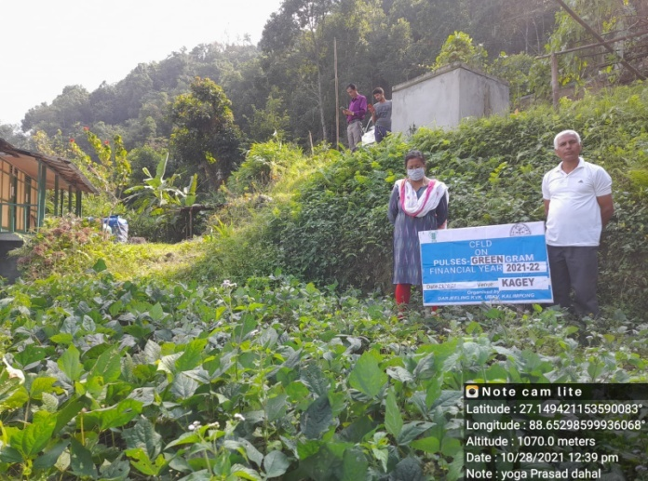

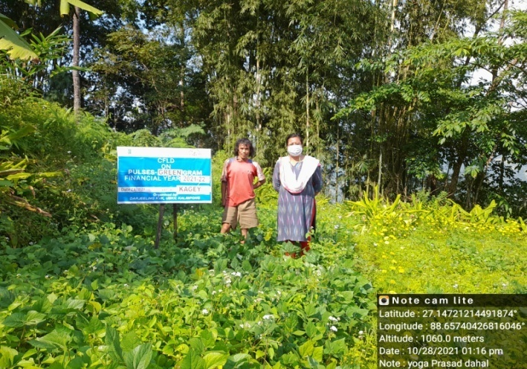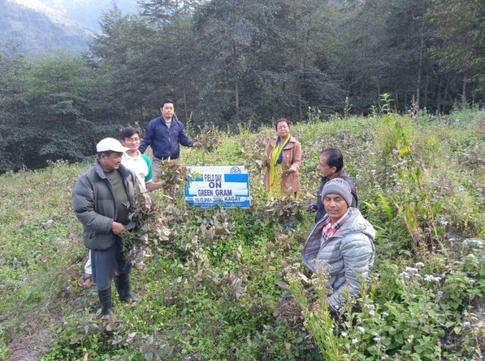

**J. Details of budget utilization**

|  |  |  |  |  |
| --- | --- | --- | --- | --- |
| Crop  (provide crop wise information ) | Items | Budget  Received  (Rs.) | Budget  Utilization  (Rs.) | Balance  (Rs.) |
|  | i) Critical input | 81000 | 72500 | 8500 |
| ii) TA/DA/POL etc. for monitoring | 4000 | 4000 | Nil |
| iii) Extension Activities (Field day) | 2500 | 2500 | Nil |
| iv)Publication of literature | 2500 | 2500 | Nil |
|  | Total |  |  | 8500 |

* 1. **Achievements on Training (Including the sponsored and FLD training programmes):**

1. **Farmers and farm women (on campus)**

| **Thematic Area** | **No. of Courses** | **No. of Participants** | | | | | | | | | | **Grand Total** | | |
| --- | --- | --- | --- | --- | --- | --- | --- | --- | --- | --- | --- | --- | --- | --- |
| **Other** | | | **SC** | | | | **ST** | | |
|  | **M** | **F** | **T** | **M** | **F** | | **T** | **M** | **F** | **T** | **M** | **F** | **T** |
| **I. Crop Production** |  |  |  |  |  |  | |  |  |  |  |  |  |  |
| Weed Management |  |  |  |  |  |  | |  |  |  |  |  |  |  |
| Resource Conservation Technologies |  |  |  |  |  |  | |  |  |  |  |  |  |  |
| Cropping Systems |  |  |  |  |  |  | |  |  |  |  |  |  |  |
| Crop Diversification |  |  |  |  |  |  | |  |  |  |  |  |  |  |
| Integrated Farming |  |  |  |  |  |  | |  |  |  |  |  |  |  |
| Micro irrigation/irrigation |  |  |  |  |  |  | |  |  |  |  |  |  |  |
| Seed production |  |  |  |  |  |  | |  |  |  |  |  |  |  |
| Nursery management |  |  |  |  |  |  | |  |  |  |  |  |  |  |
| Integrated Crop Management |  |  |  |  |  |  | |  |  |  |  |  |  |  |
| Soil & water conservation |  |  |  |  |  |  | |  |  |  |  |  |  |  |
| Integrated nutrient Management |  |  |  |  |  |  | |  |  |  |  |  |  |  |
| Production of organic inputs |  |  |  |  |  |  | |  |  |  |  |  |  |  |
| Others |  |  |  |  |  |  | |  |  |  |  |  |  |  |
| Total |  |  |  |  |  |  | |  |  |  |  |  |  |  |
| **II. Horticulture** |  |  |  |  |  |  | |  |  |  |  |  |  |  |
| **a) Vegetable Crops** |  |  |  |  |  |  | |  |  |  |  |  |  |  |
| Production of low volume and high value crops |  |  |  |  |  |  | |  |  |  |  |  |  |  |
| Off0season vegetables |  |  |  |  |  |  | |  |  |  |  |  |  |  |
| Nursery raising |  |  |  |  |  |  | |  |  |  |  |  |  |  |
| Exotic vegetables |  |  |  |  |  |  | |  |  |  |  |  |  |  |
| Export potential vegetables |  |  |  |  |  |  | |  |  |  |  |  |  |  |
| Grading and standardization |  |  |  |  |  |  | |  |  |  |  |  |  |  |
| Protective cultivation |  |  |  |  |  |  | |  |  |  |  |  |  |  |
| Others |  |  |  |  |  |  | |  |  |  |  |  |  |  |
| Total (a) |  |  |  |  |  |  | |  |  |  |  |  |  |  |
| **b) Fruits** |  |  |  |  |  |  | |  |  |  |  |  |  |  |
| Training and Pruning |  |  |  |  |  |  | |  |  |  |  |  |  |  |
| Layout and Management of Orchards |  |  |  |  |  |  | |  |  |  |  |  |  |  |
| Cultivation of Fruit | 1 | 15 | 10 | 25 | 2 | 3 | | 5 | 2 | 3 | 5 | 19 | 16 | 35 |
| Management of young plants/orchards |  |  |  |  |  |  | |  |  |  |  |  |  |  |
| Rejuvenation of old orchards |  |  |  |  |  |  | |  |  |  |  |  |  |  |
| Export potential fruits |  |  |  |  |  |  | |  |  |  |  |  |  |  |
| Micro irrigation systems of orchards |  |  |  |  |  |  | |  |  |  |  |  |  |  |
| Plant propagation techniques |  |  |  |  |  |  | |  |  |  |  |  |  |  |
| Others |  |  |  |  |  |  | |  |  |  |  |  |  |  |
| Total (b) | **1** | **15** | **10** | **25** | **2** | **3** | | **5** | **2** | **3** | **5** | **19** | **16** | **35** |
| **c) Ornamental Plants** |  |  |  |  |  |  | |  |  |  |  |  |  |  |
| Nursery Management |  |  |  |  |  |  | |  |  |  |  |  |  |  |
| Management of potted plants |  |  |  |  |  |  | |  |  |  |  |  |  |  |
| Export potential of ornamental plants |  |  |  |  |  |  | |  |  |  |  |  |  |  |
| Propagation techniques of Ornamental Plants |  |  |  |  |  |  | |  |  |  |  |  |  |  |
| Others |  |  |  |  |  |  | |  |  |  |  |  |  |  |
| Total (c) |  |  |  |  |  |  | |  |  |  |  |  |  |  |
| **d) Plantation crops** |  |  |  |  |  |  | |  |  |  |  |  |  |  |
| Production and Management technology |  |  |  |  |  |  | |  |  |  |  |  |  |  |
| Processing and value addition |  |  |  |  |  |  | |  |  |  |  |  |  |  |
| Others |  |  |  |  |  |  | |  |  |  |  |  |  |  |
| Total (d) |  |  |  |  |  |  | |  |  |  |  |  |  |  |
| **e) Tuber crops** |  |  |  |  |  |  | |  |  |  |  |  |  |  |
| Production and Management technology |  |  |  |  |  |  | |  |  |  |  |  |  |  |
| Processing and value addition |  |  |  |  |  |  | |  |  |  |  |  |  |  |
| Others |  |  |  |  |  |  | |  |  |  |  |  |  |  |
| Total (e) |  |  |  |  |  |  | |  |  |  |  |  |  |  |
| **f) Spices** |  |  |  |  |  |  | |  |  |  |  |  |  |  |
| Production and Management technology | 1 | 10 | 4 | 14 | 0 | 0 | | 0 | 9 | 2 | 11 | 19 | 6 | 25 |
| Processing and value addition |  |  |  |  |  |  | |  |  |  |  |  |  |  |
| Others |  |  |  |  |  |  | |  |  |  |  |  |  |  |
| Total (f) | **1** | **10** | **4** | **14** | **0** | **0** | | **0** | **9** | **2** | **11** | **19** | **6** | **25** |
| **g) Medicinal and Aromatic Plants** |  |  |  |  |  |  | |  |  |  |  |  |  |  |
| Nursery management |  |  |  |  |  |  | |  |  |  |  |  |  |  |
| Production and management technology |  |  |  |  |  |  | |  |  |  |  |  |  |  |
| Post harvest technology and value addition |  |  |  |  |  |  | |  |  |  |  |  |  |  |
| Others |  |  |  |  |  |  | |  |  |  |  |  |  |  |
| Total (g) |  |  |  |  |  |  | |  |  |  |  |  |  |  |
| Total(a-g) | **2** | **25** | **14** | **39** | **2** | **3** | | **5** | **11** | **5** | **16** | **38** | **22** | **60** |
| **III. Soil Health and Fertility Management** |  |  |  |  |  |  | |  |  |  |  |  |  |  |
| Soil fertility management |  |  |  |  |  |  | |  |  |  |  |  |  |  |
| Integrated water management |  |  |  |  |  |  | |  |  |  |  |  |  |  |
| Integrated Nutrient Management |  |  |  |  |  |  | |  |  |  |  |  |  |  |
| Production and use of organic inputs |  |  |  |  |  |  | |  |  |  |  |  |  |  |
| Management of Problematic soils |  |  |  |  |  |  | |  |  |  |  |  |  |  |
| Micro nutrient deficiency in crops |  |  |  |  |  |  | |  |  |  |  |  |  |  |
| Nutrient Use Efficiency |  |  |  |  |  |  | |  |  |  |  |  |  |  |
| Balance Use of fertilizer |  |  |  |  |  |  | |  |  |  |  |  |  |  |
| Soil & water testing |  |  |  |  |  |  | |  |  |  |  |  |  |  |
| others |  |  |  |  |  |  | |  |  |  |  |  |  |  |
| **Total** |  |  |  |  |  |  | |  |  |  |  |  |  |  |
| **IV. Livestock Production and Management** |  |  |  |  |  |  | |  |  |  |  |  |  |  |
| Dairy Management |  |  |  |  |  |  | |  |  |  |  |  |  |  |
| Poultry Management | 1 | 0 | 13 | 13 | 0 | 0 | | 0 | 0 | 13 | 13 | 0 | 26 | 26 |
| Piggery Management |  |  |  |  |  |  | |  |  |  |  |  |  |  |
| Rabbit Management |  |  |  |  |  |  | |  |  |  |  |  |  |  |
| Animal Nutrition Management |  |  |  |  |  |  | |  |  |  |  |  |  |  |
| Disease Management |  |  |  |  |  |  | |  |  |  |  |  |  |  |
| Feed & fodder technologies |  |  |  |  |  |  | |  |  |  |  |  |  |  |
| Production of quality animal products |  |  |  |  |  |  | |  |  |  |  |  |  |  |
| Others |  |  |  |  |  |  | |  |  |  |  |  |  |  |
| **Total** | **1** | **0** | **13** | **13** | **0** | **0** | | **0** | **0** | **13** | **13** | **0** | **26** | **26** |
| **V. Home Science/Women empowerment** |  |  |  |  |  |  | |  |  |  |  |  |  |  |
| Household food security by kitchen gardening and nutrition gardening |  |  |  |  |  |  | |  |  |  |  |  |  |  |
| Design and development of low/minimum cost diet |  |  |  |  |  |  | |  |  |  |  |  |  |  |
| Designing and development for high nutrient efficiency diet |  |  |  |  |  |  | |  |  |  |  |  |  |  |
| Minimization of nutrient loss in processing |  |  |  |  |  |  | |  |  |  |  |  |  |  |
| Processing & cooking |  |  |  |  |  |  | |  |  |  |  |  |  |  |
| Gender mainstreaming through SHGs |  |  |  |  |  |  | |  |  |  |  |  |  |  |
| Storage loss minimization techniques |  |  |  |  |  |  | |  |  |  |  |  |  |  |
| Value addition |  |  |  |  |  |  | |  |  |  |  |  |  |  |
| Women empowerment |  |  |  |  |  |  | |  |  |  |  |  |  |  |
| Location specific drudgery reduction technologies |  |  |  |  |  |  | |  |  |  |  |  |  |  |
| Rural Crafts |  |  |  |  |  |  | |  |  |  |  |  |  |  |
| Women and child care |  |  |  |  |  |  | |  |  |  |  |  |  |  |
| Others |  |  |  |  |  |  | |  |  |  |  |  |  |  |
| **Total** |  |  |  |  |  |  | |  |  |  |  |  |  |  |
| **VI. Agril. Engineering** |  |  |  |  |  |  | |  |  |  |  |  |  |  |
| Farm machinery & its maintenance |  |  |  |  |  |  | |  |  |  |  |  |  |  |
| Installation and maintenance of micro irrigation systems |  |  |  |  |  |  | |  |  |  |  |  |  |  |
| Use of Plastics in farming practices |  |  |  |  |  |  | |  |  |  |  |  |  |  |
| Production of small tools and implements |  |  |  |  |  |  | |  |  |  |  |  |  |  |
| Repair and maintenance of farm machinery and implements |  |  |  |  |  |  | |  |  |  |  |  |  |  |
| Small scale processing and value addition |  |  |  |  |  |  | |  |  |  |  |  |  |  |
| Post Harvest Technology |  |  |  |  |  |  | |  |  |  |  |  |  |  |
| Others |  |  |  |  |  |  | |  |  |  |  |  |  |  |
| **Total** |  |  |  |  |  |  | |  |  |  |  |  |  |  |
| **VII. Plant Protection** |  |  |  |  |  |  | |  |  |  |  |  |  |  |
| Integrated Pest Management | 1 | 0 | 13 | 13 | 0 | 0 | | 0 | 0 | 13 | 13 | 0 | 26 | 26 |
| Integrated Disease Management | 2 | 8 | 10 | 3 | 0 | 3 | | 5 | 2 | 7 | 10 | 10 | 20 | 2 |
| Bio0control of pests and diseases |  |  |  |  |  |  | |  |  |  |  |  |  |  |
| Production of bio control agents and bio pesticides |  |  |  |  |  |  | |  |  |  |  |  |  |  |
| Others |  |  |  |  |  |  | |  |  |  |  |  |  |  |
| **Total** | **3** | **8** | **23** | **16** | **0** | **3** | | **5** | **2** | **20** | **23** | **10** | **46** | **28** |
| **VIII. Fisheries** |  |  |  |  |  |  | |  |  |  |  |  |  |  |
| Integrated fish farming |  |  |  |  |  |  | |  |  |  |  |  |  |  |
| Carp breeding and hatchery management |  |  |  |  |  |  | |  |  |  |  |  |  |  |
| Carp fry and fingerling rearing |  |  |  |  |  |  | |  |  |  |  |  |  |  |
| Composite fish culture |  |  |  |  |  | |  |  |  |  |  |  |  |  |
| Hatchery management and culture of freshwater prawn |  |  |  |  |  | |  |  |  |  |  |  |  |  |
| Breeding and culture of ornamental fishes |  |  |  |  |  | |  |  |  |  |  |  |  |  |
| Portable plastic carp hatchery |  |  |  |  |  | |  |  |  |  |  |  |  |  |
| Pen culture of fish and prawn |  |  |  |  |  | |  |  |  |  |  |  |  |  |
| Shrimp farming |  |  |  |  |  | |  |  |  |  |  |  |  |  |
| Edible oyster farming |  |  |  |  |  | |  |  |  |  |  |  |  |  |
| Pearl culture |  |  |  |  |  | |  |  |  |  |  |  |  |  |
| Fish processing and value addition |  |  |  |  |  | |  |  |  |  |  |  |  |  |
| Others |  |  |  |  |  | |  |  |  |  |  |  |  |  |
| **Total** |  |  |  |  |  | |  |  |  |  |  |  |  |  |
| **IX. Production of Input at site** |  |  |  |  |  | |  |  |  |  |  |  |  |  |
| Seed Production |  |  |  |  |  | |  |  |  |  |  |  |  |  |
| Planting material production |  |  |  |  |  | |  |  |  |  |  |  |  |  |
| Bio0agents production |  |  |  |  |  | |  |  |  |  |  |  |  |  |
| Bio0pesticides production |  |  |  |  |  | |  |  |  |  |  |  |  |  |
| Bio0fertilizer production |  |  |  |  |  | |  |  |  |  |  |  |  |  |
| Vermi0compost production |  |  |  |  |  | |  |  |  |  |  |  |  |  |
| Organic manures production |  |  |  |  |  | |  |  |  |  |  |  |  |  |
| Production of fry and fingerlings |  |  |  |  |  | |  |  |  |  |  |  |  |  |
| Production of Bee0colonies and wax sheets |  |  |  |  |  | |  |  |  |  |  |  |  |  |
| Small tools and implements |  |  |  |  |  | |  |  |  |  |  |  |  |  |
| Production of livestock feed and fodder |  |  |  |  |  | |  |  |  |  |  |  |  |  |
| Production of Fish feed |  |  |  |  |  | |  |  |  |  |  |  |  |  |
| Mushroom production |  |  |  |  |  | |  |  |  |  |  |  |  |  |
| Apiculture |  |  |  |  |  | |  |  |  |  |  |  |  |  |
| Others |  |  |  |  |  | |  |  |  |  |  |  |  |  |
| **Total** |  |  |  |  |  | |  |  |  |  |  |  |  |  |
| **X. Capacity Building and Group Dynamics** |  |  |  |  |  | |  |  |  |  |  |  |  |  |
| Leadership development |  |  |  |  |  | |  |  |  |  |  |  |  |  |
| Group dynamics |  |  |  |  |  | |  |  |  |  |  |  |  |  |
| Formation and Management of SHGs |  |  |  |  |  | |  |  |  |  |  |  |  |  |
| Mobilization of social capital |  |  |  |  |  | |  |  |  |  |  |  |  |  |
| Entrepreneurial development of farmers/youths |  |  |  |  |  | |  |  |  |  |  |  |  |  |
| WTO and IPR issues |  |  |  |  |  | |  |  |  |  |  |  |  |  |
| Others |  |  |  |  |  | |  |  |  |  |  |  |  |  |
| **Total** |  |  |  |  |  | |  |  |  |  |  |  |  |  |
| **XI. Agro forestry** |  |  |  |  |  | |  |  |  |  |  |  |  |  |
| Production technologies |  |  |  |  |  | |  |  |  |  |  |  |  |  |
| Nursery management |  |  |  |  |  | |  |  |  |  |  |  |  |  |
| Integrated Farming Systems |  |  |  |  |  | |  |  |  |  |  |  |  |  |
| Others |  |  |  |  |  | |  |  |  |  |  |  |  |  |
| **Total** |  |  |  |  |  | |  |  |  |  |  |  |  |  |
| **XII. Others (Pl. Specify)** |  |  |  |  |  | |  |  |  |  |  |  |  |  |
| **GRAND TOTAL** | **6** | **33** | **50** | **68** | **2** | | **6** | **10** | **13** | **38** | **52** | **48** | **94** | **114** |

**B) Rural Youth (on campus)**

| **Thematic Area** | **No. of Courses** | **No. of Participants** | | | | | | | | | | **Grand Total** | | |
| --- | --- | --- | --- | --- | --- | --- | --- | --- | --- | --- | --- | --- | --- | --- |
| **Other** | | | **SC** | | | | **ST** | | |
|  | **M** | **F** | **T** | **M** | **F** | | **T** | **M** | **F** | **T** | **M** | **F** | **T** |
| Nursery Management of Horticulture crops |  |  |  |  |  | |  |  |  |  |  |  |  |  |
| Training and pruning of orchards |  |  |  |  |  | |  |  |  |  |  |  |  |  |
| Protected cultivation of vegetable crops |  |  |  |  |  | |  |  |  |  |  |  |  |  |
| Commercial fruit production |  |  |  |  |  | |  |  |  |  |  |  |  |  |
| Integrated farming |  |  |  |  |  | |  |  |  |  |  |  |  |  |
| Seed production |  |  |  |  |  | |  |  |  |  |  |  |  |  |
| Production of organic inputs |  |  |  |  |  | |  |  |  |  |  |  |  |  |
| Planting material production |  |  |  |  |  | |  |  |  |  |  |  |  |  |
| Vermiculture |  |  |  |  |  | |  |  |  |  |  |  |  |  |
| Mushroom Production |  |  |  |  |  | |  |  |  |  |  |  |  |  |
| Beekeeping | 2 | 7 | 1 | 8 | 0 | | 0 | 0 | 5 | 2 | 7 | 12 | 3 | 15 |
| Sericulture |  |  |  |  |  | |  |  |  |  |  |  |  |  |
| Repair and maintenance of farm machinery and implements |  |  |  |  |  | |  |  |  |  |  |  |  |  |
| Value addition |  |  |  |  |  | |  |  |  |  |  |  |  |  |
| Small scale processing |  |  |  |  |  | |  |  |  |  |  |  |  |  |
| Post Harvest Technology |  |  |  |  |  | |  |  |  |  |  |  |  |  |
| Tailoring and Stitching |  |  |  |  |  | |  |  |  |  |  |  |  |  |
| Rural Crafts |  |  |  |  |  | |  |  |  |  |  |  |  |  |
| Production of quality animal products |  |  |  |  |  | |  |  |  |  |  |  |  |  |
| Dairying |  |  |  |  |  | |  |  |  |  |  |  |  |  |
| Sheep and goat rearing |  |  |  |  |  | |  |  |  |  |  |  |  |  |
| Quail farming |  |  |  |  |  | |  |  |  |  |  |  |  |  |
| Piggery |  |  |  |  |  | |  |  |  |  |  |  |  |  |
| Rabbit farming |  |  |  |  |  | |  |  |  |  |  |  |  |  |
| Poultry production |  |  |  |  |  | |  |  |  |  |  |  |  |  |
| Ornamental fisheries |  |  |  |  |  | |  |  |  |  |  |  |  |  |
| Composite fish culture |  |  |  |  |  | |  |  |  |  |  |  |  |  |
| Freshwater prawn culture |  |  |  |  |  | |  |  |  |  |  |  |  |  |
| Shrimp farming |  |  |  |  |  | |  |  |  |  |  |  |  |  |
| Pearl culture |  |  |  |  |  | |  |  |  |  |  |  |  |  |
| Cold water fisheries |  |  |  |  |  | |  |  |  |  |  |  |  |  |
| Fish harvest and processing technology |  |  |  |  |  | |  |  |  |  |  |  |  |  |
| Fry and fingerling rearing |  |  |  |  |  | |  |  |  |  |  |  |  |  |
| Others |  |  |  |  |  | |  |  |  |  |  |  |  |  |
| **Total** | **2** | **7** | **1** | **8** | **0** | | **0** | **0** | **5** | **2** | **7** | **12** | **3** | **15** |

**C) Extension Personnel (on campus)**

| **Thematic Area** | **No. of Courses** | **No. of Participants** | | | | | | | | | | **Grand Total** | | |
| --- | --- | --- | --- | --- | --- | --- | --- | --- | --- | --- | --- | --- | --- | --- |
| **Other** | | | **SC** | | | | **ST** | | |
|  | **M** | **F** | **T** | **M** | **F** | | **T** | **M** | **F** | **T** | **M** | **F** | **T** |
| Productivity enhancement in field crops |  |  |  |  |  | |  |  |  |  |  |  |  |  |
| Integrated Pest Management |  |  |  |  |  | |  |  |  |  |  |  |  |  |
| Integrated Nutrient management |  |  |  |  |  | |  |  |  |  |  |  |  |  |
| Rejuvenation of old orchards |  |  |  |  |  | |  |  |  |  |  |  |  |  |
| Protected cultivation technology |  |  |  |  |  | |  |  |  |  |  |  |  |  |
| Production and use of organic inputs |  |  |  |  |  | |  |  |  |  |  |  |  |  |
| Care and maintenance of farm machinery and implements |  |  |  |  |  | |  |  |  |  |  |  |  |  |
| Gender mainstreaming through SHGs |  |  |  |  |  | |  |  |  |  |  |  |  |  |
| Formation and Management of SHGs |  |  |  |  |  | |  |  |  |  |  |  |  |  |
| Women and Child care |  |  |  |  |  | |  |  |  |  |  |  |  |  |
| Low cost and nutrient efficient diet designing |  |  |  |  |  | |  |  |  |  |  |  |  |  |
| Group Dynamics and farmers organization |  |  |  |  |  | |  |  |  |  |  |  |  |  |
| Information networking among farmers |  |  |  |  |  | |  |  |  |  |  |  |  |  |
| Capacity building for ICT application |  |  |  |  |  | |  |  |  |  |  |  |  |  |
| Management in farm animals |  |  |  |  |  | |  |  |  |  |  |  |  |  |
| Livestock feed and fodder production |  |  |  |  |  | |  |  |  |  |  |  |  |  |
| Household food security |  |  |  |  |  | |  |  |  |  |  |  |  |  |
| Other |  |  |  |  |  | |  |  |  |  |  |  |  |  |
| **Total** |  |  |  |  |  | |  |  |  |  |  |  |  |  |

**D) Farmers and farm women (off campus)**

| **Thematic Area** | **No. of Courses** | **No. of Participants** | | | | | | | | | **Grand Total** | | |
| --- | --- | --- | --- | --- | --- | --- | --- | --- | --- | --- | --- | --- | --- |
| **Other** | | | **SC** | | | **ST** | | |
|  | **M** | **F** | **T** | **M** | **F** | **T** | **M** | **F** | **T** | **M** | **F** | **T** |
| **I. Crop Production** |  |  |  |  |  |  |  |  |  |  |  |  |  |
| Weed Management |  |  |  |  |  |  |  |  |  |  |  |  |  |
| Resource Conservation Technologies |  |  |  |  |  |  |  |  |  |  |  |  |  |
| Cropping Systems |  |  |  |  |  |  |  |  |  |  |  |  |  |
| Crop Diversification |  |  |  |  |  |  |  |  |  |  |  |  |  |
| Integrated Farming |  |  |  |  |  |  |  |  |  |  |  |  |  |
| Micro irrigation/irrigation |  |  |  |  |  |  |  |  |  |  |  |  |  |
| Seed production |  |  |  |  |  |  |  |  |  |  |  |  |  |
| Nursery management |  |  |  |  |  |  |  |  |  |  |  |  |  |
| Integrated Crop Management |  |  |  |  |  |  |  |  |  |  |  |  |  |
| Soil & water conservation |  |  |  |  |  |  |  |  |  |  |  |  |  |
| Integrated nutrient Management |  |  |  |  |  |  |  |  |  |  |  |  |  |
| Production of organic inputs |  |  |  |  |  |  |  |  |  |  |  |  |  |
| Others |  |  |  |  |  |  |  |  |  |  |  |  |  |
| Total |  |  |  |  |  |  |  |  |  |  |  |  |  |
| **II. Horticulture** |  |  |  |  |  |  |  |  |  |  |  |  |  |
| **a) Vegetable Crops** |  |  |  |  |  |  |  |  |  |  |  |  |  |
| Production of low volume and high value crops | 1 | 2 | 1 | 3 | 3 | 19 | 22 | 0 | 1 | 1 | 5 | 21 | 26 |
| Off0season vegetables | 3 | 23 | 7 | 28 | 3 | 1 | 3 | 7 | 8 | 15 | 33 | 16 | 49 |
| Nursery raising |  |  |  |  |  |  |  |  |  |  |  |  |  |
| Exotic vegetables | 1 | 2 | 11 | 13 | 1 | 0 | 1 | 0 | 4 | 4 | 3 | 15 | 18 |
| Export potential vegetables |  |  |  |  |  |  |  |  |  |  |  |  |  |
| Grading and standardization |  |  |  |  |  |  |  |  |  |  |  |  |  |
| Protective cultivation |  |  |  |  |  |  |  |  |  |  |  |  |  |
| Others |  |  |  |  |  |  |  |  |  |  |  |  |  |
| Total (a) | **5** | **27** | **19** | **44** | **7** | **20** | **26** | **7** | **13** | **20** | **41** | **52** | **93** |
| **b) Fruits** |  |  |  |  |  |  |  |  |  |  |  |  |  |
| Training and Pruning | 1 | 10 | 0 | 10 | 0 | 0 | 0 | 0 | 0 | 0 | 10 | 0 | 10 |
| Layout and Management of Orchards |  |  |  |  |  |  |  |  |  |  |  |  |  |
| Cultivation of Fruit |  |  |  |  |  |  |  |  |  |  |  |  |  |
| Management of young plants/orchards |  |  |  |  |  |  |  |  |  |  |  |  |  |
| Rejuvenation of old orchards |  |  |  |  |  |  |  |  |  |  |  |  |  |
| Export potential fruits |  |  |  |  |  |  |  |  |  |  |  |  |  |
| Micro irrigation systems of orchards |  |  |  |  |  |  |  |  |  |  |  |  |  |
| Plant propagation techniques |  |  |  |  |  |  |  |  |  |  |  |  |  |
| Others |  |  |  |  |  |  |  |  |  |  |  |  |  |
| Total (b) | **1** | **10** | **0** | **10** | **0** | **0** | **0** | **0** | **0** | **0** | **10** | **0** | **10** |
| **c) Ornamental Plants** |  |  |  |  |  |  |  |  |  |  |  |  |  |
| Nursery Management | 1 | 11 | 12 | 23 | 0 | 0 | 0 | 2 | 3 | 5 | 13 | 15 | 28 |
| Management of potted plants |  |  |  |  |  |  |  |  |  |  |  |  |  |
| Export potential of ornamental plants |  |  |  |  |  |  |  |  |  |  |  |  |  |
| Propagation techniques of Ornamental Plants |  |  |  |  |  |  |  |  |  |  |  |  |  |
| Others |  |  |  |  |  |  |  |  |  |  |  |  |  |
| Total (c) | **1** | **11** | **12** | **23** | **0** | **0** | **0** | **2** | **3** | **5** | **13** | **15** | **28** |
| **d) Plantation crops** |  |  |  |  |  |  |  |  |  |  |  |  |  |
| Production and Management technology |  |  |  |  |  |  |  |  |  |  |  |  |  |
| Processing and value addition |  |  |  |  |  |  |  |  |  |  |  |  |  |
| Others |  |  |  |  |  |  |  |  |  |  |  |  |  |
| Total (d) |  |  |  |  |  |  |  |  |  |  |  |  |  |
| **e) Tuber crops** |  |  |  |  |  |  |  |  |  |  |  |  |  |
| Production and Management technology |  |  |  |  |  |  |  |  |  |  |  |  |  |
| Processing and value addition |  |  |  |  |  |  |  |  |  |  |  |  |  |
| Others |  |  |  |  |  |  |  |  |  |  |  |  |  |
| Total (e) |  |  |  |  |  |  |  |  |  |  |  |  |  |
| **f) Spices** |  |  |  |  |  |  |  |  |  |  |  |  |  |
| Production and Management technology | 5 | 22 | 22 | 44 | 22 | 32 | 55 | 1 | 9 | 10 | 45 | 64 | 109 |
| Processing and value addition |  |  |  |  |  |  |  |  |  |  |  |  |  |
| Others |  |  |  |  |  |  |  |  |  |  |  |  |  |
| Total (f) | **5** | **22** | **22** | **44** | **22** | **32** | **55** | **1** | **9** | **10** | **45** | **64** | **109** |
| **g) Medicinal and Aromatic Plants** |  |  |  |  |  |  |  |  |  |  |  |  |  |
| Nursery management |  |  |  |  |  |  |  |  |  |  |  |  |  |
| Production and management technology |  |  |  |  |  |  |  |  |  |  |  |  |  |
| Post harvest technology and value addition |  |  |  |  |  |  |  |  |  |  |  |  |  |
| Others |  |  |  |  |  |  |  |  |  |  |  |  |  |
| Total (g) |  |  |  |  |  |  |  |  |  |  |  |  |  |
| Total(a-g) | **12** | **70** | **53** | **121** | **29** | **52** | **81** | **10** | **25** | **35** | **109** | **131** | **240** |
| **III. Soil Health and Fertility Management** |  |  |  |  |  |  |  |  |  |  |  |  |  |
| Soil fertility management | 1 | 14 | 3 | 17 | 0 | 0 | 0 | 0 | 0 | 0 | 14 | 3 | 17 |
| Integrated water management |  |  |  |  |  |  |  |  |  |  |  |  |  |
| Integrated Nutrient Management | 1 | 9 | 12 | 21 | 1 | 1 | 2 | 3 | 0 | 3 | 13 | 13 | 26 |
| Production and use of organic inputs | 1 | 1 | 0 | 1 | 4 | 14 | 19 | 0 | 0 | 1 | 5 | 14 | 19 |
| Management of Problematic soils |  |  |  |  |  |  |  |  |  |  |  |  |  |
| Micro nutrient deficiency in crops |  |  |  |  |  |  |  |  |  |  |  |  |  |
| Nutrient Use Efficiency |  |  |  |  |  |  |  |  |  |  |  |  |  |
| Balance Use of fertilizer |  |  |  |  |  |  |  |  |  |  |  |  |  |
| Soil & water testing | 4 | 31 | 50 | 81 | 2 | 1 | 3 | 23 | 26 | 49 | 56 | 77 | 133 |
| others |  |  |  |  |  |  |  |  |  |  |  |  |  |
| **Total** | **7** | **55** | **65** | **120** | **7** | **16** | **24** | **26** | **26** | **53** | **88** | **107** | **195** |
| **IV. Livestock Production and Management** |  |  |  |  |  |  |  |  |  |  |  |  |  |
| Dairy Management | 5 | 41 | 28 | 69 | 1 | 1 | 2 | 11 | 16 | 27 | 53 | 45 | 98 |
| Poultry Management | 2 | 8 | 9 | 17 | 12 | 16 | 28 | 3 | 4 | 7 | 23 | 29 | 52 |
| Piggery Management |  |  |  |  |  |  |  |  |  |  |  |  |  |
| Rabbit Management |  |  |  |  |  |  |  |  |  |  |  |  |  |
| Animal Nutrition Management |  |  |  |  |  |  |  |  |  |  |  |  |  |
| Disease Management | 1 | 6 | 3 | 9 | 1 |  | 1 | 1 |  | 1 | 8 | 3 | 11 |
| Feed & fodder technologies |  |  |  |  |  |  |  |  |  |  |  |  |  |
| Production of quality animal products |  |  |  |  |  |  |  |  |  |  |  |  |  |
| Goat farming | 1 | 2 | 7 | 9 | 3 | 1 | 4 | 1 | 1 | 1 | 6 | 9 | 15 |
| **Total** | **9** | **57** | **47** | **104** | **17** | **18** | **35** | **16** | **21** | **36** | **90** | **86** | **176** |
| **V. Home Science/Women empowerment** |  |  |  |  |  |  |  |  |  |  |  |  |  |
| Household food security by kitchen gardening and nutrition gardening |  |  |  |  |  |  |  |  |  |  |  |  |  |
| Design and development of low/minimum cost diet |  |  |  |  |  |  |  |  |  |  |  |  |  |
| Designing and development for high nutrient efficiency diet |  |  |  |  |  |  |  |  |  |  |  |  |  |
| Minimization of nutrient loss in processing |  |  |  |  |  |  |  |  |  |  |  |  |  |
| Processing & cooking |  |  |  |  |  |  |  |  |  |  |  |  |  |
| Gender mainstreaming through SHGs |  |  |  |  |  |  |  |  |  |  |  |  |  |
| Storage loss minimization techniques |  |  |  |  |  |  |  |  |  |  |  |  |  |
| Value addition |  |  |  |  |  |  |  |  |  |  |  |  |  |
| Women empowerment |  |  |  |  |  |  |  |  |  |  |  |  |  |
| Location specific drudgery reduction technologies |  |  |  |  |  |  |  |  |  |  |  |  |  |
| Rural Crafts |  |  |  |  |  |  |  |  |  |  |  |  |  |
| Women and child care |  |  |  |  |  |  |  |  |  |  |  |  |  |
| Others |  |  |  |  |  |  |  |  |  |  |  |  |  |
| **Total** |  |  |  |  |  |  |  |  |  |  |  |  |  |
| **VI. Agril. Engineering** |  |  |  |  |  |  |  |  |  |  |  |  |  |
| Farm machinery & its maintenance |  |  |  |  |  |  |  |  |  |  |  |  |  |
| Installation and maintenance of micro irrigation systems |  |  |  |  |  |  |  |  |  |  |  |  |  |
| Use of Plastics in farming practices |  |  |  |  |  |  |  |  |  |  |  |  |  |
| Production of small tools and implements |  |  |  |  |  |  |  |  |  |  |  |  |  |
| Repair and maintenance of farm machinery and implements |  |  |  |  |  |  |  |  |  |  |  |  |  |
| Small scale processing and value addition |  |  |  |  |  |  |  |  |  |  |  |  |  |
| Post Harvest Technology |  |  |  |  |  |  |  |  |  |  |  |  |  |
| Others |  |  |  |  |  |  |  |  |  |  |  |  |  |
| **Total** |  |  |  |  |  |  |  |  |  |  |  |  |  |
| **VII. Plant Protection** |  |  |  |  |  |  |  |  |  |  |  |  |  |
| Integrated Pest Management | 1 | 18 | 0 | 18 | 8 | 0 | 8 | 4 | 0 | 4 | 30 | 0 | 30 |
| Integrated Disease Management |  |  |  |  |  |  |  |  |  |  |  |  |  |
| Bio0control of pests and diseases |  |  |  |  |  |  |  |  |  |  |  |  |  |
| Production of bio control agents and bio pesticides |  |  |  |  |  |  |  |  |  |  |  |  |  |
| Others |  |  |  |  |  |  |  |  |  |  |  |  |  |
| **Total** | **1** | **18** | **0** | **18** | **8** | **0** | **8** | **4** | **0** | **4** | **30** | **0** | **30** |
| **VIII. Fisheries** |  |  |  |  |  |  |  |  |  |  |  |  |  |
| Integrated fish farming |  |  |  |  |  |  |  |  |  |  |  |  |  |
| Carp breeding and hatchery management |  |  |  |  |  |  |  |  |  |  |  |  |  |
| Carp fry and fingerling rearing |  |  |  |  |  |  |  |  |  |  |  |  |  |
| Composite fish culture |  |  |  |  |  |  |  |  |  |  |  |  |  |
| Hatchery management and culture of freshwater prawn |  |  |  |  |  |  |  |  |  |  |  |  |  |
| Breeding and culture of ornamental fishes |  |  |  |  |  |  |  |  |  |  |  |  |  |
| Portable plastic carp hatchery |  |  |  |  |  |  |  |  |  |  |  |  |  |
| Pen culture of fish and prawn |  |  |  |  |  |  |  |  |  |  |  |  |  |
| Shrimp farming |  |  |  |  |  |  |  |  |  |  |  |  |  |
| Edible oyster farming |  |  |  |  |  |  |  |  |  |  |  |  |  |
| Pearl culture |  |  |  |  |  |  |  |  |  |  |  |  |  |
| Fish processing and value addition |  |  |  |  |  |  |  |  |  |  |  |  |  |
| Others |  |  |  |  |  |  |  |  |  |  |  |  |  |
| **Total** |  |  |  |  |  |  |  |  |  |  |  |  |  |
| **IX. Production of Input at site** |  |  |  |  |  |  |  |  |  |  |  |  |  |
| Seed Production |  |  |  |  |  |  |  |  |  |  |  |  |  |
| Planting material production |  |  |  |  |  |  |  |  |  |  |  |  |  |
| Bio0agents production |  |  |  |  |  |  |  |  |  |  |  |  |  |
| Bio0pesticides production |  |  |  |  |  |  |  |  |  |  |  |  |  |
| Bio0fertilizer production |  |  |  |  |  |  |  |  |  |  |  |  |  |
| Vermi0compost production |  |  |  |  |  |  |  |  |  |  |  |  |  |
| Organic manures production |  |  |  |  |  |  |  |  |  |  |  |  |  |
| Production of fry and fingerlings |  |  |  |  |  |  |  |  |  |  |  |  |  |
| Production of Bee0colonies and wax sheets |  |  |  |  |  |  |  |  |  |  |  |  |  |
| Small tools and implements |  |  |  |  |  |  |  |  |  |  |  |  |  |
| Production of livestock feed and fodder |  |  |  |  |  |  |  |  |  |  |  |  |  |
| Production of Fish feed |  |  |  |  |  |  |  |  |  |  |  |  |  |
| Mushroom production |  |  |  |  |  |  |  |  |  |  |  |  |  |
| Apiculture |  |  |  |  |  |  |  |  |  |  |  |  |  |
| Others |  |  |  |  |  |  |  |  |  |  |  |  |  |
| **Total** |  |  |  |  |  |  |  |  |  |  |  |  |  |
| **X. Capacity Building and Group Dynamics** |  |  |  |  |  |  |  |  |  |  |  |  |  |
| Leadership development |  |  |  |  |  |  |  |  |  |  |  |  |  |
| Group dynamics |  |  |  |  |  |  |  |  |  |  |  |  |  |
| Formation and Management of SHGs |  |  |  |  |  |  |  |  |  |  |  |  |  |
| Mobilization of social capital |  |  |  |  |  |  |  |  |  |  |  |  |  |
| Entrepreneurial development of farmers/youths | 1 | 4 | 11 | 15 | 0 | 0 | 0 | 16 | 19 | 35 | 20 | 30 | 50 |
| WTO and IPR issues |  |  |  |  |  |  |  |  |  |  |  |  |  |
| Others |  |  |  |  |  |  |  |  |  |  |  |  |  |
| **Total** | **1** | **4** | **11** | **15** | **0** | **0** | **0** | **16** | **19** | **35** | **20** | **30** | **50** |
| **XI. Agro forestry** |  |  |  |  |  |  |  |  |  |  |  |  |  |
| Production technologies |  |  |  |  |  |  |  |  |  |  |  |  |  |
| Nursery management |  |  |  |  |  |  |  |  |  |  |  |  |  |
| Integrated Farming Systems |  |  |  |  |  |  |  |  |  |  |  |  |  |
| Others |  |  |  |  |  |  |  |  |  |  |  |  |  |
| **Total** |  |  |  |  |  |  |  |  |  |  |  |  |  |
| **XII. Others (Pl. Specify)** |  |  |  |  |  |  |  |  |  |  |  |  |  |
| **GRAND TOTAL** | **30** | **204** | **176** | **378** | **61** | **86** | **148** | **72** | **91** | **163** | **337** | **354** | **691** |

**E)RURAL YOUTH (Off Campus)**

| **Thematic Area** | **No. of Courses** | **No. of Participants** | | | | | | | | | | **Grand Total** | | |
| --- | --- | --- | --- | --- | --- | --- | --- | --- | --- | --- | --- | --- | --- | --- |
| **Other** | | | **SC** | | | | **ST** | | |
|  | **M** | **F** | **T** | **M** | **F** | | **T** | **M** | **F** | **T** | **M** | **F** | **T** |
| Nursery Management of Horticulture crops |  |  |  |  |  | |  |  |  |  |  |  |  |  |
| Training and pruning of orchards |  |  |  |  |  | |  |  |  |  |  |  |  |  |
| Protected cultivation of vegetable crops |  |  |  |  |  | |  |  |  |  |  |  |  |  |
| Commercial fruit production |  |  |  |  |  | |  |  |  |  |  |  |  |  |
| Integrated farming |  |  |  |  |  | |  |  |  |  |  |  |  |  |
| Seed production |  |  |  |  |  | |  |  |  |  |  |  |  |  |
| Production of organic inputs |  |  |  |  |  | |  |  |  |  |  |  |  |  |
| Planting material production |  |  |  |  |  | |  |  |  |  |  |  |  |  |
| Vermiculture | 3 | 13 | 14 | 27 | 13 | | 16 | 29 | 8 | 5 | 13 | 34 | 35 | 69 |
| Mushroom Production |  |  |  |  |  | |  |  |  |  |  |  |  |  |
| Beekeeping |  |  |  |  |  | |  |  |  |  |  |  |  |  |
| Sericulture |  |  |  |  |  | |  |  |  |  |  |  |  |  |
| Repair and maintenance of farm machinery and implements |  |  |  |  |  | |  |  |  |  |  |  |  |  |
| Value addition |  |  |  |  |  | |  |  |  |  |  |  |  |  |
| Small scale processing |  |  |  |  |  | |  |  |  |  |  |  |  |  |
| Post Harvest Technology |  |  |  |  |  | |  |  |  |  |  |  |  |  |
| Tailoring and Stitching |  |  |  |  |  | |  |  |  |  |  |  |  |  |
| Rural Crafts |  |  |  |  |  | |  |  |  |  |  |  |  |  |
| Production of quality animal products |  |  |  |  |  | |  |  |  |  |  |  |  |  |
| Dairying |  |  |  |  |  | |  |  |  |  |  |  |  |  |
| Sheep and goat rearing |  |  |  |  |  | |  |  |  |  |  |  |  |  |
| Quail farming |  |  |  |  |  | |  |  |  |  |  |  |  |  |
| Piggery |  |  |  |  |  | |  |  |  |  |  |  |  |  |
| Rabbit farming |  |  |  |  |  | |  |  |  |  |  |  |  |  |
| Poultry production |  |  |  |  |  | |  |  |  |  |  |  |  |  |
| Ornamental fisheries |  |  |  |  |  | |  |  |  |  |  |  |  |  |
| Composite fish culture |  |  |  |  |  | |  |  |  |  |  |  |  |  |
| Freshwater prawn culture |  |  |  |  |  | |  |  |  |  |  |  |  |  |
| Shrimp farming |  |  |  |  |  | |  |  |  |  |  |  |  |  |
| Pearl culture |  |  |  |  |  | |  |  |  |  |  |  |  |  |
| Cold water fisheries |  |  |  |  |  | |  |  |  |  |  |  |  |  |
| Fish harvest and processing technology |  |  |  |  |  | |  |  |  |  |  |  |  |  |
| Fry and fingerling rearing |  |  |  |  |  | |  |  |  |  |  |  |  |  |
| Others |  |  |  |  |  | |  |  |  |  |  |  |  |  |
| **Total** | **3** | **13** | **14** | **27** | **13** | | **16** | **29** | **8** | **5** | **13** | **34** | **35** | **69** |

**F) Extension Personnel (Off Campus)**

| **Thematic Area** | **No. of Courses** | **No. of Participants** | | | | | | | | | | **Grand Total** | | |
| --- | --- | --- | --- | --- | --- | --- | --- | --- | --- | --- | --- | --- | --- | --- |
| **Other** | | | **SC** | | | | **ST** | | |
|  | **M** | **F** | **T** | **M** | **F** | | **T** | **M** | **F** | **T** | **M** | **F** | **T** |
| Productivity enhancement in field crops |  |  |  |  |  | |  |  |  |  |  |  |  |  |
| Integrated Pest Management |  |  |  |  |  | |  |  |  |  |  |  |  |  |
| Integrated Nutrient management |  |  |  |  |  | |  |  |  |  |  |  |  |  |
| Rejuvenation of old orchards |  |  |  |  |  | |  |  |  |  |  |  |  |  |
| Protected cultivation technology |  |  |  |  |  | |  |  |  |  |  |  |  |  |
| Production and use of organic inputs |  |  |  |  |  | |  |  |  |  |  |  |  |  |
| Care and maintenance of farm machinery and implements |  |  |  |  |  | |  |  |  |  |  |  |  |  |
| Gender mainstreaming through SHGs |  |  |  |  |  | |  |  |  |  |  |  |  |  |
| Formation and Management of SHGs |  |  |  |  |  | |  |  |  |  |  |  |  |  |
| Women and Child care |  |  |  |  |  | |  |  |  |  |  |  |  |  |
| Low cost and nutrient efficient diet designing |  |  |  |  |  | |  |  |  |  |  |  |  |  |
| Group Dynamics and farmers organization |  |  |  |  |  | |  |  |  |  |  |  |  |  |
| Information networking among farmers |  |  |  |  |  | |  |  |  |  |  |  |  |  |
| Capacity building for ICT application |  |  |  |  |  | |  |  |  |  |  |  |  |  |
| Management in farm animals |  |  |  |  |  | |  |  |  |  |  |  |  |  |
| Livestock feed and fodder production |  |  |  |  |  | |  |  |  |  |  |  |  |  |
| Household food security |  |  |  |  |  | |  |  |  |  |  |  |  |  |
| Other |  |  |  |  |  | |  |  |  |  |  |  |  |  |
| **Total** |  |  |  |  |  | |  |  |  |  |  |  |  |  |

**G) Consolidated table (ON and OFF Campus)**

**i. Farmers& Farm Women**

| **Thematic Area** | **No. of Courses** | **No. of Participants** | | | | | | | | | **Grand Total** | | |
| --- | --- | --- | --- | --- | --- | --- | --- | --- | --- | --- | --- | --- | --- |
| **Other** | | | **SC** | | | **ST** | | |
|  | **M** | **F** | **T** | **M** | **F** | **T** | **M** | **F** | **T** | **M** | **F** | **T** |
| **I. Crop Production** |  |  |  |  |  |  |  |  |  |  |  |  |  |
| Weed Management |  |  |  |  |  |  |  |  |  |  |  |  |  |
| Resource Conservation Technologies |  |  |  |  |  |  |  |  |  |  |  |  |  |
| Cropping Systems |  |  |  |  |  |  |  |  |  |  |  |  |  |
| Crop Diversification |  |  |  |  |  |  |  |  |  |  |  |  |  |
| Integrated Farming |  |  |  |  |  |  |  |  |  |  |  |  |  |
| Micro irrigation/irrigation |  |  |  |  |  |  |  |  |  |  |  |  |  |
| Seed production |  |  |  |  |  |  |  |  |  |  |  |  |  |
| Nursery management |  |  |  |  |  |  |  |  |  |  |  |  |  |
| Integrated Crop Management |  |  |  |  |  |  |  |  |  |  |  |  |  |
| Soil & water conservation |  |  |  |  |  |  |  |  |  |  |  |  |  |
| Integrated nutrient Management |  |  |  |  |  |  |  |  |  |  |  |  |  |
| Production of organic inputs |  |  |  |  |  |  |  |  |  |  |  |  |  |
| Others |  |  |  |  |  |  |  |  |  |  |  |  |  |
| Total |  |  |  |  |  |  |  |  |  |  |  |  |  |
| **II. Horticulture** |  |  |  |  |  |  |  |  |  |  |  |  |  |
| **a) Vegetable Crops** |  |  |  |  |  |  |  |  |  |  |  |  |  |
| Production of low volume and high value crops | 1 | 2 | 1 | 3 | 3 | 19 | 22 | 0 | 1 | 1 | 5 | 21 | 26 |
| Off0season vegetables | 3 | 23 | 7 | 28 | 3 | 1 | 3 | 7 | 8 | 15 | 33 | 16 | 49 |
| Nursery raising |  |  |  |  |  |  |  |  |  |  |  |  |  |
| Exotic vegetables | 1 | 2 | 11 | 13 | 1 | 0 | 1 | 0 | 4 | 4 | 3 | 15 | 18 |
| Export potential vegetables |  |  |  |  |  |  |  |  |  |  |  |  |  |
| Grading and standardization |  |  |  |  |  |  |  |  |  |  |  |  |  |
| Protective cultivation |  |  |  |  |  |  |  |  |  |  |  |  |  |
| Others |  |  |  |  |  |  |  |  |  |  |  |  |  |
| Total (a) | **5** | **27** | **19** | **44** | **7** | **20** | **26** | **7** | **13** | **20** | **41** | **52** | **93** |
| **b) Fruits** |  |  |  |  |  |  |  |  |  |  |  |  |  |
| Training and Pruning | 1 | 10 | 0 | 10 | 0 | 0 | 0 | 0 | 0 | 0 | 10 | 0 | 10 |
| Layout and Management of Orchards |  |  |  |  |  |  |  |  |  |  |  |  |  |
| Cultivation of Fruit | 1 | 15 | 10 | 25 | 2 | 3 | 5 | 2 | 3 | 5 | 19 | 16 | 35 |
| Management of young plants/orchards |  |  |  |  |  |  |  |  |  |  |  |  |  |
| Rejuvenation of old orchards |  |  |  |  |  |  |  |  |  |  |  |  |  |
| Export potential fruits |  |  |  |  |  |  |  |  |  |  |  |  |  |
| Micro irrigation systems of orchards |  |  |  |  |  |  |  |  |  |  |  |  |  |
| Plant propagation techniques |  |  |  |  |  |  |  |  |  |  |  |  |  |
| Others |  |  |  |  |  |  |  |  |  |  |  |  |  |
| Total (b) | **2** | **25** | **10** | **35** | **2** | **3** | **5** | **2** | **3** | **5** | **29** | **16** | **45** |
| **c) Ornamental Plants** |  |  |  |  |  |  |  |  |  |  |  |  |  |
| Nursery Management | 1 | 11 | 12 | 23 | 0 | 0 | 0 | 2 | 3 | 5 | 13 | 15 | 28 |
| Management of potted plants |  |  |  |  |  |  |  |  |  |  |  |  |  |
| Export potential of ornamental plants |  |  |  |  |  |  |  |  |  |  |  |  |  |
| Propagation techniques of Ornamental Plants |  |  |  |  |  |  |  |  |  |  |  |  |  |
| Others |  |  |  |  |  |  |  |  |  |  |  |  |  |
| Total (c) | **1** | **11** | **12** | **23** | **0** | **0** | **0** | **2** | **3** | **5** | **13** | **15** | **28** |
| **d) Plantation crops** |  |  |  |  |  |  |  |  |  |  |  |  |  |
| Production and Management technology |  |  |  |  |  |  |  |  |  |  |  |  |  |
| Processing and value addition |  |  |  |  |  |  |  |  |  |  |  |  |  |
| Others |  |  |  |  |  |  |  |  |  |  |  |  |  |
| Total (d) |  |  |  |  |  |  |  |  |  |  |  |  |  |
| **e) Tuber crops** |  |  |  |  |  |  |  |  |  |  |  |  |  |
| Production and Management technology |  |  |  |  |  |  |  |  |  |  |  |  |  |
| Processing and value addition |  |  |  |  |  |  |  |  |  |  |  |  |  |
| Others |  |  |  |  |  |  |  |  |  |  |  |  |  |
| Total (e) |  |  |  |  |  |  |  |  |  |  |  |  |  |
| **f) Spices** |  |  |  |  |  |  |  |  |  |  |  |  |  |
| Production and Management technology | 6 | 32 | 26 | 58 | 22 | 32 | 55 | 10 | 11 | 21 | 64 | 70 | 134 |
| Processing and value addition |  |  |  |  |  |  |  |  |  |  |  |  |  |
| Others |  |  |  |  |  |  |  |  |  |  |  |  |  |
| Total (f) | **6** | **32** | **26** | **58** | **22** | **32** | **55** | **10** | **11** | **21** | **64** | **70** | **134** |
| **g) Medicinal and Aromatic Plants** |  |  |  |  |  |  |  |  |  |  |  |  |  |
| Nursery management |  |  |  |  |  |  |  |  |  |  |  |  |  |
| Production and management technology |  |  |  |  |  |  |  |  |  |  |  |  |  |
| Post harvest technology and value addition |  |  |  |  |  |  |  |  |  |  |  |  |  |
| Others |  |  |  |  |  |  |  |  |  |  |  |  |  |
| Total (g) |  |  |  |  |  |  |  |  |  |  |  |  |  |
| Total(a-g) | **14** | **95** | **67** | **160** | **31** | **55** | **86** | **21** | **30** | **51** | **147** | **153** | **300** |
| **III. Soil Health and Fertility Management** |  |  |  |  |  |  |  |  |  |  |  |  |  |
| Soil fertility management | 1 | 14 | 3 | 17 | 0 | 0 | 0 | 0 | 0 | 0 | 14 | 3 | 17 |
| Integrated water management |  |  |  |  |  |  |  |  |  |  |  |  |  |
| Integrated Nutrient Management | 1 | 9 | 12 | 21 | 1 | 1 | 2 | 3 | 0 | 3 | 13 | 13 | 26 |
| Production and use of organic inputs | 1 | 1 | 0 | 1 | 4 | 14 | 19 | 0 | 0 | 1 | 5 | 14 | 19 |
| Management of Problematic soils |  |  |  |  |  |  |  |  |  |  |  |  |  |
| Micro nutrient deficiency in crops |  |  |  |  |  |  |  |  |  |  |  |  |  |
| Nutrient Use Efficiency |  |  |  |  |  |  |  |  |  |  |  |  |  |
| Balance Use of fertilizer |  |  |  |  |  |  |  |  |  |  |  |  |  |
| Soil & water testing | 4 | 31 | 50 | 81 | 2 | 1 | 3 | 23 | 26 | 49 | 56 | 77 | 133 |
| others |  |  |  |  |  |  |  |  |  |  |  |  |  |
| **Total** | **7** | **55** | **65** | **120** | **7** | **16** | **24** | **26** | **26** | **53** | **88** | **107** | **195** |
| **IV. Livestock Production and Management** |  |  |  |  |  |  |  |  |  |  |  |  |  |
| Dairy Management | 5 | 41 | 28 | 69 | 1 | 1 | 2 | 11 | 16 | 27 | 53 | 45 | 98 |
| Poultry Management | 3 | 8 | 22 | 30 | 12 | 16 | 28 | 3 | 17 | 20 | 23 | 55 | 78 |
| Piggery Management |  |  |  |  |  |  |  |  |  |  |  |  |  |
| Rabbit Management |  |  |  |  |  |  |  |  |  |  |  |  |  |
| Animal Nutrition Management |  |  |  |  |  |  |  |  |  |  |  |  |  |
| Disease Management | 1 | 6 | 3 | 9 | 1 |  | 1 | 1 |  | 1 | 8 | 3 | 11 |
| Feed & fodder technologies |  |  |  |  |  |  |  |  |  |  |  |  |  |
| Production of quality animal products |  |  |  |  |  |  |  |  |  |  |  |  |  |
| Others | 1 | 2 | 7 | 9 | 3 | 1 | 4 | 1 | 1 | 1 | 6 | 9 | 15 |
| **Total** | **10** | **57** | **60** | **117** | **17** | **18** | **35** | **16** | **34** | **49** | **90** | **112** | **202** |
| **V. Home Science/Women empowerment** |  |  |  |  |  |  |  |  |  |  |  |  |  |
| Household food security by kitchen gardening and nutrition gardening |  |  |  |  |  |  |  |  |  |  |  |  |  |
| Design and development of low/minimum cost diet |  |  |  |  |  |  |  |  |  |  |  |  |  |
| Designing and development for high nutrient efficiency diet |  |  |  |  |  |  |  |  |  |  |  |  |  |
| Minimization of nutrient loss in processing |  |  |  |  |  |  |  |  |  |  |  |  |  |
| Processing & cooking |  |  |  |  |  |  |  |  |  |  |  |  |  |
| Gender mainstreaming through SHGs |  |  |  |  |  |  |  |  |  |  |  |  |  |
| Storage loss minimization techniques |  |  |  |  |  |  |  |  |  |  |  |  |  |
| Value addition |  |  |  |  |  |  |  |  |  |  |  |  |  |
| Women empowerment |  |  |  |  |  |  |  |  |  |  |  |  |  |
| Location specific drudgery reduction technologies |  |  |  |  |  |  |  |  |  |  |  |  |  |
| Rural Crafts |  |  |  |  |  |  |  |  |  |  |  |  |  |
| Women and child care |  |  |  |  |  |  |  |  |  |  |  |  |  |
| Others |  |  |  |  |  |  |  |  |  |  |  |  |  |
| **Total** |  |  |  |  |  |  |  |  |  |  |  |  |  |
| **VI. Agril. Engineering** |  |  |  |  |  |  |  |  |  |  |  |  |  |
| Farm machinery & its maintenance |  |  |  |  |  |  |  |  |  |  |  |  |  |
| Installation and maintenance of micro irrigation systems |  |  |  |  |  |  |  |  |  |  |  |  |  |
| Use of Plastics in farming practices |  |  |  |  |  |  |  |  |  |  |  |  |  |
| Production of small tools and implements |  |  |  |  |  |  |  |  |  |  |  |  |  |
| Repair and maintenance of farm machinery and implements |  |  |  |  |  |  |  |  |  |  |  |  |  |
| Small scale processing and value addition |  |  |  |  |  |  |  |  |  |  |  |  |  |
| Post Harvest Technology |  |  |  |  |  |  |  |  |  |  |  |  |  |
| Others |  |  |  |  |  |  |  |  |  |  |  |  |  |
| **Total** |  |  |  |  |  |  |  |  |  |  |  |  |  |
| **VII. Plant Protection** |  |  |  |  |  |  |  |  |  |  |  |  |  |
| Integrated Pest Management | 2 | 18 | 13 | 31 | 8 | 0 | 8 | 4 | 13 | 17 | 30 | 26 | 56 |
| Integrated Disease Management | 2 | 8 | 10 | 3 | 0 | 3 | 5 | 2 | 7 | 10 | 10 | 20 | 2 |
| Bio0control of pests and diseases |  |  |  |  |  |  |  |  |  |  |  |  |  |
| Production of bio control agents and bio pesticides |  |  |  |  |  |  |  |  |  |  |  |  |  |
| Others |  |  |  |  |  |  |  |  |  |  |  |  |  |
| **Total** | **4** | **26** | **23** | **34** | **8** | **3** | **13** | **6** | **20** | **27** | **40** | **46** | **58** |
| **VIII. Fisheries** |  |  |  |  |  |  |  |  |  |  |  |  |  |
| Integrated fish farming |  |  |  |  |  |  |  |  |  |  |  |  |  |
| Carp breeding and hatchery management |  |  |  |  |  |  |  |  |  |  |  |  |  |
| Carp fry and fingerling rearing |  |  |  |  |  |  |  |  |  |  |  |  |  |
| Composite fish culture |  |  |  |  |  |  |  |  |  |  |  |  |  |
| Hatchery management and culture of freshwater prawn |  |  |  |  |  |  |  |  |  |  |  |  |  |
| Breeding and culture of ornamental fishes |  |  |  |  |  |  |  |  |  |  |  |  |  |
| Portable plastic carp hatchery |  |  |  |  |  |  |  |  |  |  |  |  |  |
| Pen culture of fish and prawn |  |  |  |  |  |  |  |  |  |  |  |  |  |
| Shrimp farming |  |  |  |  |  |  |  |  |  |  |  |  |  |
| Edible oyster farming |  |  |  |  |  |  |  |  |  |  |  |  |  |
| Pearl culture |  |  |  |  |  |  |  |  |  |  |  |  |  |
| Fish processing and value addition |  |  |  |  |  |  |  |  |  |  |  |  |  |
| Others |  |  |  |  |  |  |  |  |  |  |  |  |  |
| **Total** |  |  |  |  |  |  |  |  |  |  |  |  |  |
| **IX. Production of Input at site** |  |  |  |  |  |  |  |  |  |  |  |  |  |
| Seed Production |  |  |  |  |  |  |  |  |  |  |  |  |  |
| Planting material production |  |  |  |  |  |  |  |  |  |  |  |  |  |
| Bio0agents production |  |  |  |  |  |  |  |  |  |  |  |  |  |
| Bio0pesticides production |  |  |  |  |  |  |  |  |  |  |  |  |  |
| Bio0fertilizer production |  |  |  |  |  |  |  |  |  |  |  |  |  |
| Vermi0compost production |  |  |  |  |  |  |  |  |  |  |  |  |  |
| Organic manures production |  |  |  |  |  |  |  |  |  |  |  |  |  |
| Production of fry and fingerlings |  |  |  |  |  |  |  |  |  |  |  |  |  |
| Production of Bee0colonies and wax sheets |  |  |  |  |  |  |  |  |  |  |  |  |  |
| Small tools and implements |  |  |  |  |  |  |  |  |  |  |  |  |  |
| Production of livestock feed and fodder |  |  |  |  |  |  |  |  |  |  |  |  |  |
| Production of Fish feed |  |  |  |  |  |  |  |  |  |  |  |  |  |
| Mushroom production |  |  |  |  |  |  |  |  |  |  |  |  |  |
| Apiculture |  |  |  |  |  |  |  |  |  |  |  |  |  |
| Others |  |  |  |  |  |  |  |  |  |  |  |  |  |
| **Total** |  |  |  |  |  |  |  |  |  |  |  |  |  |
| **X. Capacity Building and Group Dynamics** |  |  |  |  |  |  |  |  |  |  |  |  |  |
| Leadership development |  |  |  |  |  |  |  |  |  |  |  |  |  |
| Group dynamics |  |  |  |  |  |  |  |  |  |  |  |  |  |
| Formation and Management of SHGs |  |  |  |  |  |  |  |  |  |  |  |  |  |
| Mobilization of social capital |  |  |  |  |  |  |  |  |  |  |  |  |  |
| Entrepreneurial development of farmers/youths | 1 | 4 | 11 | 15 | 0 | 0 | 0 | 16 | 19 | 35 | 20 | 30 | 50 |
| WTO and IPR issues |  |  |  |  |  |  |  |  |  |  |  |  |  |
| Others |  |  |  |  |  |  |  |  |  |  |  |  |  |
| **Total** | **1** | **4** | **11** | **15** | **0** | **0** | **0** | **16** | **19** | **35** | **20** | **30** | **50** |
| **XI. Agro forestry** |  |  |  |  |  |  |  |  |  |  |  |  |  |
| Production technologies |  |  |  |  |  |  |  |  |  |  |  |  |  |
| Nursery management |  |  |  |  |  |  |  |  |  |  |  |  |  |
| Integrated Farming Systems |  |  |  |  |  |  |  |  |  |  |  |  |  |
| Others |  |  |  |  |  |  |  |  |  |  |  |  |  |
| **Total** |  |  |  |  |  |  |  |  |  |  |  |  |  |
| **XII. Others (Pl. Specify)** |  |  |  |  |  |  |  |  |  |  |  |  |  |
| **GRAND TOTAL** | **36** | **237** | **226** | **446** | **63** | **92** | **158** | **85** | **129** | **215** | **385** | **448** | **805** |

**ii. RURAL YOUTH (On and Off Campus)**

| **Thematic Area** | **No. of Courses** | **No. of Participants** | | | | | | | | | | **Grand Total** | | |
| --- | --- | --- | --- | --- | --- | --- | --- | --- | --- | --- | --- | --- | --- | --- |
| **Other** | | | **SC** | | | | **ST** | | |
|  | **M** | **F** | **T** | **M** | **F** | | **T** | **M** | **F** | **T** | **M** | **F** | **T** |
| Nursery Management of Horticulture crops |  |  |  |  |  | |  |  |  |  |  |  |  |  |
| Training and pruning of orchards |  |  |  |  |  | |  |  |  |  |  |  |  |  |
| Protected cultivation of vegetable crops |  |  |  |  |  | |  |  |  |  |  |  |  |  |
| Commercial fruit production |  |  |  |  |  | |  |  |  |  |  |  |  |  |
| Integrated farming |  |  |  |  |  | |  |  |  |  |  |  |  |  |
| Seed production |  |  |  |  |  | |  |  |  |  |  |  |  |  |
| Production of organic inputs |  |  |  |  |  | |  |  |  |  |  |  |  |  |
| Planting material production |  |  |  |  |  | |  |  |  |  |  |  |  |  |
| Vermiculture | 3 | 13 | 14 | 27 | 13 | | 16 | 29 | 8 | 5 | 13 | 34 | 35 | 69 |
| Mushroom Production |  |  |  |  |  | |  |  |  |  |  |  |  |  |
| Beekeeping | 2 | 7 | 1 | 8 | 0 | | 0 | 0 | 5 | 2 | 7 | 12 | 3 | 15 |
| Sericulture |  |  |  |  |  | |  |  |  |  |  |  |  |  |
| Repair and maintenance of farm machinery and implements |  |  |  |  |  | |  |  |  |  |  |  |  |  |
| Value addition |  |  |  |  |  | |  |  |  |  |  |  |  |  |
| Small scale processing |  |  |  |  |  | |  |  |  |  |  |  |  |  |
| Post Harvest Technology |  |  |  |  |  | |  |  |  |  |  |  |  |  |
| Tailoring and Stitching |  |  |  |  |  | |  |  |  |  |  |  |  |  |
| Rural Crafts |  |  |  |  |  | |  |  |  |  |  |  |  |  |
| Production of quality animal products |  |  |  |  |  | |  |  |  |  |  |  |  |  |
| Dairying |  |  |  |  |  | |  |  |  |  |  |  |  |  |
| Sheep and goat rearing |  |  |  |  |  | |  |  |  |  |  |  |  |  |
| Quail farming |  |  |  |  |  | |  |  |  |  |  |  |  |  |
| Piggery |  |  |  |  |  | |  |  |  |  |  |  |  |  |
| Rabbit farming |  |  |  |  |  | |  |  |  |  |  |  |  |  |
| Poultry production |  |  |  |  |  | |  |  |  |  |  |  |  |  |
| Ornamental fisheries |  |  |  |  |  | |  |  |  |  |  |  |  |  |
| Composite fish culture |  |  |  |  |  | |  |  |  |  |  |  |  |  |
| Freshwater prawn culture |  |  |  |  |  | |  |  |  |  |  |  |  |  |
| Shrimp farming |  |  |  |  |  | |  |  |  |  |  |  |  |  |
| Pearl culture |  |  |  |  |  | |  |  |  |  |  |  |  |  |
| Cold water fisheries |  |  |  |  |  | |  |  |  |  |  |  |  |  |
| Fish harvest and processing technology |  |  |  |  |  | |  |  |  |  |  |  |  |  |
| Fry and fingerling rearing |  |  |  |  |  | |  |  |  |  |  |  |  |  |
| Others |  |  |  |  |  | |  |  |  |  |  |  |  |  |
| **Total** | **5** | **20** | **15** | **35** | **13** | | **16** | **29** | **13** | **7** | **20** | **46** | **38** | **84** |

**iii. Extension Personnel (On and Off Campus)**

| **Thematic Area** | **No. of Courses** | **No. of Participants** | | | | | | | | | | **Grand Total** | | |
| --- | --- | --- | --- | --- | --- | --- | --- | --- | --- | --- | --- | --- | --- | --- |
| **Other** | | | **SC** | | | | **ST** | | |
|  | **M** | **F** | **T** | **M** | **F** | | **T** | **M** | **F** | **T** | **M** | **F** | **T** |
| Productivity enhancement in field crops |  |  |  |  |  | |  |  |  |  |  |  |  |  |
| Integrated Pest Management |  |  |  |  |  | |  |  |  |  |  |  |  |  |
| Integrated Nutrient management |  |  |  |  |  | |  |  |  |  |  |  |  |  |
| Rejuvenation of old orchards |  |  |  |  |  | |  |  |  |  |  |  |  |  |
| Protected cultivation technology |  |  |  |  |  | |  |  |  |  |  |  |  |  |
| Production and use of organic inputs |  |  |  |  |  | |  |  |  |  |  |  |  |  |
| Care and maintenance of farm machinery and implements |  |  |  |  |  | |  |  |  |  |  |  |  |  |
| Gender mainstreaming through SHGs |  |  |  |  |  | |  |  |  |  |  |  |  |  |
| Formation and Management of SHGs |  |  |  |  |  | |  |  |  |  |  |  |  |  |
| Women and Child care |  |  |  |  |  | |  |  |  |  |  |  |  |  |
| Low cost and nutrient efficient diet designing |  |  |  |  |  | |  |  |  |  |  |  |  |  |
| Group Dynamics and farmers organization |  |  |  |  |  | |  |  |  |  |  |  |  |  |
| Information networking among farmers |  |  |  |  |  | |  |  |  |  |  |  |  |  |
| Capacity building for ICT application |  |  |  |  |  | |  |  |  |  |  |  |  |  |
| Management in farm animals |  |  |  |  |  | |  |  |  |  |  |  |  |  |
| Livestock feed and fodder production |  |  |  |  |  | |  |  |  |  |  |  |  |  |
| Household food security |  |  |  |  |  | |  |  |  |  |  |  |  |  |
| Other |  |  |  |  |  | |  |  |  |  |  |  |  |  |
| **Total** |  |  |  |  |  | |  |  |  |  |  |  |  |  |

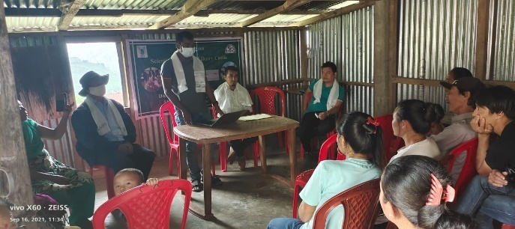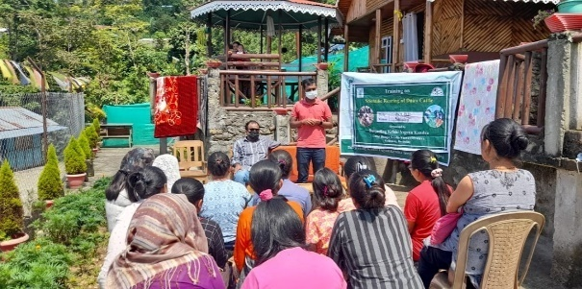

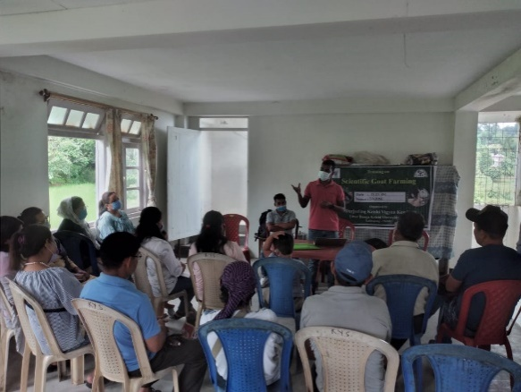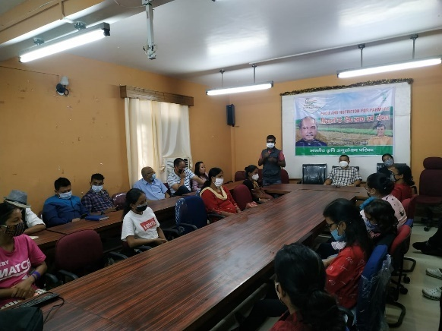

## Please furnish the details of training programmes as Annexure in the proforma given below

|  |  |  |  |  |  |  |  |  |  |  |
| --- | --- | --- | --- | --- | --- | --- | --- | --- | --- | --- |
| Discipline | Clientele | Title of the training programme | Duration in days | Venue (Off / On Campus) | Number of participants | | | Number of SC/ST | | |
| Male | Female | Total | Male | Female | Total |
| Plant  Protection | PF | Disease and pest management of vegetable crops | 1 | ON | 0 | 26 | 26 | 0 | 13 | 13 |
| Plant  Protection | RY | Promotion of bee keeping in hill agriculture | 1 | OFF | 25 | 0 | 25 | 17 | 0 | 17 |
| Plant  Protection | RY | Promotion of bee keeping in hill agriculture | 2 | ON | 12 | 3 | 15 | 5 | 2 | 7 |
| Plant  Protection | PF | Eco-friendly management of major pest & diseases of mandarin orange | 1 | ON | 10 | 10 | 20 | 8 | 2 | 10 |
| Plant  Protection | RY | Promotion of bee keeping in hill agriculture | 2 | OFF | 1 | 8 | 9 | 1 | 8 | 9 |
| Horticulture | PF | Package and Practices of Round chillies cultivation | 1 | off | 10 | 16 | 26 | 10 | 13 | 23 |
| Horticulture | PF | Package and Practice of Ginger Cultivation | 1 | ON | 19 | 6 | 25 | 9 | 2 | 11 |
| Horticulture | PF | Package and Practice of Cole crops Cultivation -Cabbage,Cauliflower and BROCOLLI | 1 | OFF | 5 | 21 | 26 | 3 | 20 | 23 |
| Horticulture | PF | Package and Practice of Round Chillies cultivation | 1 | OFF | 10 | 16 | 26 | 8 | 15 | 24 |
| Horticulture | PF | Package and Practice of Different floricultural crops | 2 | off | 13 | 15 | 28 | 2 | 3 | 5 |
| Horticulture | PF | Package and Practice of ginger cultivation | 1 | off | 3 | 26 | 29 | 3 | 13 | 16 |
| Horticulture | PF | Package and practice of Ginger cultivation | 1 | OFF | 8 | 3 | 11 | 2 | 0 | 2 |
| Horticulture | PF | Package and practice of Green gram cultivation | 1 | OFF | 17 | 10 | 27 | 9 | 7 | 15 |
| Horticulture | PF | Package and practice of Green gram cultivation | 1 | OFF | 9 | 3 | 12 | 1 | 1 | 2 |
| Horticulture | PF | Package and Practice of Round chili cultivation | 1 | OFF | 14 | 3 | 17 | 0 | 0 | 0 |
| Horticulture | PF | Package and Practice of Brocolli cultivation | 1 | OFF | 3 | 15 | 18 | 1 | 4 | 5 |
| Horticulture | RY | Round the year cultivation of Round chillies in low cost polyhouse | 1 | OFF | 9 | 16 | 25 | 6 | 7 | 13 |
| Horticulture | PF | Cultivation aspects of Guava and citrus | 1 | on | 19 | 16 | 35 | 4 | 6 | 10 |
| Horticulture | PF | Package and Practice of Mandarin cultivation | 1 | OFF | 10 | 0 | 10 | 0 | 0 | 0 |
| Horticulture | PF | Seed preservation Techniques on Green Gram cultivation | 1 | OFF | 7 | 3 | 10 | 0 | 1 | 1 |
| Animal Science | PF | Winter management of livestock and poultry under SCSP | 1 | OFF | 17 | 22 | 39 | 14 | 17 | 31 |
| Animal Science | PF | Scientific Poultry Farming | 1 | ON | 0 | 26 | 26 | 0 | 13 | 13 |
| Animal Science | PF | Role of Animal Husbandary in Rural Economy | 1 | OFF | 20 | 30 | 50 | 16 | 19 | 35 |
| Animal Science | PF | Care and Management of Liviestock during Monsoon | 1 | OFF | 8 | 3 | 11 | 2 | 0 | 2 |
| Animal Science | PF | Scientific Rearing of Dairy Cattle | 1 | OFF | 10 | 13 | 23 | 3 | 3 | 6 |
| Animal Science | PF | Scientific Goat farming | 1 | OFF | 6 | 9 | 15 | 4 | 2 | 5 |
| Animal Science | PF | Scientific Rearing of Dairy Cattle | 1 | OFF | 8 | 18 | 26 | 1 | 10 | 11 |
| Animal Science | PF | Scientific Rearing of Dairy Cattle | 1 | OFF | 14 | 9 | 23 | 3 | 2 | 5 |
| Animal Science | PF | Scientific Rearing of Dairy Cattle | 1 | OFF | 17 | 1 | 18 | 2 | 0 | 2 |
| Animal Science | PF | Scientific Rearing of Dairy Cattle | 1 | OFF | 4 | 4 | 8 | 3 | 2 | 5 |
| Animal Science | PF | backyard poultry farming | 1 | off | 6 | 7 | 13 | 1 | 3 | 4 |
| Soil Science | PF | Importance of Soil Testing and Soil Sample Collection Technique (practical on field) | 1 | OFF | 14 | 12 | 26 | 3 | 2 | 5 |
| Soil Science | PF | Training on vermi-compost production under SCSP | 1 | OFF | 14 | 18 | 32 | 12 | 16 | 28 |
| Soil Science | PF | Collection technique of Soil Sample for Soil testing | 1 | OFF | 10 | 16 | 26 | 3 | 8 | 11 |
| Soil Science | PF | Collection technique and processing of Soil Sample for Testing | 1 | OFF | 15 | 24 | 39 | 2 | 2 | 4 |
| Soil Science | PF | Collection technique and processing of Soil Sample for Testing | 1 | OFF | 17 | 25 | 42 | 17 | 15 | 32 |
| Soil Science | PF | Scientific Methods of Vermicompost Production | 1 | OFF | 8 | 3 | 11 | 2 | 0 | 2 |
| Soil Science | PF | Training on CFLD - Oilseed, Soybean production | 1 | OFF | 13 | 13 | 26 | 4 | 1 | 5 |
| Soil Science | PF | Importance of Organic matter and bio-fertilizer to increase soil fertility and crop production | 1 | OFF | 14 | 3 | 17 | 0 | 0 | 0 |
| Soil Science | PF | Training on scientific method of vermi compost production and its uses | 1 | OFF | 12 | 14 | 26 | 7 | 5 | 12 |
| Soil Science | EF | Application of Bio-fertilizer and organic matter for crop production and sustainability of soil | 1 | OFF | 37 | 3 | 40 | 10 | 1 | 11 |
| Soil Science | PF | Training on Oil seeds cultivation for Soil health Management with Seeds Distribution | 1 | OFF | 9 | 10 | 19 | 6 | 9 | 15 |
| Soil Science | PF | Distribution cum training program on Oilseed cultivation for soil health manangent | 1 | OFF | 5 | 14 | 19 | 4 | 14 | 20 |

## H) Vocational training programmes for Rural Youth : NIL

## a) Details of training programmes for Rural Youth

|  |  |  |  |  |  |  |  |  |  |  |
| --- | --- | --- | --- | --- | --- | --- | --- | --- | --- | --- |
| Crop / Enterprise | Identified Thrust Area | Training title* | Duration (days) | No. of Participants | | | Self employed after training | | | Number of persons employed else where |
| Male | Female | Total | Type of units | Number  of units | Number of persons employed |  |
|  |  |  |  |  |  |  |  |  |  |  |
|  |  |  |  |  |  |  |  |  |  |  |

*training title should specify the major technology /skill transferred

b) Details of participation

|  |  |  |  |  |  |  |  |  |  |  |  |  |  |  |
| --- | --- | --- | --- | --- | --- | --- | --- | --- | --- | --- | --- | --- | --- | --- |
| **Thematic Area** | **No. of Courses** | **No. of Participants** | | | | | | | | | **Grand Total** | | | |
| **Other** | | | **SC** | | | **ST** | | |
|  | **M** | **F** | **T** | **M** | **F** | **T** | **M** | **F** | **T** | **M** | **F** | | **T** |
| **Crop production and management** |  |  |  |  |  |  |  |  |  |  |  | |  |  |
| Commercial floriculture |  |  |  |  |  |  |  |  |  |  |  | |  |  |
| Commercial fruit production |  |  |  |  |  |  |  |  |  |  |  | |  |  |
| Commercial vegetable production |  |  |  |  |  |  |  |  |  |  |  | |  |  |
| Integrated crop management |  |  |  |  |  |  |  |  |  |  |  | |  |  |
| Organic farming |  |  |  |  |  |  |  |  |  |  |  | |  |  |
| Other |  |  |  |  |  |  |  |  |  |  |  | |  |  |
| **Total** |  |  |  |  |  |  |  |  |  |  |  | |  |  |
| **Post harvest technology and value addition** |  |  |  |  |  |  |  |  |  |  |  | |  |  |
| Value addition |  |  |  |  |  |  |  |  |  |  |  | |  |  |
| Other |  |  |  |  |  |  |  |  |  |  |  | |  |  |
| **Total** |  |  |  |  |  |  |  |  |  |  |  | |  |  |
| **Livestock and fisheries** |  |  |  |  |  |  |  |  |  |  |  | |  |  |
| Dairy farming |  |  |  |  |  |  |  |  |  |  |  | |  |  |
| Composite fish culture |  |  |  |  |  |  |  |  |  |  |  | |  |  |
| Sheep and goat rearing |  |  |  |  |  |  |  |  |  |  |  | |  |  |
| Piggery |  |  |  |  |  |  |  |  |  |  |  | |  |  |
| Poultry farming |  |  |  |  |  |  |  |  |  |  |  | |  |  |
| Other |  |  |  |  |  |  |  |  |  |  |  | |  |  |
| **Total** |  |  |  |  |  |  |  |  |  |  |  | |  |  |
| **Income generation activities** |  |  |  |  |  |  |  |  |  |  |  | |  |  |
| Vermicomposting |  |  |  |  |  |  |  |  |  |  |  | |  |  |
| Production of bioagents, biopesticides, |  |  |  |  |  |  |  |  |  |  |  | |  |  |
| biofertilizers etc. |  |  |  |  |  |  |  |  |  |  |  | |  |  |
| Repair and maintenance of farm machinery &imlements |  |  |  |  |  |  |  |  |  |  |  | |  |  |
| Rural Crafts |  |  |  |  |  |  |  |  |  |  |  | |  |  |
| Seed production |  |  |  |  |  |  |  |  |  |  |  | |  |  |
| Sericulture |  |  |  |  |  |  |  |  |  |  |  | |  |  |
| Mushroom cultivation |  |  |  |  |  |  |  |  |  |  |  | |  |  |
| Nursery, grafting etc. |  |  |  |  |  |  |  |  |  |  |  | |  |  |
| Tailoring, stitching, embroidery, dying etc. |  |  |  |  |  |  |  |  |  |  |  | |  |  |
| Agril. Para-workers, para0vet training |  |  |  |  |  |  |  |  |  |  |  | |  |  |
| Other |  |  |  |  |  |  |  |  |  |  |  | |  |  |
| **Total** |  |  |  |  |  |  |  |  |  |  |  | |  |  |
| **Agricultural Extension** |  |  |  |  |  |  |  |  |  |  |  | |  |  |
| Capacity building and group dynamics |  |  |  |  |  |  |  |  |  |  |  | |  |  |
| Other |  |  |  |  |  |  |  |  |  |  |  | |  |  |
| **Total** |  |  |  |  |  |  |  |  |  |  |  | |  |  |
| **Grand Total** |  |  |  |  |  |  |  |  |  |  |  | |  |  |

**I) Sponsored Training Programmes**

a) Details of Sponsored Training Programme

|  |  |  |  |  |  |  |  |  |
| --- | --- | --- | --- | --- | --- | --- | --- | --- |
| Sl.No | Title | Thematic area | Month | Duration (days) | Client | No. of courses | No. of participants | Sponsoring Agency |
| PF/RY/EF |
| 1 | Scientific Mushroom cultivation | Crop Production | 07-01-2021 | 1 | RY | 1 | 26 | DAESI |
| 2 | Promotion of Bee keeping in hill agriculture | Apiculture | 19-01-2021 | 1 | RY | 1 | 16 | DAESI |
| 3 | Feeding of pigs | Animal Science | 13-01-2012 | 1 | PF | 1 | 26 | DAESI |
| 4 | Scientific poultry farming | Animal Science | 08-01-2021 | 1 | PF | 1 | 26 | DAESI |
| 5 | Scientific poultry farming | Animal Science | 20-01-2021 | 1 | PF | 1 | 16 | DAESI |
| 6 | Package and practices of Cereals and Pulses crop | Crop Production | 19-03-2021 | 1 | EF | 1 | 40 | DAESI |
| 7 | Scientific Mushroom cultivation | Crop Production | 07-01-2021 | 1 | RY | 1 | 26 | DAESI |
| 8 | Scientific Poultry Production | Animal Science | 03.02.2021 | 1 | PF | 1 | 32 | ATMA |
| 9 | Integrated Farming System | IFS | 04.02.2021 | 1 | PF | 1 | 32 | ATMA |
| 10 | Role of Micro-nutrients in crop and its management for improving crop production | Crop Production | 26-04-2021 | 1 | EF | 1 | 40 | DAESI |
| 11 | Seed quality production method and certification | Seed Production | 07-05-2021 | 1 | EF | 1 | 40 | DAESI |
| 12 | Identification and management of different types of diseases on Rice Crop | IPM | 04-06-2021 | 1 | EF | 1 | 40 | DAESI |
| 13 | Micronutrient fertilizer - There sources uses and benefits | Crop Production | 02-07-2021 | 1 | EF | 1 | 40 | DAESI |
| 14 | Resource Conservation Technologies - future of indian agriculture | Crop Production | 06-08-2021 | 1 | EF | 1 | 40 | DAESI |
| 15 | Scientific method of vermicompost production and uses of vermi-compost for farming community | Vermi Compost | 10-09-2021 | 1 | EF | 1 | 40 | DAESI |
| 16 | Traiing on collection techniques of soil sample for testing | Soil Testing | 10-09-2021 | 1 | EF | 1 | 39 | DAESI |
| 17 | Scientific Rearing of Dairy Cattle | Animal Science | 24-09-2021 | 1 | PF | 1 | 16 | DAESI |
| 18 | Cultivation of important meditional and aeromatic plants | Medicinal Plant | 01-10-2021 | 1 | EF | 1 | 40 | DAESI |
| 19 | Balance Use of Fertilizer for Better Production & soil Health Managment | Soil Health | 27.11.2021 | 1 | PF | 1 | 22 | DAESI |
| 20 | Backyard poultry farming | Animal Science | 27.11.2021 | 1 | PF | 1 | 28 | NGO |
| 21 | Package and practices of Dragon fruits and Strawberry | Fruit Production | 03-11-2021 | 1 | EF | 1 | 40 | DAESI |
| 22 | Training on impotance of organic matter to increase the soil fertility and productivity of soil | Soil Health | 07-12-2021 | 1 | PF | 1 | 12 | DAESI |
| 23 | Fertilizer calculation with scientific pest and diseases management in Chilli | Soil Health | 10-12-2021 | 1 | EF | 1 | 40 | DAESI |

b) Details of participation

|  |  |  |  |  |  |  |  |  |  |  |  |  |  |  |
| --- | --- | --- | --- | --- | --- | --- | --- | --- | --- | --- | --- | --- | --- | --- |
| **Thematic Area** | **No. of Courses** | **No. of Participants** | | | | | | | | | **Grand Total** | | | |
| **Other** | | | **SC** | | | **ST** | | |
|  | **M** | **F** | **T** | **M** | **F** | **T** | **M** | **F** | **T** | **M** | **F** | | **T** |
| **Crop production and management** |  |  |  |  |  |  |  |  |  |  |  | |  |  |
| Increasing production and productivity of crops |  |  |  |  |  |  |  |  |  |  |  | |  |  |
| Commercial production of vegetables |  |  |  |  |  |  |  |  |  |  |  | |  |  |
| Production and value addition |  |  |  |  |  |  |  |  |  |  |  | |  |  |
| Fruit Plants |  |  |  |  |  |  |  |  |  |  |  | |  |  |
| Ornamental plants |  |  |  |  |  |  |  |  |  |  |  | |  |  |
| Spices crops |  |  |  |  |  |  |  |  |  |  |  | |  |  |
| Soil health and fertility management |  |  |  |  |  |  |  |  |  |  |  | |  |  |
| Production of Inputs at site |  |  |  |  |  |  |  |  |  |  |  | |  |  |
| Methods of protective cultivation |  |  |  |  |  |  |  |  |  |  |  | |  |  |
| Other |  |  |  |  |  |  |  |  |  |  |  | |  |  |
| Total |  |  |  |  |  |  |  |  |  |  |  | |  |  |
| **Post harvest technology and value addition** |  |  |  |  |  |  |  |  |  |  |  | |  |  |
| Processing and value addition |  |  |  |  |  |  |  |  |  |  |  | |  |  |
| Other |  |  |  |  |  |  |  |  |  |  |  | |  |  |
| Total |  |  |  |  |  |  |  |  |  |  |  | |  |  |
| **Farm machinery** |  |  |  |  |  |  |  |  |  |  |  | |  |  |
| Farm machinery, tools and implements |  |  |  |  |  |  |  |  |  |  |  | |  |  |
| Other |  |  |  |  |  |  |  |  |  |  |  | |  |  |
| Total |  |  |  |  |  |  |  |  |  |  |  | |  |  |
| **Livestock and fisheries** |  |  |  |  |  |  |  |  |  |  |  | |  |  |
| Livestock production and management |  |  |  |  |  |  |  |  |  |  |  | |  |  |
| Animal Nutrition Management |  |  |  |  |  |  |  |  |  |  |  | |  |  |
| Animal Disease Management |  |  |  |  |  |  |  |  |  |  |  | |  |  |
| Fisheries Nutrition |  |  |  |  |  |  |  |  |  |  |  | |  |  |
| Fisheries Management |  |  |  |  |  |  |  |  |  |  |  | |  |  |
| Other |  |  |  |  |  |  |  |  |  |  |  | |  |  |
| Total |  |  |  |  |  |  |  |  |  |  |  | |  |  |
| **Home Science** |  |  |  |  |  |  |  |  |  |  |  | |  |  |
| Household nutritional security |  |  |  |  |  |  |  |  |  |  |  | |  |  |
| Economic empowerment of women |  |  |  |  |  |  |  |  |  |  |  | |  |  |
| Drudgery reduction of women |  |  |  |  |  |  |  |  |  |  |  | |  |  |
| Other |  |  |  |  |  |  |  |  |  |  |  | |  |  |
| Total |  |  |  |  |  |  |  |  |  |  |  | |  |  |
| **Agricultural Extension** |  |  |  |  |  |  |  |  |  |  |  | |  |  |
| Capacity Building and Group Dynamics |  |  |  |  |  |  |  |  |  |  |  | |  |  |
| Other |  |  |  |  |  |  |  |  |  |  |  | |  |  |
| **Total** |  |  |  |  |  |  |  |  |  |  |  | |  |  |
| **Grant Total** |  |  |  |  |  |  |  |  |  |  |  | |  |  |

3.4. A. Extension Activities (including activities of FLD programmes)

|  |  |  |  |  |  |  |  |  |  |  |  |  |
| --- | --- | --- | --- | --- | --- | --- | --- | --- | --- | --- | --- | --- |
| Activity | No. |  | SC |  |  | ST |  |  | Others |  | Total | |
|  |  | M | F | T | M | F | T | M | F | T | Male | Female |
| Field Day | 1 | 0 | 0 | 0 | 0 | 1 | 1 | 5 | 2 | 9 | 9 | 3 |
| Kisan Gosthi | 1 | 0 | 0 | 0 | 1 | 6 | 7 | 4 | 5 | 9 | 5 | 11 |
| Kisan Mela | 0 | 0 | 0 | 0 | 0 | 0 | 0 | 0 | 0 | 0 | 0 | 0 |
| Scientist Visit to Farmers Field | 52 | 17 | 21 | 34 | 32 | 21 | 47 | 80 | 37 | 116 | 127 | 84 |
| Farmers Visit to KVK | 18 | 2 | 0 | 0 | 5 | 0 | 5 | 15 | 4 | 18 | 21 | 5 |
| Other Extension Activities | 3 | 5 | 10 | 15 | 1 | 14 | 15 | 0 | 35 | 35 | 6 | 69 |
| Kisan Mobile Advisory | 0 | 0 | 0 | 0 | 0 | 0 | 0 | 0 | 0 | 0 | 0 | 0 |
| Exhibition | 0 | 0 | 0 | 0 | 0 | 0 | 0 | 0 | 0 | 0 | 0 | 0 |
| Film Show | 1 | 0 | 0 | 0 | 0 | 13 | 13 | 0 | 13 | 13 | 0 | 26 |
| Method Demonstrations | 8 | 56 | 70 | 126 | 43 | 31 | 74 | 4 | 8 | 12 | 103 | 109 |
| Farmers Seminar | 1 | 18 | 11 | 29 | 6 | 4 | 10 | 6 | 8 | 14 | 30 | 23 |
| Workshop | 0 | 0 | 0 | 0 | 0 | 0 | 0 | 0 | 0 | 0 | 0 | 0 |
| Group meetings | 2 | 0 | 0 | 0 | 4 | 5 | 9 | 6 | 9 | 15 | 10 | 13 |
| Lectures delivered as resource persons | 44 | 136 | 133 | 269 | 123 | 354 | 477 | 225 | 142 | 367 | 463 | 615 |
| Advisory Services | 1 | 0 | 0 | 0 | 0 | 13 | 13 | 0 | 13 | 13 | 0 | 26 |
| Diagnostic visits | 3 | 1 | 1 | 2 | 1 | 3 | 3 | 6 | 3 | 9 | 8 | 7 |
| Exposure visits | 1 | 1 | 0 | 0 | 0 | 0 | 0 | 11 | 0 | 11 | 12 | 0 |
| Ex-trainees Sammelan | 0 | 0 | 0 | 0 | 0 | 0 | 0 | 0 | 0 | 0 | 0 | 0 |
| Soil health Camp | 0 | 0 | 0 | 0 | 0 | 0 | 0 | 0 | 0 | 0 | 0 | 0 |
| Animal Health Camp | 1 | 0 | 0 | 0 | 0 | 0 | 0 | 0 | 0 | 0 | 8 | 18 |
| Agri mobile clinic | 2 | 0 | 0 | 0 | 1 | 0 | 0 | 0 | 0 | 0 | 9 | 3 |
| Soil test campaigns | 1 | 2 | 0 | 2 | 7 | 0 | 7 | 16 | 0 | 16 | 25 | 0 |
| Farm Science Club Conveners meet | 0 | 0 | 0 | 0 | 0 | 0 | 0 | 0 | 0 | 0 | 0 | 0 |
| Self Help Group Conveners meetings | 0 | 0 | 0 | 0 | 0 | 0 | 0 | 0 | 0 | 0 | 0 | 0 |
| Mahila Mandals Conveners meetings | 0 | 0 | 0 | 0 | 0 | 0 | 0 | 0 | 0 | 0 | 0 | 0 |
| World Soil Health Day | 3 | 6 | 7 | 13 | 8 | 12 | 20 | 18 | 30 | 48 | 32 | 49 |
| Farmers' scientist interaction | 1 | 0 | 2 | 2 | 0 | 0 | 0 | 10 | 1 | 11 | 10 | 3 |
| TOTAL | **144** | **244** | **255** | **492** | **232** | **477** | **701** | **406** | **310** | **716** | **878** | **1064** |

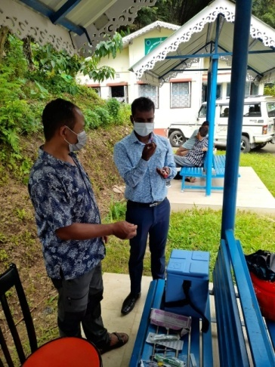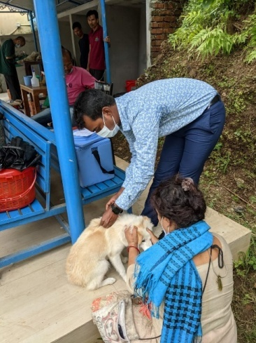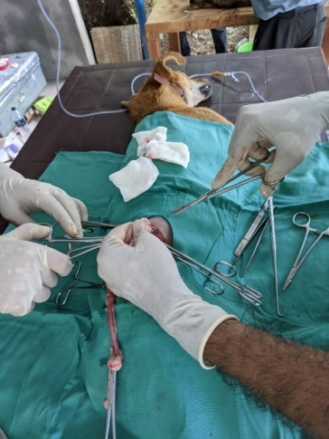

Vaccination and ABC Camp

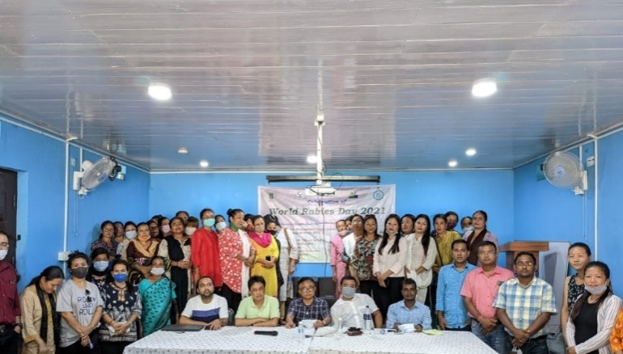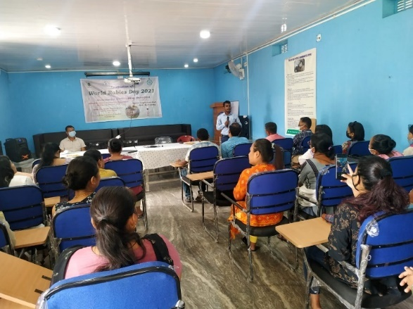

Celebration of World Rabies Day

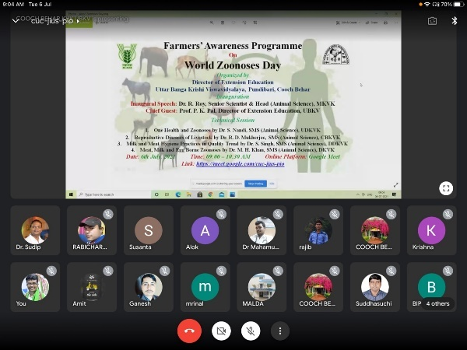 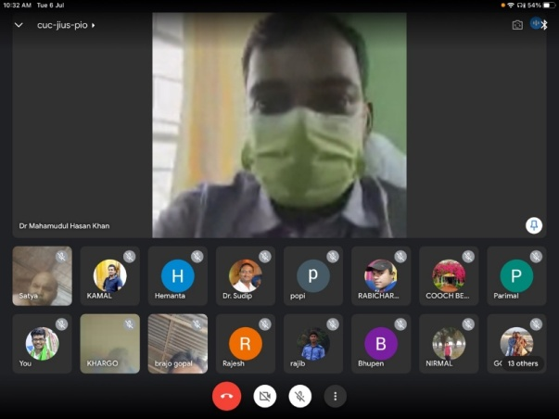

Celebration of World Zoonones Day

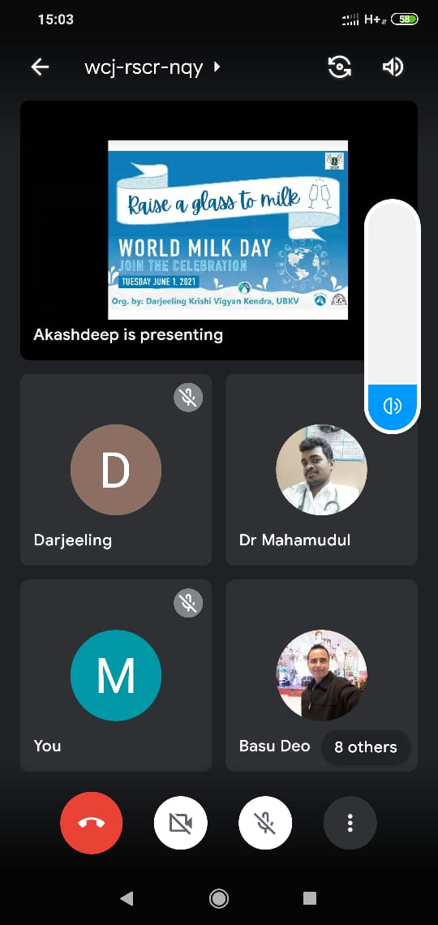

B. Other Extension activities

|  |  |
| --- | --- |
| **Nature of Extension Activity** | **No. of activities** |
|
| Newspaper coverage | -- |
| Radio talks | 2 |
| TV talks | -- |
| Popular articles | -- |
| Extension Literature | 5 |
| Other, if any | -- |

**3.5 a. Production and supply of Technological products**

***Village seed***

|  |  |  |  |  |  |  |  |  |  |  |  |  |
| --- | --- | --- | --- | --- | --- | --- | --- | --- | --- | --- | --- | --- |
| Crop | Variety | Quantity of seed  (q) | Value  (Rs) | No. of farmers involved in village seed production | Number of farmers  to whom seed provided | | | | | | | |
|  |  |  |  |  | SC | | ST | | Other | | Total | |
|  |  |  |  |  | M | F | M | F | M | F | M | F |
|  |  |  |  |  |  |  |  |  |  |  |  |  |
| Total |  |  |  |  |  |  |  |  |  |  |  |  |

# *KVK farm*

|  |  |  |  |  |  |  |  |  |  |  |  |
| --- | --- | --- | --- | --- | --- | --- | --- | --- | --- | --- | --- |
| Crops | Variety | Quantity of seed (q) | Value (Rs) | Number of farmers to whom seed provided | | | | | | | |
| SC | | ST | | Others | | Total | |
| M | F | M | F | M | F | M | F |
| Maize | Kaveri | 40 kg | 1200/- | 3 | - | 3 | - | - | 2 | 6 | 2 |
| Ginger | Gorubathaney | 60 kg | 4200/- | 1 | - | 1 | - | 1 | - | 3 | - |
| Turmeric | Paheli (Local) | 50 kg | 2000/- | 1 | 1 | 1 | - | 1 | 1 | 3 | 2 |
| Potato | Kanchan | 80 kg | 2800/- | - | 2 | - | 2 | 2 | 2 | 4 | 4 |
| G.Total |  | 230 kg | 10200/- | 5 | 3 | 5 | 2 | 4 | 5 | 16 | 8 |

Production of planting materials by the KVK’s

|  |  |  |  |  |  |  |  |  |  |  |  |
| --- | --- | --- | --- | --- | --- | --- | --- | --- | --- | --- | --- |
| Crops | Variety | Quantity of seed (q) | Value (Rs) | Number of farmers to whom planting materials provided | | | | | | | |
| SC | | ST | | Others | | Total | |
| M | F | M | F | M | F | M | F |
| 1.  Vegetables Seedlings |  |  |  |  |  |  |  |  |  |  |  |
| 1. Cabbage | Rareball | 7000 | 7000 | 2 | 2 | 2 | 2 | 2 | 2 | 6 | 6 |
| 1. Cauliflower | Madhuri | 7000 | 7000 | 3 | 3 | 2 | - | 2 | 2 | 7 | 5 |
| 1. Brocolli | Green magic | 4000 | 4000 | 3 | - | 3 | 3 | - | 3 | 6 | 6 |
| 1. Radish | Pusa Reshmi | 3000 | 3000 | 2 | 2 | - | 3 | 3 | - | 5 | 5 |
| II  Fruits |  |  |  |  |  |  |  |  |  |  |  |
| 1. Kiwi | Allison | 1 unit (Nine plants) | 1350 | - | - | - | - | 1 | - | 1 | 0 |
| III.  Plantation |  |  |  |  |  |  |  |  |  |  |  |
| 1. Zinger | Gorubathaney | 60 kg | 4200 | 1 | - | 1 | - | 1 | - | 3 | 0 |
| 1. Turmeric | Paheli (Local) | 50 kg | 2000 | 1 | 1 | 1 | - | 1 | 1 | 3 | 2 |
| IV.  Fodder crop saplings |  |  |  |  |  |  |  |  |  |  |  |
| 1. Broomstick | Local | 3500 | 17500 | 3 | 2 | 3 | 2 | 2 | 2 | 8 | 6 |
| **Total** |  |  |  | 15 | 10 | 12 | 10 | 12 | 10 | 39 | 30 |

**Production of Bio-Products**

|  |  |  |  |  |  |  |  |  |  |  |
| --- | --- | --- | --- | --- | --- | --- | --- | --- | --- | --- |
| Name of product | Quantity | Value (Rs.) | No. of Farmers benefitted | | | | | | | |
| Kg |
|  |  |  | SC | | ST | | Other | | Total | |
|  |  |  | M | F | M | F | M | F | M | F |
| Bio-fertilizers |  |  |  |  |  |  |  |  |  |  |
| Bio-pesticide |  |  |  |  |  |  |  |  |  |  |
| Bio-fungicide |  |  |  |  |  |  |  |  |  |  |
| Bio-agents |  |  |  |  |  |  |  |  |  |  |
| Others, please specify. |  |  |  |  |  |  |  |  |  |  |
| Total |  |  |  |  |  |  |  |  |  |  |

# Production of livestock materials

|  |  |  |  |  |  |  |  |  |  |  |  |
| --- | --- | --- | --- | --- | --- | --- | --- | --- | --- | --- | --- |
| Particulars of Live stock | Name of the breed | Number | Value (Rs.) | No. of Farmers benefitted | | | | | | | |
|  |  |  |  | SC | | ST | | Other | | Total | |
|  |  |  |  | M | F | M | F | M | F | M | F |
| Dairy animals |  |  |  |  |  |  |  |  |  |  |  |
| Cows |  |  |  |  |  |  |  |  |  |  |  |
| Buffaloes |  |  |  |  |  |  |  |  |  |  |  |
| Calves |  |  |  |  |  |  |  |  |  |  |  |
| Others (Pl. specify) |  |  |  |  |  |  |  |  |  |  |  |
| Small ruminants |  |  |  |  |  |  |  |  |  |  |  |
| Sheep |  |  |  |  |  |  |  |  |  |  |  |
| Goat |  |  |  |  |  |  |  |  |  |  |  |
| Other, please specify |  |  |  |  |  |  |  |  |  |  |  |
| Poultry |  |  |  |  |  |  |  |  |  |  |  |
| Broilers |  |  |  |  |  |  |  |  |  |  |  |
| Layers |  |  |  |  |  |  |  |  |  |  |  |
| Duals (broiler and layer) |  |  |  |  |  |  |  |  |  |  |  |
| Japanese Quail |  |  |  |  |  |  |  |  |  |  |  |
| Turkey |  |  |  |  |  |  |  |  |  |  |  |
| Emu |  |  |  |  |  |  |  |  |  |  |  |
| Ducks |  |  |  |  |  |  |  |  |  |  |  |
| Others (Pl. specify) |  |  |  |  |  |  |  |  |  |  |  |
| Piggery |  |  |  |  |  |  |  |  |  |  |  |
| Piglet |  |  |  |  |  |  |  |  |  |  |  |
| Hog |  |  |  |  |  |  |  |  |  |  |  |
| Others (Pl. specify) |  |  |  |  |  |  |  |  |  |  |  |
| Fisheries |  |  |  |  |  |  |  |  |  |  |  |
| Indian carp |  |  |  |  |  |  |  |  |  |  |  |
| Exotic carp |  |  |  |  |  |  |  |  |  |  |  |
| Mixed carp |  |  |  |  |  |  |  |  |  |  |  |
| Fish fingerlings |  |  |  |  |  |  |  |  |  |  |  |
| Spawn |  |  |  |  |  |  |  |  |  |  |  |
| Others (Pl. specify) |  |  |  |  |  |  |  |  |  |  |  |
| Grand Total |  |  |  |  |  |  |  |  |  |  |  |

**3.5. b. Seed Hub Programme-*“Creation of Seed Hubs for Increasing Indigenous Production of Pulses in India”***

i) Name of Seed Hub Centre:

|  |  |
| --- | --- |
| Name of Nodal Officer : |  |
| Address : |  |
| e-mail : |  |
| Phone No. :  Mobile : |  |

ii) Quality Seed Production Reports

|  |  |  |  |  |  |  |
| --- | --- | --- | --- | --- | --- | --- |
| Season | Crop | Variety | Production (q) | | | |
| Target | Area sown (ha) | Production | Category of Seed  (F/S, C/S) |
| Kharif 2020 |  |  |  |  |  |  |
|  |  |  |  |  |  |  |
| Rabi 2020-21 |  |  |  |  |  |  |
|  |  |  |  |  |  |  |
| Summer/Spring 2021 |  |  |  |  |  |  |
| Kharif 2021 |  |  |  |  |  |  |
| Rabi 2021-2022 |  |  |  |  |  |  |

iii) Financial Progress

|  |  |  |  |  |
| --- | --- | --- | --- | --- |
| Fund received  (2017-18, 2018-19, 2019-20, 2020-21, 2021-22) | Expenditure (Rs. in lakh) | | Unspent balance  (Rs. in lakhs) | Remarks |
| Infrastructure | Revolving fund |
| 2017-18 |  |  |  |  |
| 2018-19 |  |  |  |  |
| 2019-20 |  |  |  |  |
| 2020-2021 |  |  |  |  |
| 2021-2022 |  |  |  |  |

iv) Infrastructure Development

|  |  |
| --- | --- |
| Item | Progress |
| Seed processing unit |  |
| Seed storage structure |

3.6. (A) Literature Developed/Published (with full title, author & reference)

|  |  |  |  |  |
| --- | --- | --- | --- | --- |
| Item | Title | Author’s name | Number | Circulation |
| Research paper | Performance of different mustard variety in Terai Zone of West Bengal | P. Barma, H K Tarafdar, R Sarkar, M W Moktan |  |  |
| Seminar/conference/ symposia papers |  |  |  |  |
| Books |  |  |  |  |
| Bulletins |  |  |  |  |
| News letter |  |  |  |  |
| Popular Articles |  |  |  |  |
| Book Chapter |  |  |  |  |
| Extension Pamphlets/ literature |  |  |  |  |
| Technical reports |  |  |  |  |
| Electronic Publication (CD/DVD etc) |  |  |  |  |
| TOTAL |  |  |  |  |

N.B.: Please enclose a copy of each. In case of literature prepared in local language please indicate the title in English

(B) Details of HRD programmes undergone by KVK personnel:

|  |  |  |  |  |  |
| --- | --- | --- | --- | --- | --- |
| Sl. No. | Name of programme | Name of course | Name of KVK personnel and designation | Date and Duration | Organized by |
| 1. |  |  |  |  |  |
| 2. |  |  |  |  |  |
| 3. |  |  |  |  |  |
| 4. |  |  |  |  |  |
| 5. |  |  |  |  |  |
| 6. |  |  |  |  |  |
| 7. |  |  |  |  |  |

3.7. Success stories/Case studies, if any (two or three pages write-up on 1-2best case(s) with suitable action photographs)

|  |  |
| --- | --- |
| Name of farmer | Sumesh Tirwa |
| Address | Tirwa Gaon ,Chibbo ,Kalimpong |
| Contact details (Phone, mobile, email Id) | 7602424044 |
| Landholding (in acre.) | 0.30 |
| Name and description of the farm/ enterprise | Tirwa Nursery  Floriculture –Succluents, cactus , ferns Bromeloids etc |
| Economic impact | Annual Turnover of 3,50,000/- |
| Social impact | He owns Nursery Tirwa Nursery he utilizes the earnings to meet his family expenses. |

**Floriculture-a profitable business in Hills**

|  |  |
| --- | --- |
| Name of farmer | Sumesh Tirwa |
| Address | Tirwa Gaon ,Chhibo Busty , Kalimpong |
| Age | 25 years |
| Education | 12 th pass |
| Size of land holdings | 30 Decimals |
| Mobile no | 7602424044 |

  
Kalimpong Hill is the natural habitat for innumerable plant species and thus much has been achieved till date by our floriculturists. Agro-climatic condition of Kalimpong is favourable for growing different types of flowers viz Alstromeria, Gerbera, Gladiolus, Anthurium , etc .

**Technology, Implementation and Support :**

Sumesh Tirwa from Tirwa Gaon upper Chibbo Kalimpong ,PO Kalimpong ,PS Kalimpong(7602424044 ) a young man after completing his studies of 12th standard and his hospitality courses was introduced in our KVK in the year2020.After attending two days training on Package and Practice for the cultivation of different flowers grown in Darjeeling Hills and also knowing about the Different activities of Horticulture faculty his interest in starting a floriculture nursery grew much stronger . He now cultivates different variety of flowers such as Azaelia, Bromeliads, Camelia , Ivy, Ferns ,orchid .cacti and succulents ,different varieties of summer and annuals etc.He is also helped by her husband to look after theday to day activities of the nursery.Her flowers are sold not only in the local market but she also manages to send her flowers to Kolkata, Assam, Delhi .

**Output and Outcome:**

* Her desire to cultivate flowers let to an establishment of a Floriculture nursery named Tirwa Nursery.
* He cultivates different variety of flowers such as Azaelia, Bromeliads, Camelia , Ivy, Ferns ,orchid .cacti and succulents ,different varieties of summer and annuals etc.
* Today he has become a successful businessmen who owns more than 3.5 lacsper year from her nursery he also gives employment two workers daily at a consolidated rate of 3000/- per month.

Mr Tirwa is one of our progressive farmer Even today he is in continuous contact with our KVK.He proves to be one of the best trainees our KVK ever had.

**FEW PHOTOGRAPHS OF THE NURSERY**

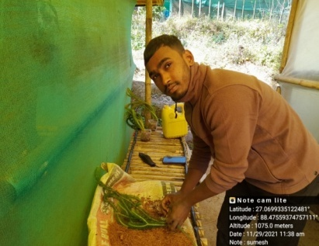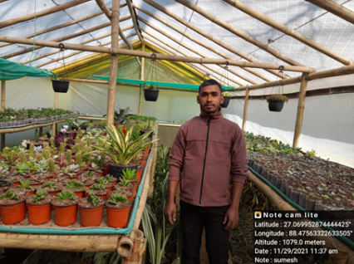

b. Give details of organic farming practiced by the farmer

|  |  |  |  |  |  |
| --- | --- | --- | --- | --- | --- |
| Sl. No. | Crop / Enterprise | Area (acre)/ No. covered | Production | No. of farmers involved | Market available (Y/N) |
| 01. | Organic seedling production | 1 | Tomato seedlings 4000 per month | 1 | Y |

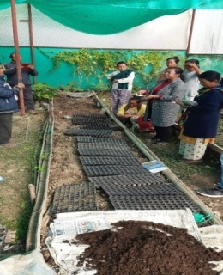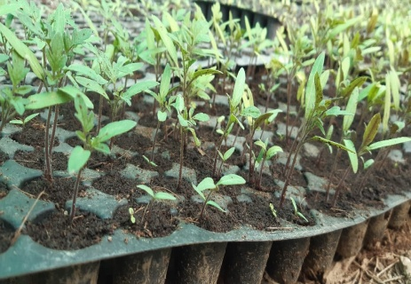

3.8. Give details of innovative methodology or innovative technology of Transfer of Technology developed and used during the year

|  |  |  |  |
| --- | --- | --- | --- |
| Sl. No. | Name/ Title of the technology | Name/ Details of the Innovator(s) | Brief details of the Innovative Technology |
|  |  |  |  |

3.9. a. Give details of indigenous technology practiced by the farmers in the KVK operational area which can be considered for technology development (in detail with suitable photographs)

|  |  |  |  |
| --- | --- | --- | --- |
| Sl. No. | Crop / Enterprise | ITK Practiced | Purpose of ITK |
|  |  |  |  |

b. Give details of organic farming practiced by the farmer

|  |  |  |  |  |  |
| --- | --- | --- | --- | --- | --- |
| Sl. No. | Crop / Enterprise | Area (ha)/ No. covered | Production | No. of farmers involved | Market available (Y/N) |
|  |  |  |  |  |  |

3.10. Indicate the specific training need analysis tools/methodology followed by KVKs

|  |  |  |
| --- | --- | --- |
| Sl. No. | Brief details of the tool/ methodology followed | Purpose for which the tool was followed |
|  |  |  |

3.11. a. Details of equipment available in Soil and Water Testing Laboratory

|  |  |  |
| --- | --- | --- |
| Sl. No | Name of the Equipment | Qty. |
| 1. | Spectrophotometer | 1 |
| 2. | Flame Photometer | 1 |
| 3. | PH Meter | 1 |
| 4. | Conductivity bridge | 1 |
| 5. | Physical balance | 1 |
| 6. | Chemical balance | 1 |
| 7. | Digestion unit | 1 |
| 8. | Kjeldhal Distillation set | 2 |
| 9. | Mechanical shaker | 1 |
| 10. | Refrigerator | 1 |
| 11. | Hot air oven | 1 |
| 12. | Hot plate | 1 |
| 13. | Grinder | 1 |
| 14. | Water distillation unit (double) | 1 |
| 15. | Chemical and Glass wares | 50 |
| 16. | Soxlet Apparatus (Big &Small) | 2 |
| 17. | Laboratory set up | 1 |
| 18. | Soil and plant sample processing and storage facility | 2 |
| Total | | 17 |

3.11.b. Details of samples analyzed so far :

|  |  |  |  |  |  |
| --- | --- | --- | --- | --- | --- |
| Number of soil samples analyzed | | | No. of Farmers | No. of Villages | Amount realized  (in Rs.) |
| Through mini soil testing kit/labs | Through soil testing laboratory | Total |  |  |  |
|  |  |  |  |  |  |
| -- | 29 | 29 | 29 | 3 | 7250/ |

3.11.c. Details on World Soil Day

|  |  |  |  |  |  |  |
| --- | --- | --- | --- | --- | --- | --- |
| Sl.  No. | Activity | No. of Participants | No. of VIPs | Name (s) of VIP(s) | Number of Soil Health Cards distributed | No. of farmers benefitted |
| 1 | Soil Health Card Distribution | 50 | - | - | 25 | 50 |
|  | And Training |  |  |  |  |  |

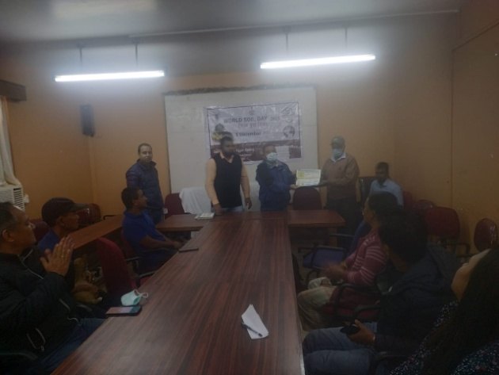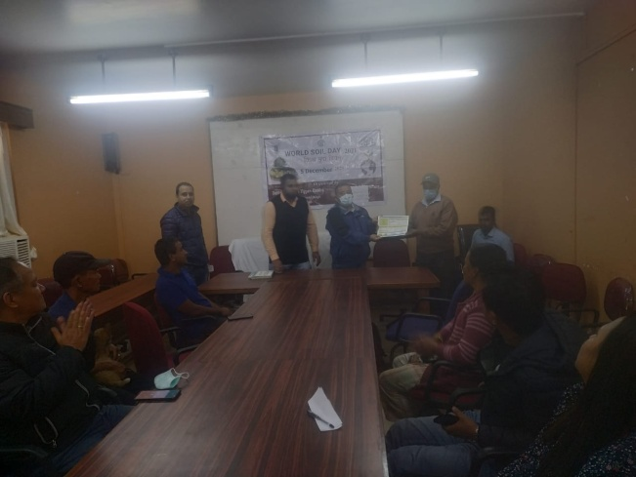

3.12. Activities of rain water harvesting structure and micro irrigation system

|  |  |  |  |  |
| --- | --- | --- | --- | --- |
| No of training programme | No of demonstrations | No of plant material produced | Visit by the farmers | Visit by the officials |
| -- | --- | -- | -- | -- |

3.13. Technology week celebration

|  |  |  |  |
| --- | --- | --- | --- |
| Type of activities | No. of activities | Number of participants | Related crop/livestock technology |
| -- | -- | -- | -- |

3.14. RAWE/ FET programme - is KVK involved? (Y/N)

|  |  |
| --- | --- |
| No of student trained | No of days stayed |
| 2 | 60 days |
| 5 | 30 days |
| 2 | 15 days |

|  |  |
| --- | --- |
| ARS trainees trained | No of days stayed |
| -- | -- |

3.15. List of VIP visitors (Minister/ MP/MLA/DM/VC/Zila Sabhadipati/Other Head of Organization/Foreigners)

|  |  |  |
| --- | --- | --- |
| Date | Name of the person | Purpose of visit |
| 06/12/2021 | A K Purahit  Scientist Ex-head, BIS, Kolkata II | Meeting with KVK Scientist |
|  |  |  |

1. IMPACT
   1. Impact of KVK activities (Not to be restricted for reporting period).

|  |  |  |  |  |
| --- | --- | --- | --- | --- |
| Name of specific technology/skill transferred | No. of participants | % of adoption | Change in income (Rs.) | |
| Before (Rs./Unit) | After (Rs./Unit) |
| Vegetable Production Protected cultivation | 10 | 40 | 51,700/- | 1,60,929/- |
| Fioriculture | 15 | 46.6 | 24,135/- | 59,021/- |
| Poultry Farming | 15 | 73.33 | 21315/- | 32510/- |
| Disease management in ginger with hot water treatment and application of bio agent | 14 | 42 | 36150 | 57200 |
| Nutritional management of Darjeeling Management | 300 | 40 | 22000(per tree) | 3000(per tree) |
|  |  |  |  |  |

NB: Should be based on actual study, questionnaire/group discussion etc. with ex-participants

4.2. Cases of large scale adoption

(Please furnish detailed information for each case)

|  |  |
| --- | --- |
| **Horizontal spread of technologies** | |
| **Technology** | **Horizontal spread** |
| Hampshire pig under backyard farming system | Hampshire pig is highly preferred by the farmers for farrowing. Hampshire pig has higher litter size and higher growth rate under backyard farming system in hill farming situation. |
| Backyard poultry farming with improved poultry breed | Scientific poultry farming under backyard systemwith improved poultry birds is a common practices under hill farming system due to its higher production performance and higher return. |
| Trapping of Fruit flies | The Kendra had demonstrated a technology on trapping of fruit flies in Darjeeling Orange at SantookVillage, Duptin village, and Bong Busty and the farmers are following this technique in the Orchards. With this techniques, there may not be 100% destruction of flies but with continuous application of this technology the natural population of insects will be reduced to a great extent resulting in less incidence of fruit drop. |
| Management of blight disease of Large Cardamom | Sri. B BThapa of Sangsey was trained on management of blight disease of Large Cardamom using 1% Bordeaux mixture.Now he applied this technology in his field and has observed reduction of blight disease up to 40% thereby increase his annual production up to 27% and increases in income up to 67%.He is recommending and teaching the technique to other farmers of his village. |
| Seed treatment of Ginger | Sri. PradipPradan of Makaldara, Bhalukhop was trained on seed treatment of Ginger using hot water at 510C for 10 minutes. Now he is using this technique and the disease incidence in his field has reduced from 60% to 15%. He is recommending and teaching the technique to other farmers of his village. |
| Nutritional Management of Darjeeling Mandarin | With the application of the balance fertilizer the number of fruits per tree increased by 59 %. The demonstration was conducted in the field of 10 farmers which was adopted by 30 more farmers of the locality. |

Give information in the same format as in case studies

4.3.Details of impact analysis of KVK activities carried out during the reporting period

|  |  |  |  |
| --- | --- | --- | --- |
| **Sl. No.** | **Brief details of technology** | **Impact of the technology in subjective terms** | **Impact of the technology in objective terms** |
| 1. | Mineral Mixture | Providing mineral mixture to the dairy animals has increased the milk production in lactating cattle and higher conception rate. | Higher milk production, higher conception rate gives higher return to the dairy farmers. This has enhanced the socio-economic condition of the dairy farmers. |
| 2. | Varietal Assessment of potato under Hill Agro-climatic conditions | Increase in the size of tubers by59%,60% and 70% of Kufri Himalini, Kufri Kanchan and Kufri Sailija compared to the local variety | Increase in the yield of tubers by 19%, 36% and 31% of Kufri Himalini, Kufri Kanchan and Kufri Sailija compared to the local variety |

**4.4. Details of innovations recorded by the KVK :**

|  |  |
| --- | --- |
| Thematic area | Poultry farming |
| Name of the Innovation | IOT based Poultry monitoring system |
| Details of Innovator | Dr. Subrata Manna |
| Back ground of innovation | Mortality rate of poultry birds are in high risk due to several adverse environmental conditions in our traditional rearing system. |
| Technology details | This device monitor the temperature, high humidity, micro dust particles, concentration of NH4, and CO2. 24x7 monitoring without extra expenses, monitoring through mobile phone. |
| I:\Print\1.jpgPractical utility of innovation | This device has been designed and developed to reduce the mortality rate of poultry bird. |

**Plate: IOT based poultry unit monitoring system**

|  |  |  |
| --- | --- | --- |
| Sl No. | Particulars | Remarks |
| 1 | Title of Innovation | **Multiple sensor-based Low-cost, Hi-tech Seed Preservation chamber** |
| 2 | Thematic area | Seed Science |
| 3 | Profile of innovator | Dr. Subrata Manna  Computer Programmer  Darjeeling KVK |
| 4 | Problem / challenge address | Several researches have revealed that the abiotic factors such as Relative Humidity between 8-14%, temperature below 250 C and increase of N2 and CO2 of storage atmosphere increase the storage life of seed. But there is no readily available solution to farmers to preserve their seed in household level maintaining the recommended scientific parameters. |
| 5 | Description of innovative practice / technology | This device has been designed and developed to increase storage life. A sensor continuously monitor the Humidity of seed container and display it on LDC. If the RH is more than 14% it opens a valve containing Silica gel which absorbs the moisture from the inside air; again if the RH is below 14% it closes the valve. Another gas sensor monitors the presence of Oxygen inside the container and burn the oxygen automatically to increase CO2 of storage atmosphere. For the small unit temperature has controlled but in large size set-up temperature can also be controlled with this existing system. Thus this system is maintaining abiotic factors to preserve seed in scientific way. |
| 6 | Practical Utility | * Seed can be preserved for longer period * Helps to retain good germination rate of seed for longer period * Small size, easy to handle * Low implementation cost |
| 7 | Source of Information | Different research journal |
| 8 | Economics/ Profitability of innovation Practice  Technology cost / Return | Rs. 5000/- for control Unit.  Bette seed germination rate increases production rate. |
| 9 | Potential : Acceptance level, horizontal spread of innovation and number of farmer adopting | NABARD willing for funding to set up scientific seed preservation unit to be used by community basis. |
| 10 | Illustrate with high quality photos |  |

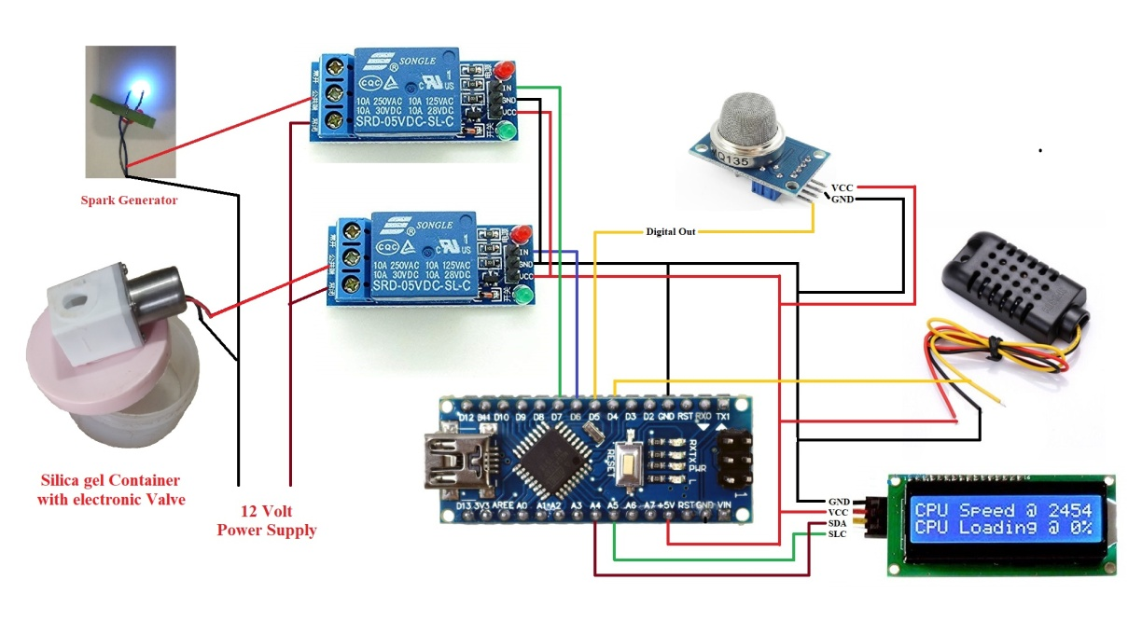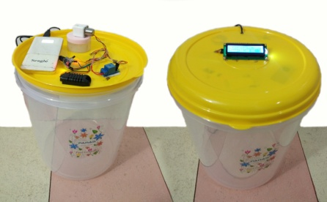

|  |  |  |
| --- | --- | --- |
| Sl No. | Particulars | Remarks |
| 1 | Title of Innovation | **IOT based Smart Irrigation System to Reduce Water Requirement in Irrigation Process** |
| 2 | Thematic area | Soil and Water Conservation |
| 3 | Profile of innovator | Dr. Subrata Manna  Computer Programmer  Darjeeling KVK |
| 4 | Problem / challenge address | In flood irrigation system, maximum water is either evaporated or goes inside to recharge ground water. It results a lots of water loss in irrigation process. |
| 5 | Description of innovative practice / technology | * This device is designed to measure the soil moisture level through moisture sensor and operate irrigation system as per the specified value set by user. Therefore the required moisture level is maintained in “Root Zone” soil only. * Embedded internet facility upload the soil moisture status in Cloud and it can be monitored from anywhere using mobile phone. |
| 6 | Practical Utility | * The system can run without human intervention, sensing soil moisture and threshold value set by the user. * It can reduce wastage of water in irrigation system. * It can reduce labour input-cost by minimizing farmers’ presence during irrigation process. * Field status can be monitored through mobile phone anywhere * Water logger facility gives the date-wise data of water disbursement through smart irrigation system, therefore at the end of a cropping period exact water requirement can be calculated for a particular crop. |
| 7 | Source of Information | Different research journal |
| 8 | Economics/ Profitability of innovation Practice  Technology cost / Return | Rs. 5000/- for control Unit. |
| 9 | Potential : Acceptance level, horizontal spread of innovation and number of farmer adopting | NABARD has sanctioned project to disseminate the technology. Fifty farmers will be benefited for this project. |
| 10 | Illustrate with high quality photos |  |

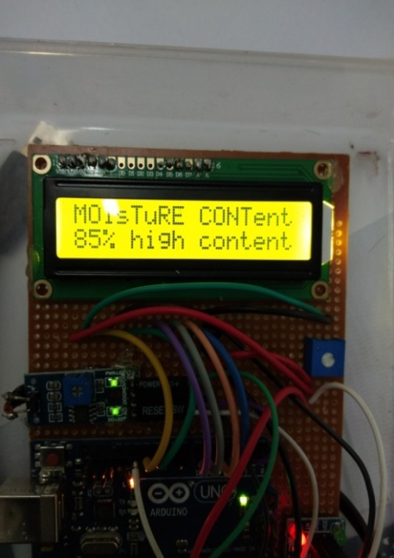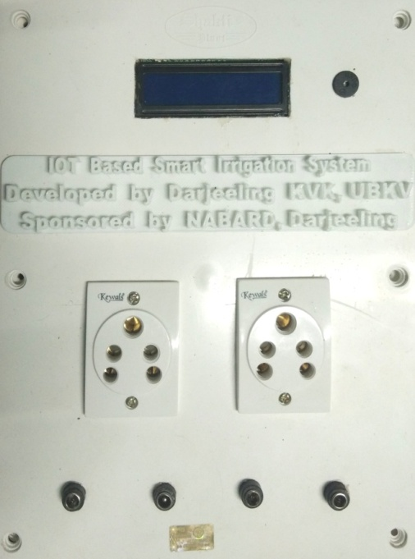

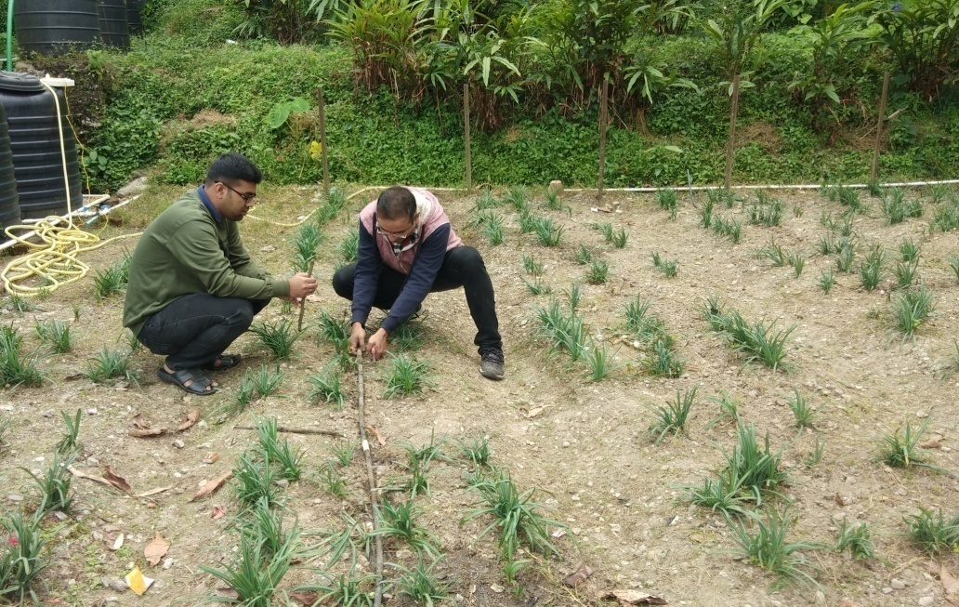

.5. Details of entrepreneurship development

|  |  |
| --- | --- |
| Entrepreneurship development under Horticulture | |
| Name of the enterprise | Organic seed Production of Vegetable crops . |
| Name & complete address of the entrepreneur | Hem Kumar Tamang  Village-Purba Samalbong  Samalbong GP |
| Role of KVK with quantitative data support: | Mr Tamang was into traditional farming since his childhood but his interest in Seedling production of vegetables grew when he was given training on topic Seedling production conducted off campus sponsored by Rotary club at Samalbong GP on January 2018 regarding.His keen interest has made him entrepreneur them . |
| Timeline of the entrepreneurship development | 1.5 Years. |
| Technical Components of the Enterprise | Seedling Production Unit (30/15 ft). |
| Status of entrepreneur before and after the enterprise | Mr Tamang being traditional farmer had a very irratic source of income but after the establishment of the unit he has now a regular source of income and also he has become a resource person or a adviser for the farmers of the locality. |
| Present working condition of enterprise in terms of raw materials availability, labour availability, consumer preference, marketing the product etc. ( Economic viability of the enterprise): | He produces seedling of Tomato, Cabbage, Capsicum, Cauliflower and Brocolli 1000/-seedling each at 15 days interval.  He also provides employment to 1 worker daily for maintenance of his business.  His produce are sold locally in the market as well as |
| Horizontal spread of enterprise | After his establishment of the seedling production unit Six more farmers of the nearby villages have started their unit. |

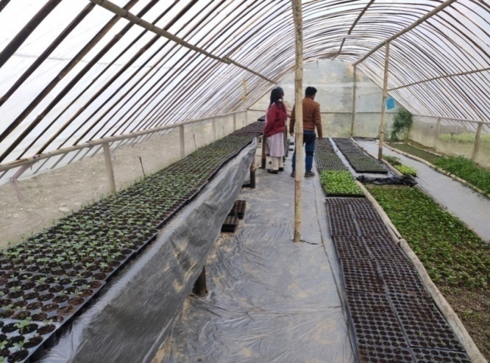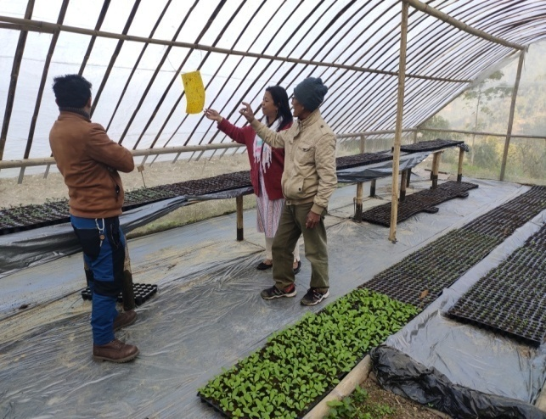

|  |  |
| --- | --- |
| Entrepreneurship development (Under Agril. Extension) | |
| Name of the enterprise | Value addition |
| Name & complete address of the entrepreneur | Bheema Bhattarai, |
| Role of KVK with quantitative data support: | Imparted Skill development Training on value addition and marketing |
| Timeline of the entrepreneurship development | Three year |
| Technical Components of the Enterprise | “Tulsi Ark and Tulsi Tea” |
| Status of entrepreneur before and after the enterprise | KVK organized different training programme of scientific cultivation practices, value addition and marketing. She started her venture and successfully growing Tulsi and producing value added products. She sells her products in melas and locally as well as supplies to different districts with a good profit. |
| Present working condition of enterprise in terms of raw materials availability, labour availability, consumer preference, marketing the product etc.  ( Economic viability of the enterprise): | Darjeeling KVK and West Bengal Khadi & Village Industries Board jointly market the products of Tulsi in different district of West Bengal |
| Horizontal spread of enterprise | KVK mobilized the farmers of that village for the cultivation of tulsi and formed a SHG group named Tulsi Growers SHG. Around 20 farmers of 3 villages of this district have started cultivating 'Ram Tulsi'. |

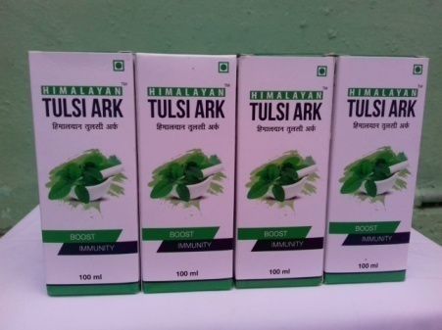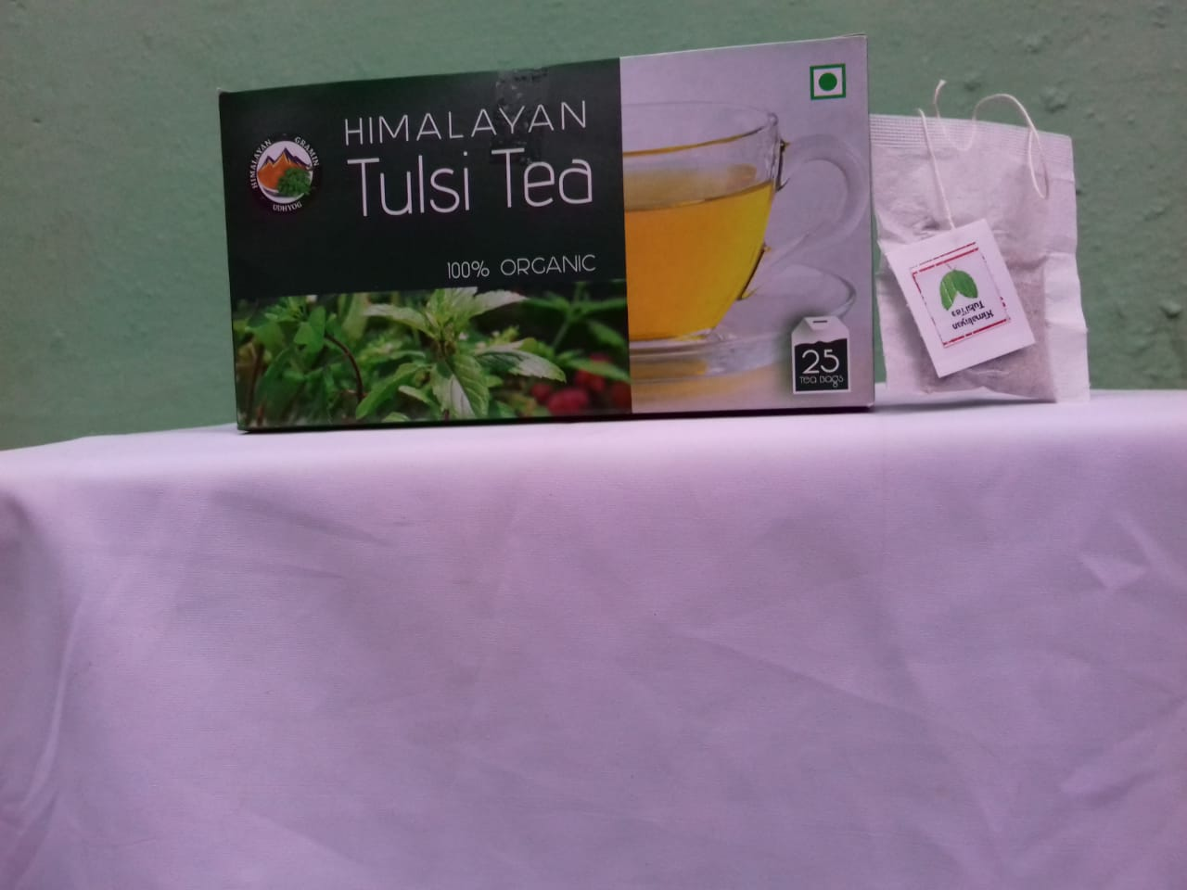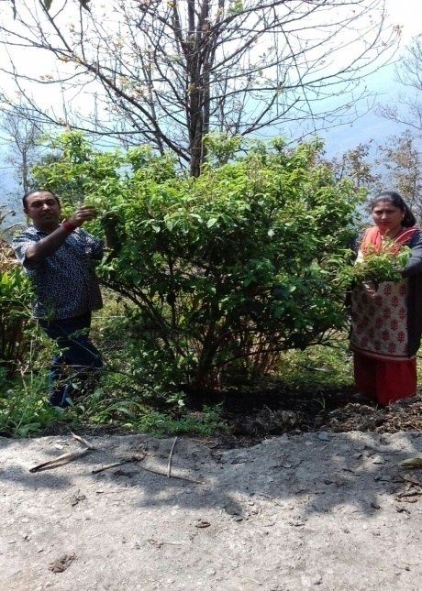

4.6. Any other initiative taken by the KVK

5. LINKAGES

5.1. Functional linkage with different organizations

|  |  |
| --- | --- |
| **Name of organization** | **Nature of linkage** |
| State Agriculture Dept., Govt. of West Bengal | Training |
| Regional Research Station (Hill Zone), Uttar Banga Krishi Viswavidyalaya, Kalimpong |
| Dept. of Animal Recourses Development, Govt. of West Bengal |
| Sasastra Seema Bal (SSB), Siliguri Frontier |
| Regional Station, Indian Agricultural Research Institute, Kalimpong |
| Regional Research Station (Hill Zone), Uttar Banga Krishi Viswavidyalaya, Kalimpong | Demonstration |
| State Agriculture Dept., Govt. of West Bengal |
| Regional Research Station (Hill Zone), Uttar Banga Krishi Viswavidyalaya, Kalimpong | Joint Survey |
| State Agriculture Dept., Govt. of West Bengal |
| State Agriculture Dept., Govt. of West Bengal | Technical Support |
| Regional Research Station (Hill Zone), Uttar Banga Krishi Viswavidyalaya, Kalimpong |
| Dept. of Animal Recourses Development, Govt. of West Bengal |
| Spices Board, Kalimpong, Govt. of India |
| Regional Station, Indian Agricultural Research Institute, Kalimpong |

5.2. List of special programmes undertaken during 2021by the KVK, which have been financed by ATMA/ Central Govt/ State Govt./NABARD/NHM/NFDB/Other Agencies **(information of previous years should not be provided)**

a) Programmes for infrastructure development

|  |  |  |  |  |
| --- | --- | --- | --- | --- |
| Name of the programme/scheme | Purpose of programme | Date/ Month of initiation | Funding agency | Amount (Rs.) |
|  |  |  |  |  |

(b) Programme for other activities (training, FLD,OFT, Mela, Exhibition etc.)

|  |  |  |  |  |
| --- | --- | --- | --- | --- |
| Name of the programme/scheme | Purpose of programme | Date/ Month of initiation | Funding agency | Amount (Rs.) |
|  |  |  |  |  |

1. PERFORMANCE OF INFRASTRUCTURE IN KVK

6.1. Performance of demonstration units (other than instructional farm)

|  |  |  |  |  |  |  |  |  |  |
| --- | --- | --- | --- | --- | --- | --- | --- | --- | --- |
| Sl. No. | Name of demo Unit | Year of estt. | Area(Sq.mt) | Details of production | | | Amount (Rs.) | | Remarks |
| Variety/breed | Produce | Qty. | Cost of inputs | Gross income |  |
| 1 | Mushroom Unit | 2020-21 | 20 | Oyster | Fruit | 40 Kg | 1200 | 4000 |  |
| 2 | Azolla Unit | 2020-21 | 2 | Azolla | Fodder | 200 Kg | 1250 | 2000 |  |
| 3 | Bee Keeping | 2020-21 | 5 No.s | Indian bee | Honey | -- |  |  |  |
| 4 | Poultry | 2020-21 | 4 | Kadaknath | Meat | -- |  |  |  |
| Total |  |  |  |  |  |  |  |  |  |

6.2. Performance of Instructional Farm (Crops)

|  |  |  |  |  |  |  |  |  |  |
| --- | --- | --- | --- | --- | --- | --- | --- | --- | --- |
| Name  Of the crop | Date of sowing | Date of harvest | Area (ha) | Details of production | | | Amount (Rs.) | | Remarks |
|  |  | Variety | Type of Produce | Qty.(q) | Cost of inputs | Gross income |
|  |  |  |  |  |  |  |  |  |  |
|  |  |  |  |  |  |  |  |  |  |
|  |  |  |  |  |  |  |  |  |  |
|  |  |  |  |  |  |  |  |  |  |
|  |  |  |  |  |  |  |  |  |  |
|  |  |  |  |  |  |  |  |  |  |
|  |  |  |  |  |  |  |  |  |  |
|  |  |  |  |  |  |  |  |  |  |
|  |  |  |  |  |  |  |  |  |  |

* 1. Performance of Production Units (bio-agents / bio pesticides/ bio fertilizers etc.,)

|  |  |  |  |  |  |
| --- | --- | --- | --- | --- | --- |
| Sl.  No. | Name of the Product | Qty. (Kg) | Amount (Rs.) | | Remarks |
| Cost of inputs | Gross income |
| 1. |  |  |  |  |  |
|  |  |  |  |  |  |

* 1. Performance of instructional farm (livestock and fisheries production)

|  |  |  |  |  |  |  |  |
| --- | --- | --- | --- | --- | --- | --- | --- |
| Sl.  No | Name  of the animal / bird / aquatics | Details of production | | | Amount (Rs.) | | Remarks |
| Breed | Type of Produce | Qty. | Cost of inputs | Gross income |
| 1. |  |  |  |  |  |  |  |
| 2. |  |  |  |  |  |  |  |
| 3. |  |  |  |  |  |  |  |

* 1. Utilization of hostel facilities

Accommodation available (No. of beds)

|  |  |  |  |
| --- | --- | --- | --- |
| Months | No. of trainees stayed | Trainee days  (days stayed) | Reason for short fall (if any) |
| Dec 2021 | 11 | 3 | Lockdown due to Covid-19 |
|  |  |  |  |
|  |  |  |  |
| Total : | 11 | 3 |  |

(For whole of the year)

* 1. Utilization of staff quarters

Whether staff quarters has been completed:

No. of staff quarters: 6

Date of completion: 2008

Occupancy details: 4 vacant

Occupancy details:

|  |  |  |  |  |  |  |
| --- | --- | --- | --- | --- | --- | --- |
| Months | Q I | QII | Q III | QIV | Q V | QVI |
|  |  | | | | | |
|  |
|  |
|  |

1. FINANCIAL PERFORMANCE

7.1. Details of KVK Bank accounts

|  |  |  |  |
| --- | --- | --- | --- |
| Bank account | Name of the bank | Location | Account Number |
| Darjeeling KVK | SBI | Kalimpong | 11283931150 |
| Darjeeling KVK | Bank of India | Kalimpong | 429310110000033 |

* 1. Utilization of funds under CFLD on Oilseed *(Rs. In Lakhs)*

|  |  |  |  |  |  |
| --- | --- | --- | --- | --- | --- |
| Item | Released by ICAR | | Expenditure | | Unspent balance as on 1st April, 2021 |
| Kharif | Rabi | Kharif | Rabi |
| Mustard |  | 75000 |  | 75000 |  |

7.3. Utilization of funds under CFLD on Pulses *(Rs. In Lakhs)*

|  |  |  |  |  |  |
| --- | --- | --- | --- | --- | --- |
| Item | Released by ICAR | | Expenditure | | Unspent balance as on 1st April 2021 |
| Kharif | Rabi | Kharif | Rabi |
| Pulses | 90000 |  | 90000 |  |  |

* 1. Utilization of KVK funds during the year 2021-22(Not audited)

|  |  |  |  |  |
| --- | --- | --- | --- | --- |
| Sl.  No. | Particulars | Sanctioned | Released | Expenditure |
| A. Recurring Contingencies | | | | |
| 1 | Pay & Allowances | 15800000 |  | 15802920 |
| 2 | Traveling allowances | 130,000 |  | 122632 |
| 3 | Contingencies | | | |
| *E* | Office Contingency | 160000 |  | 302521 |
| *F* | Training | 120000 |  | 19720 |
| *G* | FLD | 60000 |  | 12528 |
| *H* | OFT | 60000 |  | 12282 |
| *I* | SCSP | 2300000 |  | 632759 |
| *J* | Swachhta Expenditure/ SAP Fund | 1500 |  | 1500 |
| TOTAL (A) | | **18631500** |  | **16906862** |
| B. Non-Recurring Contingencies | | | | |
| 1 | Equipment and Furniture | 200000 |  | -- |
| 2 | Library | 10000 |  | 10000 |
| 3 | Works | 400000 |  |  |
| 4 | IFS | 400000 |  |  |
| TOTAL (B) | | **1010000** |  | **10000** |
| C. REVOLVING FUND | | -- | -- | -- |
| GRAND TOTAL (A+B+C) | | **19641500** |  | **16916862** |

7.5. Status of revolving fund (Rs. in lakh) for last three years

|  |  |  |  |  |
| --- | --- | --- | --- | --- |
| Year | Opening balance as on 1st April | Income during the year | Expenditure during the year | Net balance in hand as on 1st April of each year (Kind + cash) |
| 2015-16 | 4,16,841 | 17,24,056 | 16,37,151 | 5,03,745 |
| 2016-17 | 5,03,745 | 2,11,967 | 2,78,520 | 4,37,192 |
| 2017-18 | 4,37,192 | 11,96,326 | 10,65,400 | 5,68,118 |
| 2018-19 | 5,68,118 | 19,53,452 | 19,44,552 | 5,77,018 |
| 2019-20 | 5,77,018 | 2,21,440/- | 6,21,788 | 1,76,670 |
| 2020-21 | 1,76,670 | 8,31,430/- | 9,08,916/- | 99,184 |

* 1. (i) Number of SHGs formed by KVKs : NIL

(ii) Association of KVKs with SHGs formed by other organizations indicating the area of SHG activities

(iii) Details of marketing channels created for the SHGs : NIL

* 1. Joint activity carried out with line departments and ATMA :

|  |  |  |  |  |  |
| --- | --- | --- | --- | --- | --- |
| Nameof activity | Number of activity | Season | With line department | With ATMA | With both |
| Research Project | 1. Sericulture 2. Dragon Fruit Production 3. Apple Production | June – July  June – July  Jan - Feb | Agriculture Department | ATMA |  |

8. Other information

8.1. Prevalent diseases in Crops

|  |  |  |  |  |  |
| --- | --- | --- | --- | --- | --- |
| Name of the disease | Crop | Date of outbreak | Area affected (in ha) | % Commodity loss | Preventive measures taken for area (in ha) |
| FAW of Maize | Maize | 26/02/2021 | 20-25 | 40 % | 10 ha |

8.2. Prevalent diseases in Livestock/Fishery

|  |  |  |  |  |  |
| --- | --- | --- | --- | --- | --- |
| Name of the disease | Species affected | Date of outbreak | Number of death/ Morbidity rate (%) | Number of animals vaccinated | Preventive measures taken in pond (in ha) |
| PPR | Goat | 21/05/2021 | 50% | 137 | -- |
|  |  |  |  |  |  |

9.1. Nehru YuvaKendra(NYK) Training : NIL

|  |  |  |  |  |  |
| --- | --- | --- | --- | --- | --- |
| Title of the training programme | Period | | No. of the participant | | Amount of Fund Received (Rs) |
|  | From | To | M | F |  |
|  |  |  |  |  |  |
|  |  |  |  |  |  |

9.2. PPV & FR Sensitization training Programme : NIL

|  |  |  |  |  |
| --- | --- | --- | --- | --- |
| Date of organizing the programme | Resource Person | No. of participants | Registration (crop wise) | |
|  |  |  | Name of crop | No. of registration |
|  |  |  |  |  |

9.3. *mKisan*Portal (National Farmers’ Portal/ SMSPortal) : Not Working

|  |  |  |
| --- | --- | --- |
| Type of message | No. of messages | No. of farmers covered |
| Crop |  |  |
| Livestock |  |  |
| Fishery |  |  |
| Weather |  |  |
| Marketing |  |  |
| Awareness |  |  |
| Training information |  |  |
| Other |  |  |
| **Total** |  |  |

9.4. *KVK* Portal and Mobile App

|  |  |  |
| --- | --- | --- |
| Sl. No. | Particulars | Description |
| 1. | No. of visitors visited the portal | *125* |
| 2. | No. of farmers registered in the portal | *1200* |
| 3. | Mobile Apps developed by KVK | *1* |
| 4. | Name of the App | *KVK online Agrimart* |
| 5. | Language of the App | *Nepali* |
| 6. | Meant for crop/ livestock/ fishery/ others |  |
| 7. | No. of times downloaded | *47* |

9.5. a. Observation of Swachh Bharat Programme : NIL

|  |  |
| --- | --- |
| Date/ Duration of Observation | Activities undertaken |
|
|  |  |

b. Details of Swachhta activities with expenditure

|  |  |  |
| --- | --- | --- |
| **Activities** | **Number** | **Expenditure (in Rs.)** |
| 1. Digitization of office records/ e-office |  |  |
| 1. Basic maintenance |  |  |
| 1. Sanitation and SBM |  |  |
| 1. Cleaning and beautification of surrounding areas |  |  |
| 1. Vermicomposting/   Composting of biodegradable waste management & other activities on generate of wealth for waste |  |  |
| 1. Used water for agriculture/ horticulture application |  |  |
| 1. Swachhta Awareness at local level |  |  |
| 1. Swachhta Workshops |  |  |
| 1. Swachhta Pledge |  |  |
| 1. Display and Banner |  |  |
| 1. Foster healthy competition |  |  |
| 1. Involvement of print and electronic media |  |  |
| 1. Involving the farmers, farm women and village youth in the adopted villages (no of adopted village) |  |  |
| 1. No of Staff members involved in the activities |  |  |
| 1. No of VIP/VVIPs involved in the activities |  |  |
| 16. Any other specific activity (in details) |  |  |
| **Total** |  |  |

9.6. Observation of National Science day

|  |  |
| --- | --- |
| Date of Observation | Activities undertaken |
|
|  |  |

9.7. Programme with Seema Suraksha Bal/ BSF

|  |  |  |
| --- | --- | --- |
| Title of Programme | Date | No. of participants |
| Training and demonstration on Italian Honey Bee | 10/02/2021 | 45 |

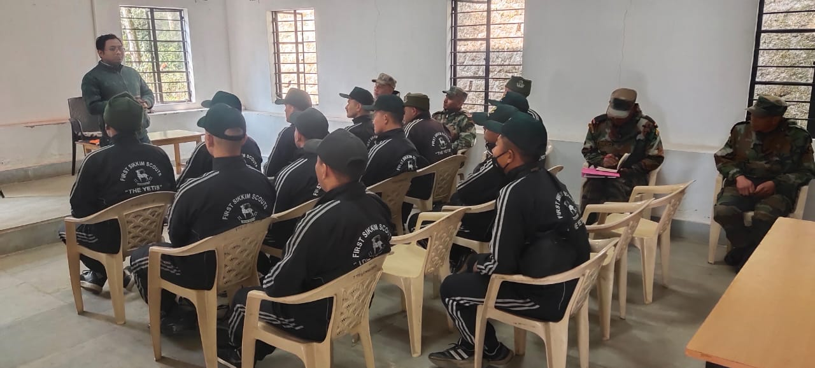 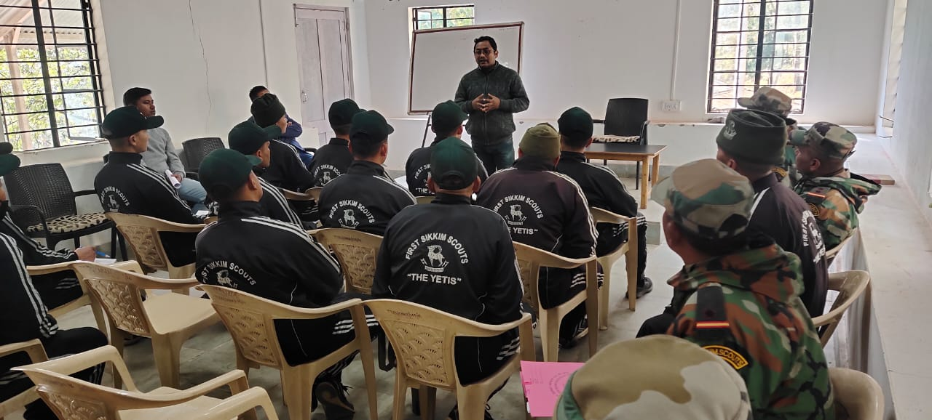

9.8. Agriculture Knowledge in rural school

|  |  |  |  |
| --- | --- | --- | --- |
| Name and address of school | Date of visit to school | Areas covered | Teaching aids used |
|  |  |  |  |
|  |  |  |  |

Give good quality 1-2 photograph(s)

9.9. Details of Swachhta Hi Suraksha programme(16-31.12.2021) organized

|  |  |  |  |  |  |
| --- | --- | --- | --- | --- | --- |
| Sl.  No. | Activity | No. of villages Involved | No. of Participants | No. of VIPs | Name (s) of VIP(s) |
|  |  |  |  |  |  |

9.10. Details of Mahila Kisan Divas programme(15.10.2021) organized

|  |  |  |  |  |  |
| --- | --- | --- | --- | --- | --- |
| Sl.  No. | Activity | No. of villages Involved | No. of Participants | No. of VIPs | Name (s) of VIP(s) |
| 01 | Training/ webcasting | 1 | 13 | -- | -- |

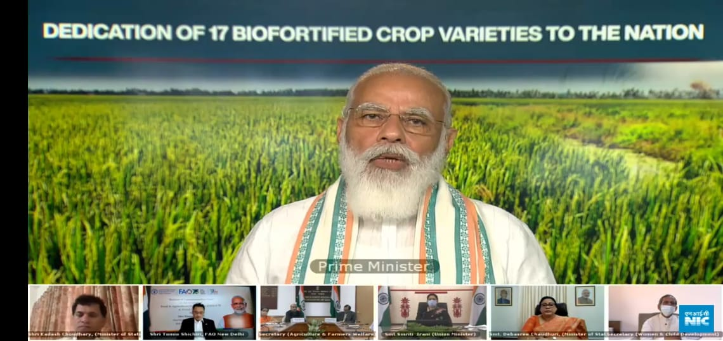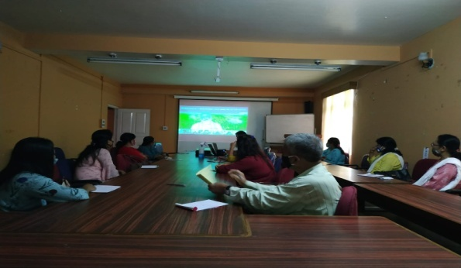

9.11. No. of Progressive/Innovative/Lead farmer identified (category wise)

|  |  |  |  |
| --- | --- | --- | --- |
| Sl.  No. | Name of Farmer | Address of the farmer with contact no. | Innovation/ Leading in enterprise |
|  |  |  |  |

9.12. Revenue generation

| Sl.No. | Name of Head | Income(Rs.) | Sponsoring agency |
| --- | --- | --- | --- |
| 1. |  |  |  |
| 2. |  |  |  |
| 3. |  |  |  |

9.13. Resource Generation:

|  |  |  |  |  |  |
| --- | --- | --- | --- | --- | --- |
| Sl.No. | Name of the programme | Purpose of the programme | Sources of fund | Amount  (Rs. lakhs) | Infrastructure created |
|  |  |  |  |  |  |

9.14. Performance of Automatic Weather Station in KVK : NA

|  |  |  |
| --- | --- | --- |
| Date of establishment | Source of funding i.e. IMD/ICAR/Others (pl. specify) | Present status of functioning |
|  |  |  |
|  |  |  |

9.15. Contingent crop planning

|  |  |  |  |  |  |
| --- | --- | --- | --- | --- | --- |
| Name of the state | Name of district/KVK | Thematic area | Number of programmes organized | Number of Farmers contacted | A brief about contingent plan executed by the KVK |
|  |  |  |  |  |  |

10. Report on Cereal Systems Initiative for South Asia (CSISA)

1. Year:
2. Introduction / General Information:

|  |  |  |  |  |  |  |
| --- | --- | --- | --- | --- | --- | --- |
|  | Title | Objective | Treatment details | Date of sowing | Replication | Result with photographs |
| Experiment 1 |  |  |  |  |  |  |
| Experiment 2 |  |  |  |  |  |  |
| Experiment 3 |  |  |  |  |  |  |
| … |  |  |  |  |  |  |
| .. |  |  |  |  |  |  |
| Others (If any) |  |  |  |  |  |  |

11. Celebration of World Food Day in 2021

|  |  |  |  |  |  |
| --- | --- | --- | --- | --- | --- |
| **Sl. No.** | **Activities undertaken** | **No. of VIPs attended** | **No. of participants** | | |
|  |  |  | **M** | **F** | **T** |
|  |  |  |  |  |  |

12.Progress report of NICRA KVK (Technology Demonstration component) during the period

(Applicable for KVKs identified under NICRA)

Natural Resource Management

|  |  |  |  |  |  |  |  |  |  |  |  |  |  |  |
| --- | --- | --- | --- | --- | --- | --- | --- | --- | --- | --- | --- | --- | --- | --- |
| Name of intervention undertaken | Numbers under taken | No of units | Area (ha) | No of farmers covered / benefitted | | | | | | | | | | Remarks |
|  |  |  |  | SC | | ST | | | Other | | Total | | |  |
|  |  |  |  | M | F | | M | F | M | F | M | F | T |  |
|  |  |  |  |  |  | |  |  |  |  |  |  |  |  |

Crop Management

|  |  |  |  |  |  |  |  |  |  |  |  |  |
| --- | --- | --- | --- | --- | --- | --- | --- | --- | --- | --- | --- | --- |
| Name of intervention undertaken | Area (ha) | No of farmers covered / benefitted | | | | | | | | | | Remarks |
|  |  | SC | | ST | | | Other | | Total | | |  |
|  |  | M | F | | M | F | M | F | M | F | T |  |
|  |  |  |  | |  |  |  |  |  |  |  |  |

Livestock and fisheries

|  |  |  |  |  |  |  |  |  |  |  |  |  |  |  |
| --- | --- | --- | --- | --- | --- | --- | --- | --- | --- | --- | --- | --- | --- | --- |
| Name of intervention undertaken | Number of animals covered | No of units | Area (ha) | No of farmers covered / benefitted | | | | | | | | | | Remarks |
|  |  |  |  | SC | | ST | | | Other | | Total | | |  |
|  |  |  |  | M | F | | M | F | M | F | M | F | T |  |
|  |  |  |  |  |  | |  |  |  |  |  |  |  |  |

Institutional interventions

|  |  |  |  |  |  |  |  |  |  |  |  |  |  |
| --- | --- | --- | --- | --- | --- | --- | --- | --- | --- | --- | --- | --- | --- |
| Name of intervention undertaken | No of units | Area (ha) | No of farmers covered / benefitted | | | | | | | | | | Remarks |
|  |  |  | SC | | ST | | | Other | | Total | | |  |
|  |  |  | M | F | | M | F | M | F | M | F | T |  |
|  |  |  |  |  | |  |  |  |  |  |  |  |  |

Capacity building

|  |  |  |  |  |  |  |  |  |  |  |  |
| --- | --- | --- | --- | --- | --- | --- | --- | --- | --- | --- | --- |
| Thematic area | No of Courses | No of beneficiaries | | | | | | | | | |
|  |  | SC | ST | | | Other | | | Total | | |
|  |  | M | F | M | F | | M | F | M | F | T |
|  |  |  |  |  |  | |  |  |  |  |  |

Extension activities

|  |  |  |  |  |  |  |  |  |  |  |  |
| --- | --- | --- | --- | --- | --- | --- | --- | --- | --- | --- | --- |
| Thematic area | No of activities | No of beneficiaries | | | | | | | | | |
|  |  | SC | ST | | | Other | | | Total | | |
|  |  | M | F | M | F | | M | F | M | F | T |
|  |  |  |  |  |  | |  |  |  |  |  |

Detailed report should be provided in the circulated Performa

13. Awards/Recognition received by the KVK

|  |  |  |  |  |  |
| --- | --- | --- | --- | --- | --- |
| Sl. No. | Name of the Award | Year | Conferring Authority | Amount | Purpose |
|  |  |  |  |  |  |
|  |  |  |  |  |  |
|  |  |  |  |  |  |

Award received by Farmers from the KVK district

|  |  |  |  |  |  |  |
| --- | --- | --- | --- | --- | --- | --- |
| Sl. No. | Name of the Award | Name of the Farmer | Year | Conferring Authority | Amount | Purpose |
|  |  |  |  |  |  |  |
|  |  |  |  |  |  |  |
|  |  |  |  |  |  |  |

14. Any significant achievement of the KVK with facts and figures as well as quality photograph

15. Number of commodity based organizations/ farmers’ cooperative society/ FPO formed/ associated with during last one year (Details of the group/society may be indicated)

|  |  |  |  |  |  |  |  |  |
| --- | --- | --- | --- | --- | --- | --- | --- | --- |
| Sl. No. | Name of the organization/ Society | Trust Deed No.& date | Date of Trust Registration        Address | Proposed Activity | Commodity Identified | No. of Members | Financial position  (Rupees in lakh) | Success indicator |
|  |  |  |  |  |  |  |  |  |

1. Integrated Farming System (IFS)

Details of KVK Demo. Unit

|  |  |  |  |  |  |  |  |
| --- | --- | --- | --- | --- | --- | --- | --- |
| Sl.  No. | Module details (Component-wise) | Area under IFS (ha) | Production (Commodity-wise) | Cost of production in Rs. (Component-wise) | Value realized in Rs. (Commodity-wise) | No. of farmer adopted practicing IFS | % Change in adoption during the year |
|  |  |  |  |  |  |  |  |

1. Technologies for Doubling Farmers' Income

|  |  |  |  |  |  |
| --- | --- | --- | --- | --- | --- |
| Sl. No. | Name of the Technology | Brief Details of Technology (3- 5 bullet points) | Net Return to the farmer (Rs.) per ha per year due to adoption of the technology | No. of farmers adopted the technology in the district | One high resolution ‘Photo’ in ‘jpg’ format for each technology |
| 1 |  |  |  |  |  |
| 2 |  |  |  |  |  |

1. a) Information on **ASCI** Skill Development Training Programme, if undertaken during 2021

|  |  |  |  |  |  |  |  |  |  |  |  |
| --- | --- | --- | --- | --- | --- | --- | --- | --- | --- | --- | --- |
| Name of the Job role | Name of the certified Trainer of KVK for the Job role | Date of start of training | Date of completion of training | No. of participants | | | | | | Whether uploaded to SIP Portal (Y/N) | Fund utilized for the training (Rs.) |
| SC | | ST | | Other | |
| M | F | M | F | M | F |
|  |  |  |  |  |  |  |  |  |  |  |  |
|  |  |  |  |  | | | | | |  |  |
|  |  |  |  |  | | | | | |  |  |
|  |  |  |  |  | | | | | |  |  |

b) Information on Skill Development Training Programme (**Other than ASCI or less than 200 hrs**., if any) if undertaken during 2021

|  |  |  |  |  |  |  |  |  |  |  |  |  |
| --- | --- | --- | --- | --- | --- | --- | --- | --- | --- | --- | --- | --- |
| Thematic area of training | Title of the training | Duration (in hrs.) | No. of participants | | | | | | | | | Fund utilized for the training (Rs.) |
|  |  |  | SC | | ST | | Other | | Total | | |  |
|  |  |  | M | F | M | F | M | F | M | F | T |  |
|  |  |  |  |  |  |  |  |  |  |  |  |  |

1. Information on NARI Project(if applicable)

|  |  |  |  |  |  |  |
| --- | --- | --- | --- | --- | --- | --- |
| Name of Nodal Officer | No. of OFT on specified aspects | Title(s) of OFT | No. of FLD on specified aspects | No. of capacity development programme on specified aspects | Total no. of farm women/ girls involved in the project | Details of Issues related to gender mainstreaming addressed through the project |
|  |  |  |  |  |  |  |

1. **Specific programmes for the period**

**i. Achievements in SCSP (Scheduled Caste Sub-Plan) (Specific for SC farmers only)**

|  |  |  |  |  |
| --- | --- | --- | --- | --- |
| Sl. No. | Activity | No. of SC farmers/ stakeholders | | |
|  |  | Male | Female | Total |
| 1 | On- farm trials |  |  |  |
| 2 | Frontline demonstrations | 7 | 3 | 10 |
| 3 | No. of Training programmes for farmers | 200 | 33 | 233 |
| 4 | Farmers trained |  |  |  |
| 5 | No. of Training programmes for Extension Personnel |  |  |  |
| 6 | Extension Personnel trained |  |  |  |
| 7 | Participants in extension activities |  |  |  |
| 8 | Distribution of seed | 50 | 30 | 80 |
| 9 | Planting material distributed | 38 | 22 | 60 |
| 10 | Livestock strains and fingerlings distributed |  |  |  |
| 11 | Soil, water, plant, manures samples tested |  |  |  |
| 12 | Mobile agro-advisory provided to farmers |  |  |  |
| 13 | Other (Please specify) |  |  |  |

**ii. Capacity building of farmers through training on Profitable Dairy Farming and Livestock Management (In case your KVK has Scientist (Animal/Veterinary Science))**

|  |  |  |  |  |  |  |  |  |  |  |
| --- | --- | --- | --- | --- | --- | --- | --- | --- | --- | --- |
| **Sl. No.** | **Title of the training** | **Date/**  **Duration** | **No. of Participants** | | | | | | | |
| **SC** | | **ST** | | **Other** | | **Total** | |
| **M** | **F** | **M** | **F** | **M** | **F** | **M** | **F** |
|  |  |  |  |  |  |  |  |  |  |  |

1. **Status of Natural Farming**

|  |  |  |  |  |
| --- | --- | --- | --- | --- |
| **Crop/ Commodity involved in Natural farming** | **Area covered under such farming (ha)** | **No. of farmers practicing Natural farming at present** | **Details of individual farmers (Name and Contact No.)** | **Organic component/ inputs used for such farming** |
|  |  |  |  |  |

1. **Farmer Producer Organizations**
2. **General information**

|  |  |  |  |  |  |  |  |
| --- | --- | --- | --- | --- | --- | --- | --- |
| **Sl. No.** | **Name & Address of FPO** | **Name &Contact No. of Head of FPO** | **No. of farmer members of FPO** | | | **Crop/ Enterprise dealt with by FPO** | **Kind of support provided by KVK in running/ starting of FPO (in brief)** |
|  |  |  | **M** | **F** | **T** |  |  |
|  |  |  |  |  |  |  |  |
|  |  |  |  |  |  |  |  |

1. **Financial information**

|  |  |  |  |  |  |  |  |
| --- | --- | --- | --- | --- | --- | --- | --- |
| **Name & Address of FPO** | **Date of Registration** | **FPO Registered (Y/N)** | **Application Submitted for Registration (Y/N)** | **No. of share-holding farmer members** | **Equity Amount Collected (Rs.)** | **Bank Account Opened (Y/N)** | **Board Reconstituted after attaining minimum membership (Y/N)** |
|  |  |  |  |  |  |  |  |
|  |  |  |  |  |  |  |  |
|  |  |  |  |  |  |  |  |
|  |  |  |  |  |  |  |  |
|  |  |  |  |  |  |  |  |

1. **Nutri-gardens (Village wise)**

|  |  |  |  |  |  |  |  |
| --- | --- | --- | --- | --- | --- | --- | --- |
| **Sl. No.** | **Name of village** | **Name of crop** | **Area under the crop (acre)** | **No. of farmers** | | | **Whether bio-fortified variety of crop used (If yes, mention variety & crop)** |
|  |  |  |  | **M** | **F** | **T** |  |
|  |  |  |  |  |  |  |  |
|  |  |  |  |  |  |  |  |
|  |  |  |  |  |  |  |  |

1. **Progress report on scientific beekeeping (2020-21 & 2021-22)**

| **Name of KVK** | **Total budget allotted (Rs.)** | **Total budget utilized (Rs.)** | **Physical Training organized** | | | | **Online Training organized** | | | |
| --- | --- | --- | --- | --- | --- | --- | --- | --- | --- | --- |
| **No. of training** | **No. of total participants** | | | **No. of training** | **No. of total participants** | | |
|  |  |  |  | **M** | **F** | **T** |  | **M** | **F** | **T** |
|  |  |  |  |  |  |  |  |  |  |  |

1. Any other programme organized by KVK, not covered above

|  |  |  |  |  |  |
| --- | --- | --- | --- | --- | --- |
| Sl.  No. | Name of the programme | Date of the programme | Venue | Purpose | No. of participants |
|  |  |  |  |  |  |

1. Good quality action photographs (with proper caption) of overall achievements of KVK during the year (best 10)

Potato Field Visit under Oft trials &Training programme atSindebong and Sakyoong Villages on 21.01.2021, 25.01.2021& 28.01.2021.

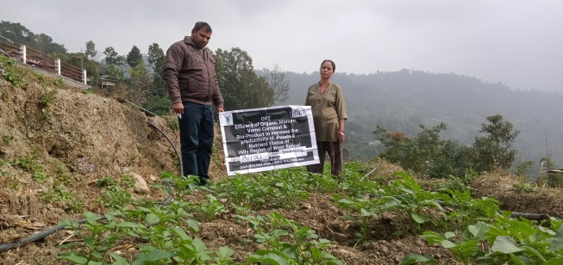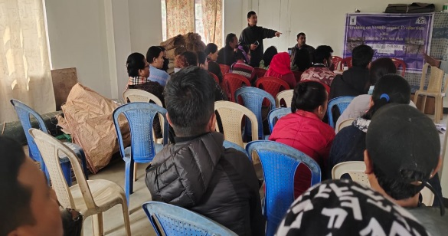

Oft Potato field visit at Sindebong on 21.01.2021 Training on Vermicompost 25.01.2021

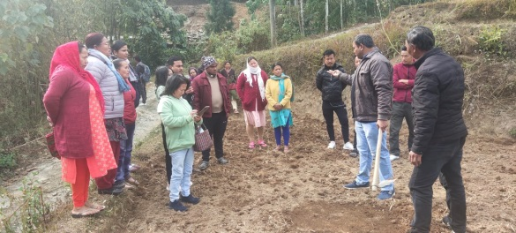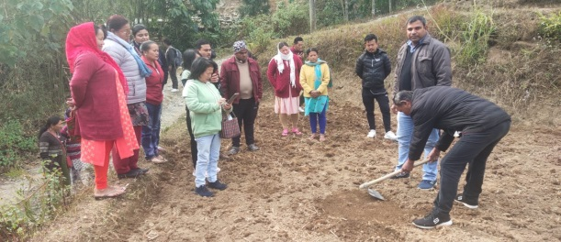

For Farmers & Farm women Training on Soil Sample Collection on 28.01.2021 at Sakyong Village

Conducting ATMA Sponsored Training Programme during 12th January to 15th January, 2021

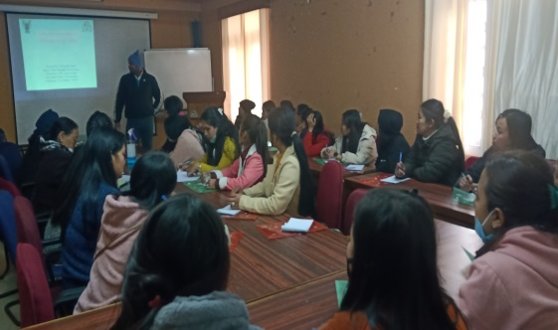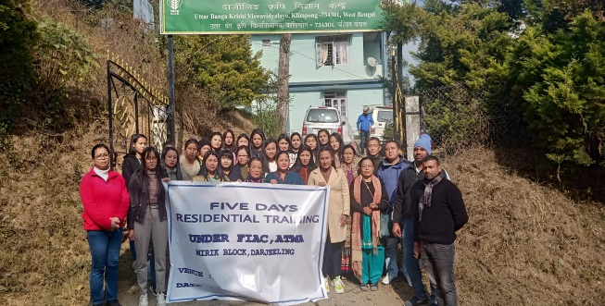

During Training Session Valedictory Session

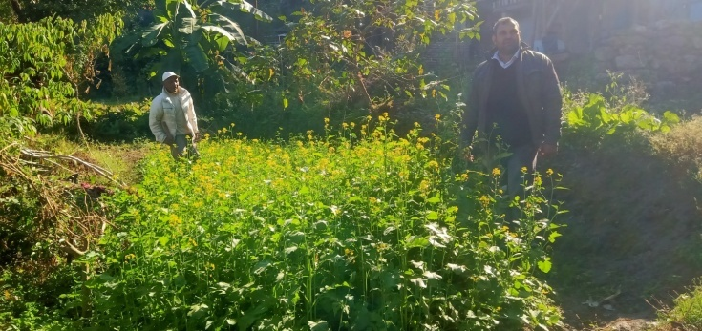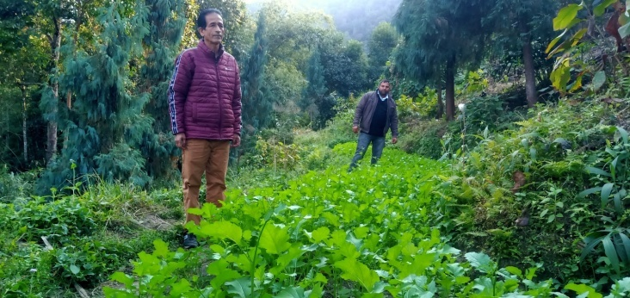

Mustrard Field Visit on 20.12.2021



***